TASK BASED LEARNING (TBL)

Small Project

TASK 1

Compare results from the reading and the demonstration you participated in your classmates’ teaching practice on Wednesday. Focus your attention on the result of the task (the final outcome), think about and create any suggestion, plan or idea to improve the end result of the task.

TASK 2: Analyzing a task

Imagine you’ve experienced one of these extreme weather events. Describe what it was like, include causes and effects.

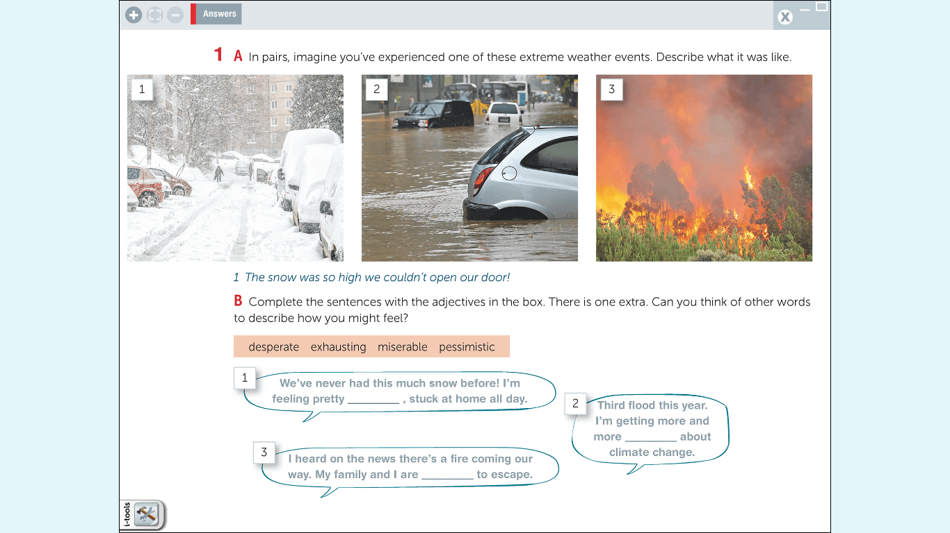

………………………………………………………………………………………………………………………………………………………
………………………………………………………………………………………………………………………………………………………
………………………………………………………………………………………………………………………………………………………
………………………………………………………………………………………………………………………………………………………

Once you finish, please analyze and answer:

• What language skills did you need to complete this task?

• What language content, vocabulary, grammatical structures are required to perform this task?

• Which is the necessary setting to do this task?

TASK 3
Reflect upon and list a few new ideas you learned from this part of the unit considering the following:
- How have the unit materials fostered, altered, or opened your perspectives towards the ELT methods you would like to employ in your local classroom?
……………………………………………………………………………………………………………………………………………
……………………………………………………………………………………………………………………………………………
……………………………………………………………………………………………………………………………………………
……………………………………………………………………………………………………………………………………………
……………………………………………………………………………………………………………………………………………
……………………………………………………………………………………………………………………………………………
……………………………………………………………………………………………………………………………………………
……………………………………………………………………………………………………………………………………………

