ROAD RAGE
- Watch the video again (Talking Zone in Richmond Platform) 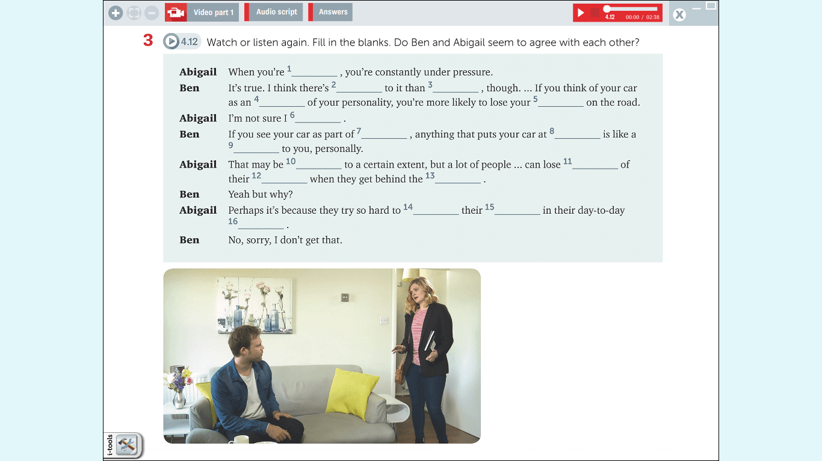

- List 6 phrase used to agree and 6 to disagree when responding to arguments. Include those Ben and Abigail use to agree or disagree politely in their conversation.

Agreeing
………………………………………………………………………………………………………………….
………………………………………………………………………………………………………………….
………………………………………………………………………………………………………………….
………………………………………………………………………………………………………………….
………………………………………………………………………………………………………………….
………………………………………………………………………………………………………………….

Disagreeing politely
………………………………………………………………………………………………………………….
………………………………………………………………………………………………………………….
………………………………………………………………………………………………………………….
………………………………………………………………………………………………………………….
………………………………………………………………………………………………………………….
………………………………………………………………………………………………………………….

- Recreate a conversation about road-rage using your own expressions.

