**HOMEWORK**

**Name:**

**Date:**

QUESTIONS ABOUT SHOPPING FOR CLOTHES

VIDEO.

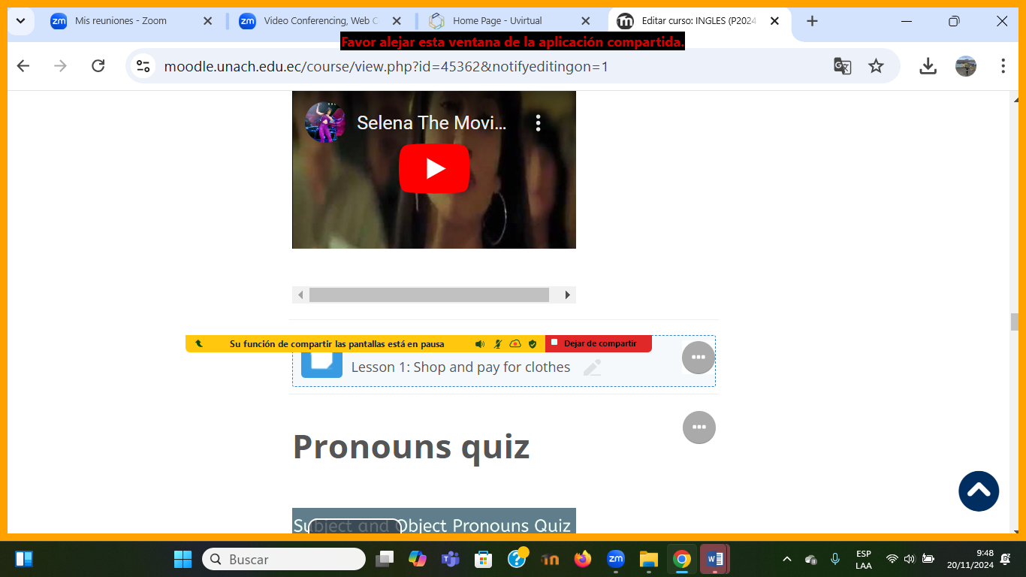

<https://youtu.be/DAqLtOVN06I>

1.- Watch the video and answer these questions.

1.- What does Selena want to buy?

2.- What color is it?

3.- How much is it?

4.- How was the service ( clerk) of the Clothing store?

5.- Why doesn´t Selena want to buy it?