** UNIVERSIDAD NACIONAL OF CHIMBORAZO.**

**Faculty of Engineering**

**NAME:**

**DATE:**

**HOMEWORK N° 2**

1. **Answer these questions**
   1. **Do you like vacation?**

_________________________________________________________________________________________________________________________________________________________________________________________________________________________________________________________ .

* 1. **Where would you like to travel?** _________________________________________________________________________________________________________________________________________________________________________________________________________________________________________________________ .

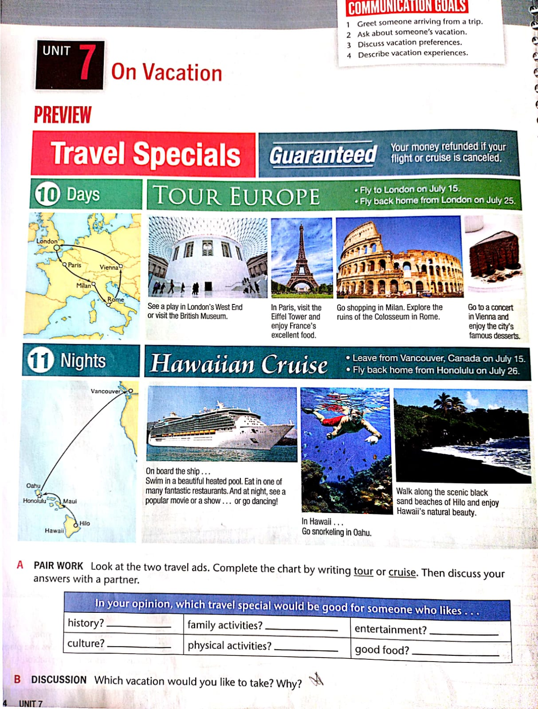

* 1. **Which vacation would you like to take? Why?**

_________________________________________________________________________________________________________________________________________________________________________________________________________________________________________________________ .