**HOMEWORK 3**

**Name:**

**Date:**

**Grammar: Present Continuous Tense**

**1) Watch again the video about Nick Vujicic and answer these statements.**

**a.- Where was he born?**

………………

**b.- What can he do?**

………………..

**c.- What is your opinion about him?**

………………………………………………….

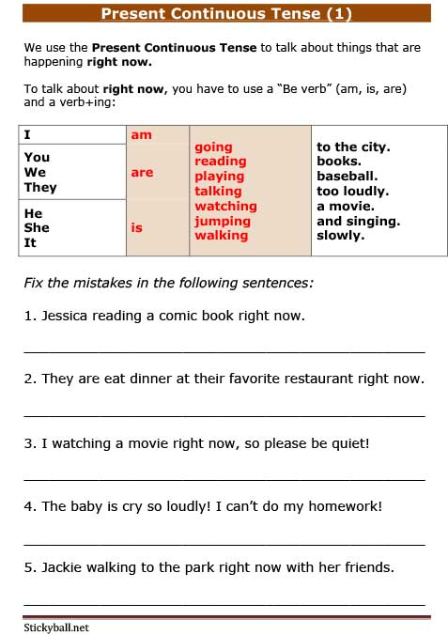

**2) Fix the mistakes in the following sentences:**

1. Jessica Reading a comic book right now.

_________________________________________________

1. They are eat dinner at their favorite restaurant right now.

_________________________________________________

1. I watching a movie right now, so please be quiet!

_________________________________________________

1. The baby is cry so loudly! I can´t do my homework!

_________________________________________________

1. Jackie walking to the park right now with her Friends.

_________________________________________________