BUT IS IT ART?
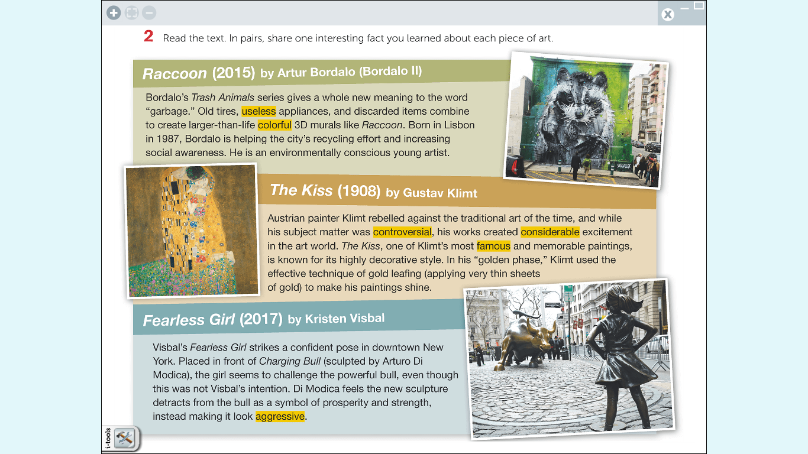

Please, read the text of this topic on page 12 and develop the tasks 2, 3 and 4. Be prepared to answer your professor’s questions in class. You can use this page to make notes.

