

**Reading activities**

Name: _______________________________ Date: ______________________________

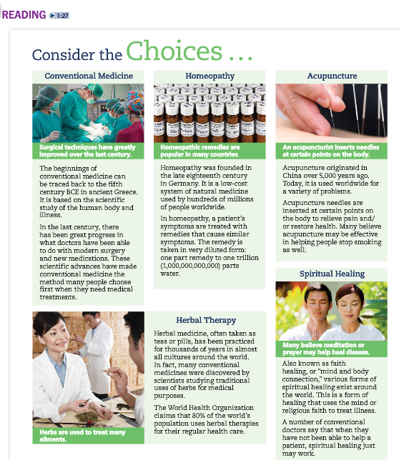

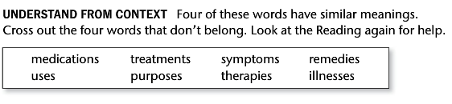



________________________________________________________________________________________________________________________________________________________________________________________________________________________________________________



________________________________________________________________________________________________________________________________________________________________________________________________________________________________________________

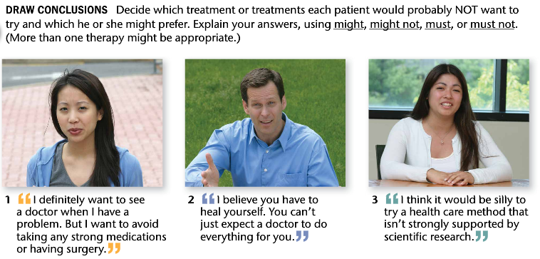

1. ____________________________________________________________________________________________________________________________________________________
2. ____________________________________________________________________________________________________________________________________________________
3. ____________________________________________________________________________________________________________________________________________________