**Page 1 of 2**

**NAME:** ____________________________ **DATE:** ____________

**Just for Fun**

**(Unit 6)**

**A. Read the clues and complete the crossword puzzle.**

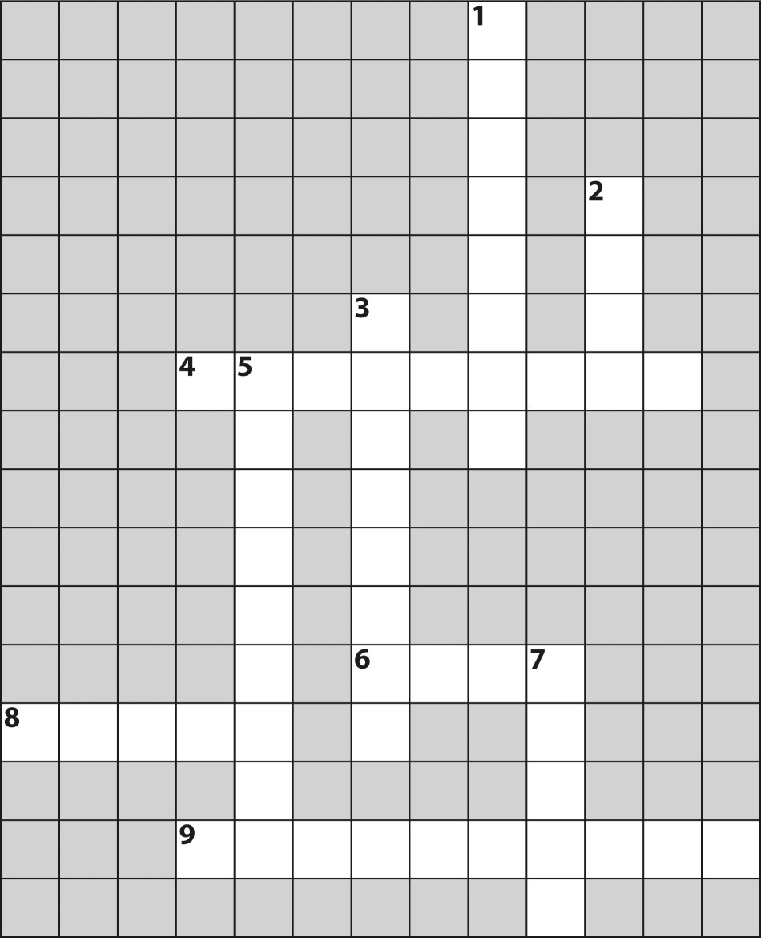

**Across Down**

**4.** It’s a long, green (or white) vegetable. **1.** It’s made of milk, it’s sweet, and it **6.** They are white and yellow inside, and comes in many flavors.

they come from a chicken. **2.** It’s made with soybeans and is popular

**8.** It’s raw fish on rice. in Asia and with vegetarians all over the

world. **9.** They’re made from cocoa beans. People often give them in a box as a gift. **3.** These are small fish that are usually very salty.

**5.** This is a little like fish but comes in a shell. Some people are allergic to this.

**7.** Vegetarians never eat this.

# Page 2 of 2

|  |  |
| --- | --- |
|  |  |
| **NAME:** ____________________________ | **DATE:** ____________ |

**B. Look at the picture and then read the clues. Write the name on the line.**

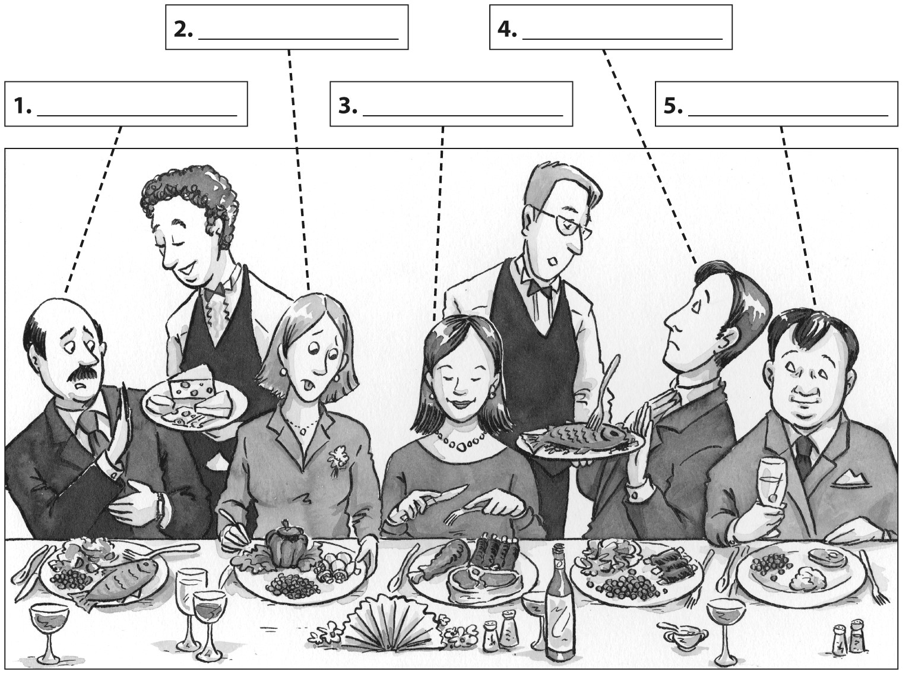

**Clues:**

* Patty doesn’t care for vegetables.
* Al’s allergic to dairy products.
* Fish doesn’t agree with Greg.
* Marcia is a vegetarian.
* Nicolas is trying to lose weight.