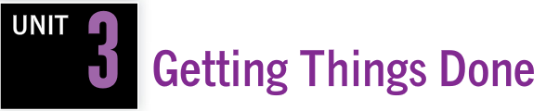

**READING ACTIVITIES**

Name: ______________________________________________ Date: ______________________



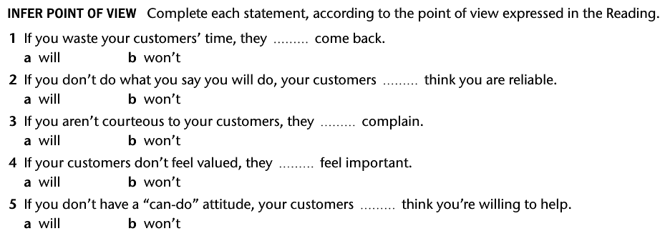

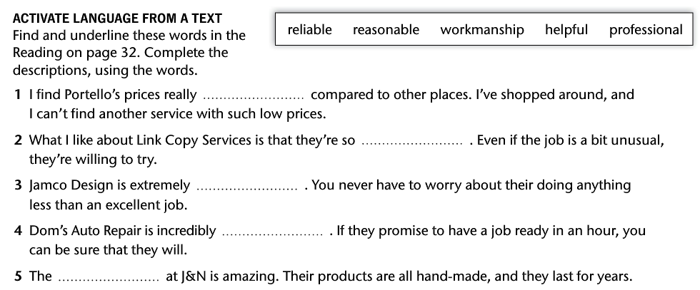

Name: ______________________________________________ Date: ______________________