**NAME: ______________________ DATE: _______________________**

**Extra Reading Comprehension Activities**

**(Unit 10, page 118)**

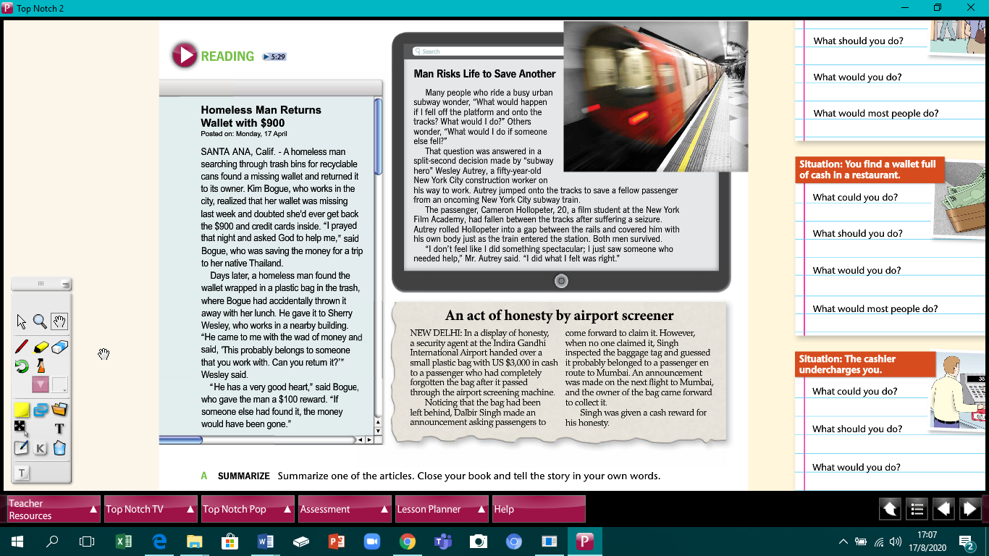

# Be ready to expose orally to your teacher and classmates next class.

________________________________________________________________________________________________________________________________________________________________________________________________________________________________________________________________________________________________________________________________________________________

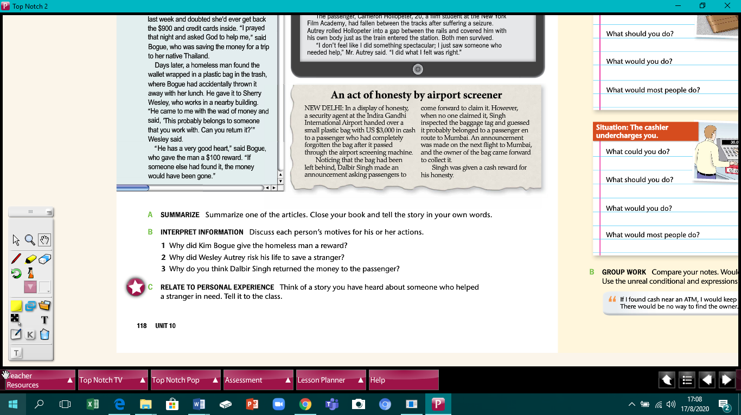

**ANSWERS**

1. _____________________________________________________________________
2. _____________________________________________________________________
3. ____________________________________________________________________

# 

# Be ready to expose orally to your teacher and classmates next class.

# ______________________________________________________________________________________________________________________________________________________________________________________________________________________________

# COMPREHENSION QUESTIONS

**A. Check the statements that are true, according to the article.**

* 1. The man who returned Kim Bogue’s wallet was homeless.

* 2. Kim Bogue was saving her money to go to New York.

* 3. Bogue believed that whoever found her wallet would return it, including the cash and credit cards inside.

* 4. Wesley Autrey was saved from an oncoming New York City subway train.

* 5. The passenger fell between the tracks because he wasn’t paying attention.

* 6. Autrey didn't think of himself as doing anything special.

* 7. The security agent at an airport in India handed over a wallet with US $3,000 in cash.

* 8. The passenger who lost the money was taking a flight to Mumbai.

* 9. The security agent was given a cash reward.

# CRITICAL THINKING

**B. Discuss your answers to these questions. Explain your reasons.**

# Be ready to expose these answers orally to your teacher and classmates next class.

1. Why do you think someone would risk his or her life to save another person?

________________________________________________________________________________________________________________________________________________________

1. Why do you think some people are more honest than others? _______________________________________________________________________________________________________________________________________________________
2. Do you think it’s important to reward people for their honesty? Why or why not?

________________________________________________________________________________________________________________________________________________________

1. What do you think the expression “What comes around, goes around” means? ________________________________________________________________________________________________________________________________________________________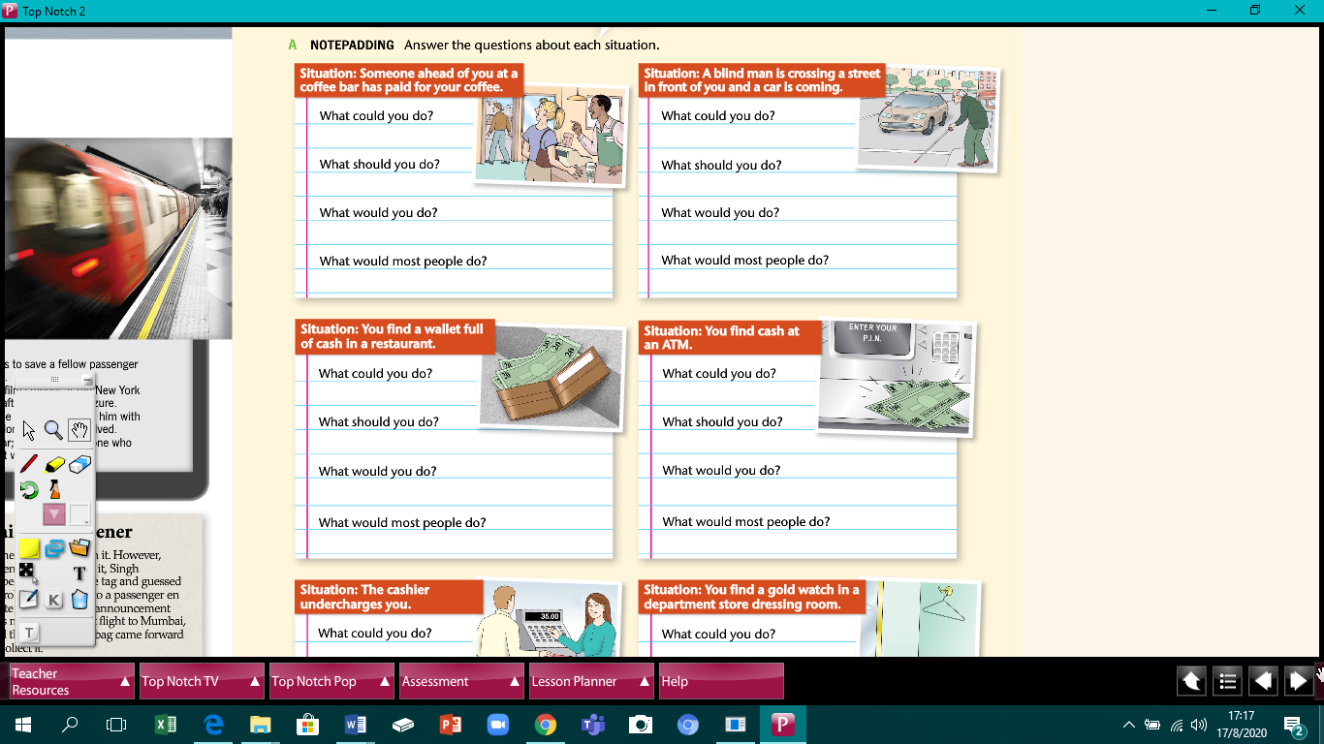



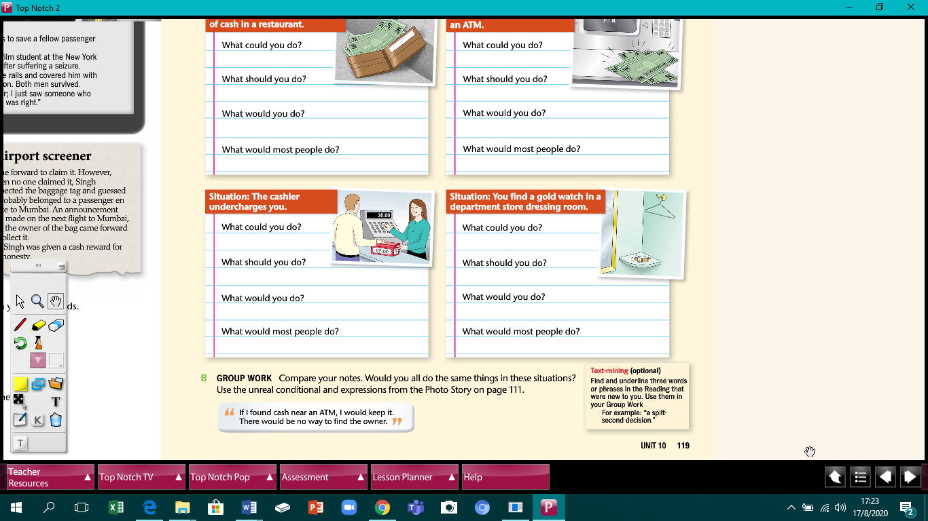

***Top Notch 2,* Third Edition Unit 10**

Copyright ©2015 by Pearson Education. Permission granted to reproduce for classroom use.