**Page 1 of 3**

**NAME:** ____________________________ **DATE:** ____________

**Just for Fun**

**(Unit 10)**

1. **Read the clues and complete the crossword puzzle.**

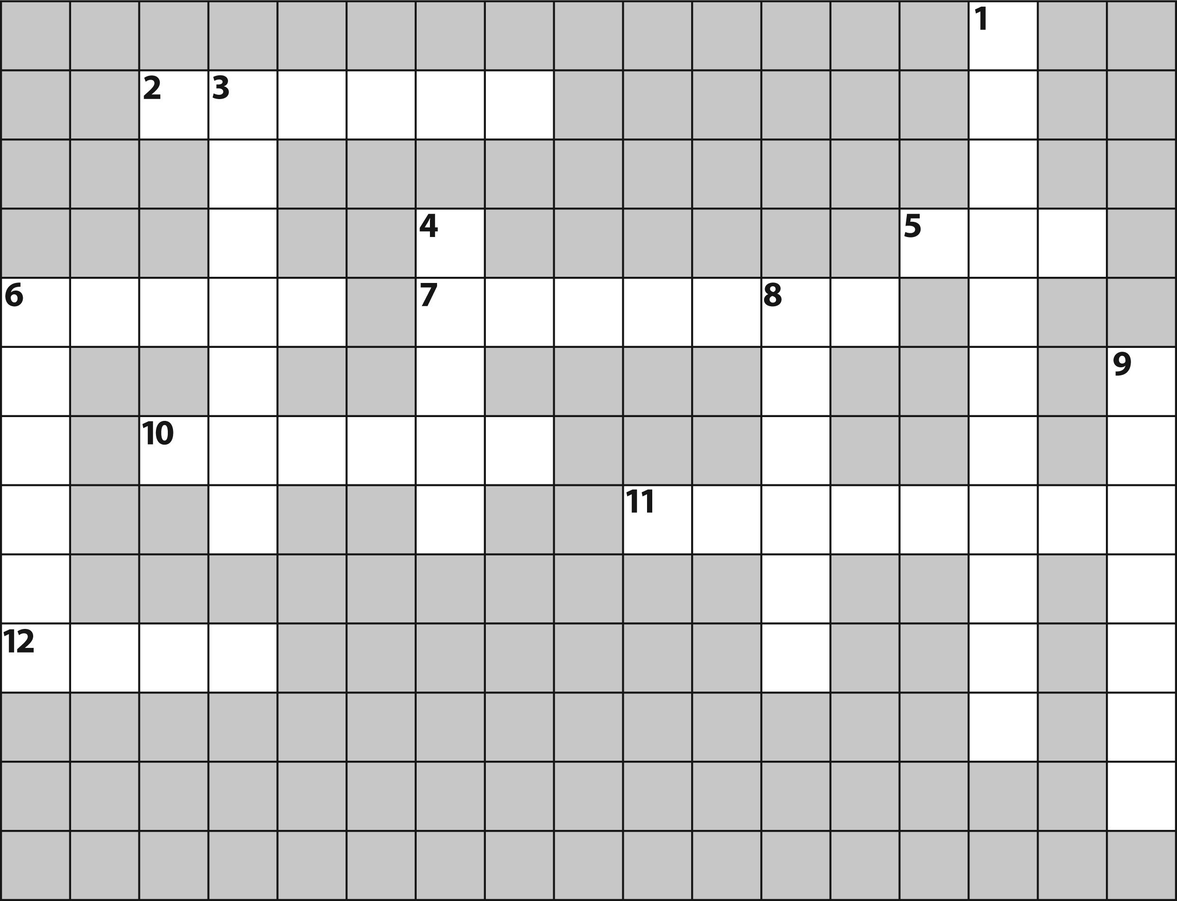

|  |  |
| --- | --- |
|  |  |
| **Across** | **Down** |
| **2.** not treating men and women equally **5.** This vacation is going to cost me an arm and a ____. **6.** leave; go away  **7.** telling the truth   1. personal beliefs and principles 2. You’re welcome. 3. to discuss | **1.** not asking for enough money for a service   1. relating to what is right and wrong 2. Put yourself in his ____, and you’ll know how he felt. **6.** to be very exact 3. a picture marked on your skin with a needle and ink 4. a difficult situation |

***Top Notch 2*, Third Edition Unit 10** Copyright © 2015 by Pearson Education, Inc. Permission granted to reproduce for classroom use.

**Page 2 of 3**

1. **Complete the sentences. Then put the numbered letters in order. You will write an English proverb.**

**1.** Those shoes are my shoes. Those shoes are ___ ___ ___ ___ .

# 1 2

1. When there are different rules for different people, it is a

___ ___ ___ ___ ___ ___ ___ ___ ___ ___ ___ ___ ___ ___ .

**3 4**

1. Lipstick, eye shadow, and mascara are all ___ ___ ___ ___ ___ ___ .

**5 6**

1. Another way to say “you’re welcome” is “___ ___ ___ ___ ___ ___ ___ ___ ___ ___ .”

# 7 8 9

**5.** If a cashier gives you back more money than you are owed, you have “___ ___ ___

___ ___ ___ ___ ___ ___ ___ ___ ___ ___ . ” **10**

# 11

**6.** When someone has ideas from the past, we say he or she is ___ ___ ___ - ___ ___ ___ ___ ___ ___ ___ ___ ___ .

**12**

**Proverb:** “__ __ __ __ __ __ __ __ __ __ __ __ __ __ __ __ __ __ __ __ __ __.” 12 10 2 5 9 4 7 1 9 4 12 5 3 5 9 4 6 10 8 1 11 7

***P0O0***

**Page 3 of 3**

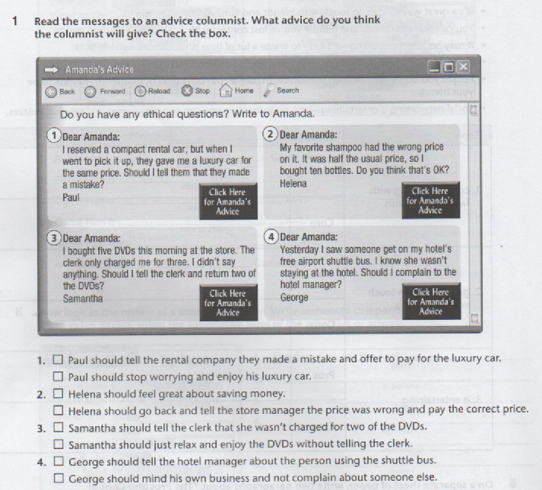

***Top Notch 2*, Third Edition Unit 10** Copyright © 2015 by Pearson Education, Inc. Permission granted to reproduce for classroom use.