**NAME: ______________________ DATE: _______________________**

**Extra Reading Comprehension Activities**

**(Unit 9, page 106)**

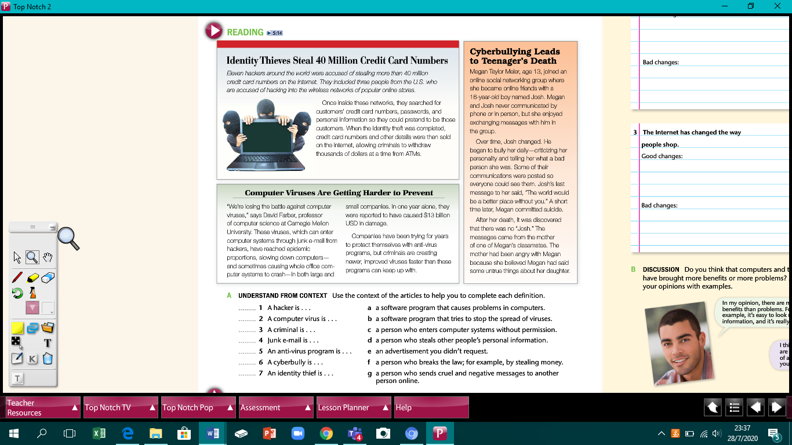

# COMPREHENSION QUESTIONS

**A. Check each statement T (True) or F (False), according to the article.**

|  |  |
| --- | --- |
|  | T F |
| 1. Personal information is always safe online. | □ □  |
| 2. There are 40 million hackers around the world who steal credit card numbers. | □ □  |
| 3. Identity thieves often sell the credit card numbers they steal to other criminals. | □ □  |
| 4. People who join online social networking groups have to use their real name. | □ □  |
| 5. Communication between two people in an online networking group is always private. | □ □  |
| 6. Cyberbullying can be very dangerous. |  □ □  |
| 7. Companies have successfully protected themselves from computer | □ □ |
| virus attacks. |   |
| 8. Computer viruses only attack computers in large companies. | □ □  |
| 9. Computer virus attacks cost businesses a lot of money. | □ □  |

# CRITICAL THINKING

**B. Discuss the following questions. Explain your answers.**

1. Why are hackers and computer viruses bad for businesses and the economy in general?

_______________________________________________________________________________________________________________________________________________________________________________________________________________

1. How should young people be protected from the dangers of the Internet?

______________________________________________________________________________________________________________________________________________________________________________________________________________