READING

Name:________________________________________________ Date:____________________________________

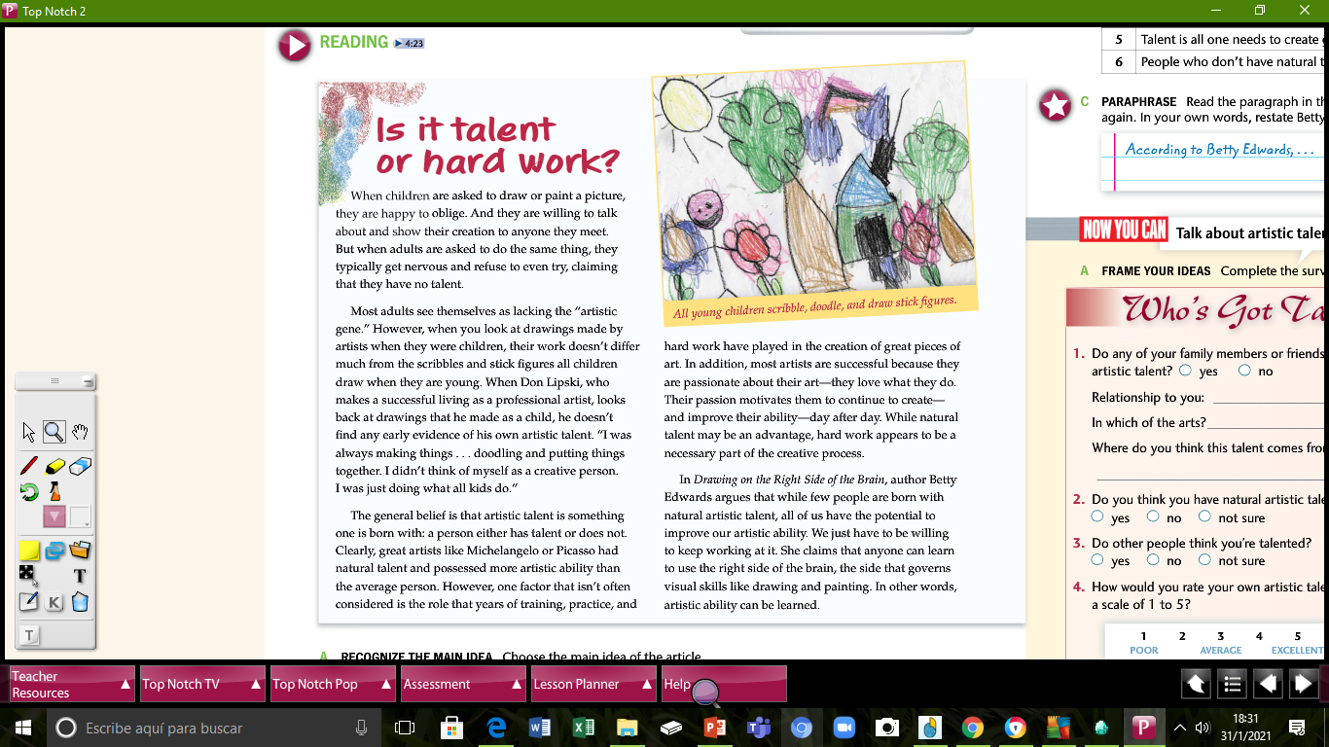

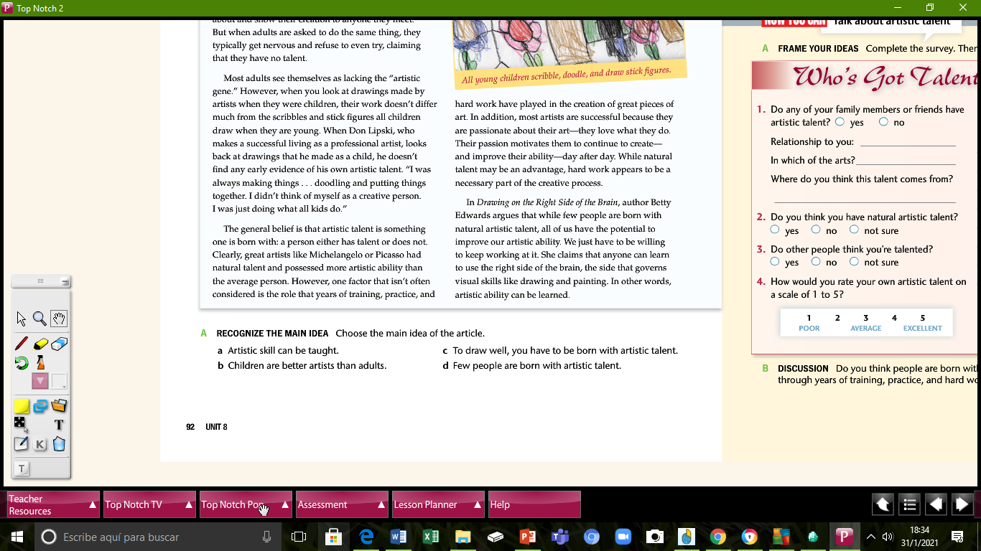

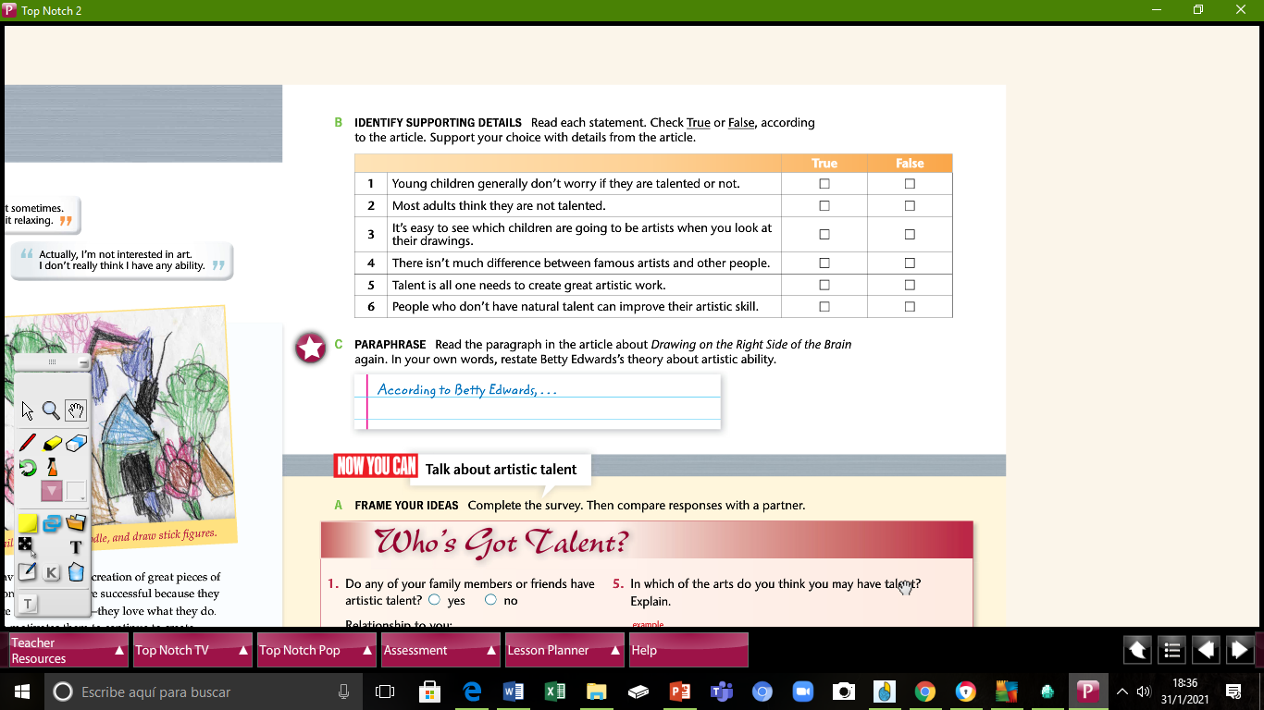

______________________________________________________________________________________________________________________________________________________________________________________________________________________________________________________________________________________________________

# COMPREHENSION QUESTIONS

**A. Check the statements that are true, according to the reading.**

* 1. Most children don't want to show their drawings.

* 2. Adults usually don't even try when they’re asked to draw or paint.

* 3. Most people don't believe they have artistic talent.

* 4. Don Lipski is a professional artist.

* 5. Lipski knew he had artistic talent, even as a child.

* 6. One reason why artists are successful is because they are passionate about their work.

* 7. To be successful as an artist, you must work hard.

* 8. According to Betty Edwards, few people have the potential to improve their artistic ability.

# CRITICAL THINKING

**B. Discuss: Do you agree or disagree with the following statements from the reading? Explain your reasons.**

1. “Artistic talent is something one is born with: a person either has talent or does not.”

__________________________________________________________________________________________________________________________________________________________________________________

1. “While natural talent may be an advantage, hard work appears to be a necessary part of the creative process.”

__________________________________________________________________________________________________________________________________________________________________________________

1. “Artistic ability can be learned.”

__________________________________________________________________________________________________________________________________________________________________________________