**Page 1 of 2**

|  |  |
| --- | --- |
|  |  |
| **NAME:** ____________________________ | **DATE:** ____________ |

**Just for Fun (Unit 8)**

1. **Unscramble the letters to find what material each object is made of. Then match the item with the picture.**

____ **1.** r e l v i s ___________________ bracelet

____ **2.** m i c r e a s c ___________________ plate

____ **3.** s a l g s ___________________ pitcher

____ **4.** c h o t l ___________________ doll

____ **5.** n e s t o ___________________ bowl

____ **6.** d o o w ___________________ figure

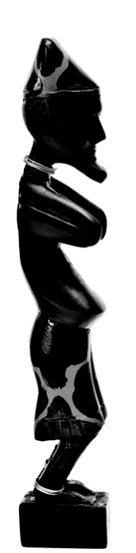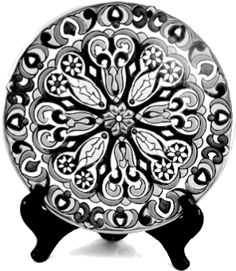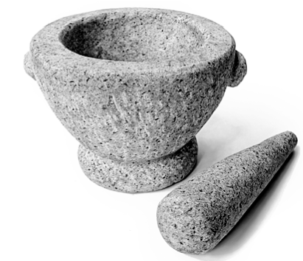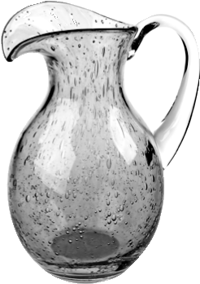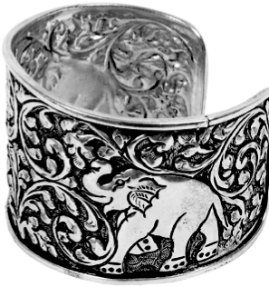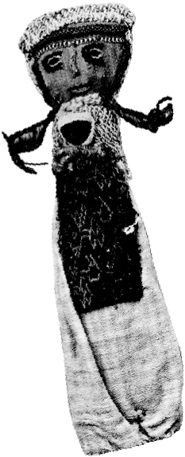

**B**

**A**

**C**

**D**

**E**

**F**

1. **Who makes what? Read the clues and complete the sentences.**

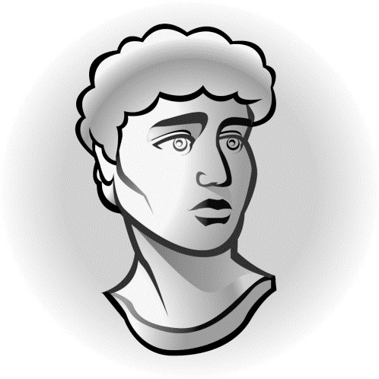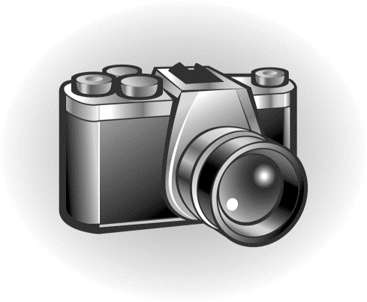

**1.** The figure was created by __________. **2.** The photograph was taken by __________.

***Top Notch 2*, Third Edition Unit 8** Copyright © 2015 by Pearson Education, Inc. Permission granted to reproduce for classroom use.

# Page 2 of 2

|  |  |
| --- | --- |
|  |  |
| **NAME:** ____________________________ | **DATE:** ____________ |

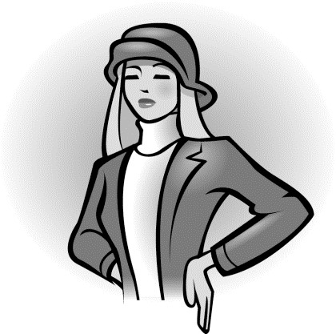

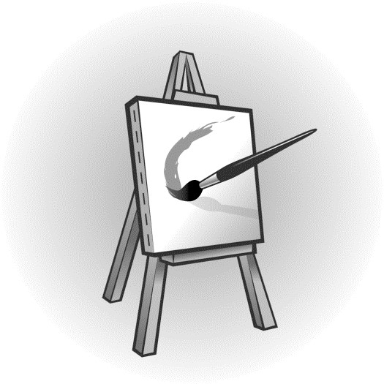

|  |  |  |
| --- | --- | --- |
|  |  |  |
| **3.** The suit was designed by __________. |  | **4.** The painting was done by __________. |

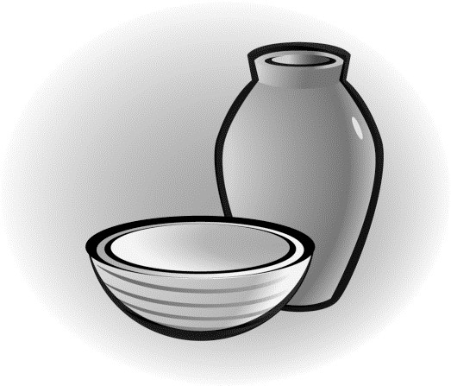

**Clues:**

Leo takes a lot of pictures.

Nicole works in the fashion industry.

**5.** The pottery was made by __________.

Ju works with stone.

Brigitte’s exhibit is at the gallery.

Tom uses clay in his work.

***Top Notch 2*, Third Edition Unit 8** Copyright © 2015 by Pearson Education, Inc. Permission granted to reproduce for classroom use.