Name:_____________________________________________ Date:_____________________

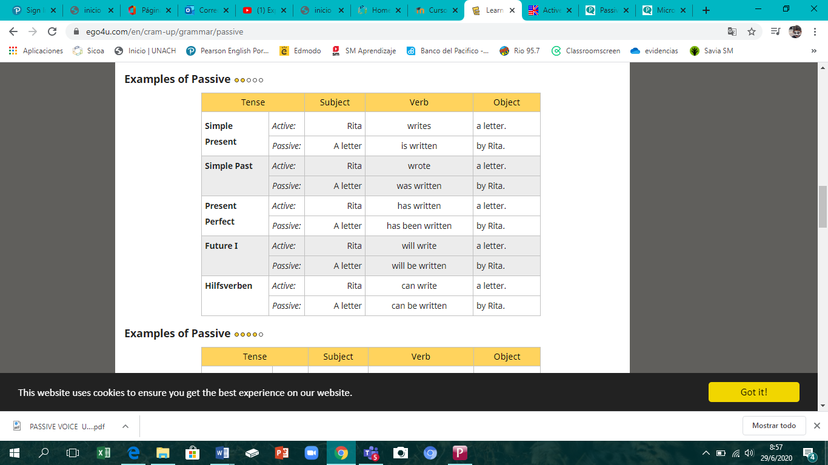

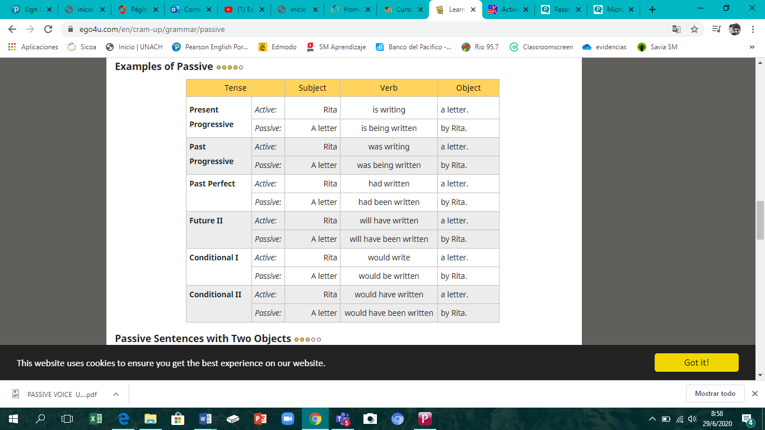

**Rewrite the sentences in passive voice.**

He opens the door. -

_____________________________________________

The door is opened by him.

_____________________________________________

We set the table. –

_____________________________________________

She pays a lot of money. –

_____________________________________________

I draw a picture. –

_____________________________________________

They wear blue shoes. -

_____________________________________________

They don't help you. -

_____________________________________________

He doesn't open the book. -

_____________________________________________

You do not write the letter. -

_____________________________________________

Does your mum pick you up? -

_____________________________________________

Does the police officer catch the thief? –

_____________________________________________

**Rewrite the sentences in passive voice.**

She sang a song. –

____________________________________________

A song was sung by her.

____________________________________________

Somebody hit me. -

____________________________________________

We stopped the bus. -

____________________________________________

A thief stole my car. -

____________________________________________

They didn't let him go. -

____________________________________________

She didn't win the prize. -

____________________________________________

They didn't make their beds. -

____________________________________________

I did not tell them. -

____________________________________________

Did you tell them? -

____________________________________________

Did he send the letter? –

____________________________________________

**Rewrite the sentences in passive voice.**

Kerrie has paid the bill. –

___________________________________________

The bill has been paid by Kerrie.

___________________________________________

I have eaten a hamburger. -

___________________________________________

We have cycled five miles. -

___________________________________________

I have opened the present. -

___________________________________________

They have not read the book. -

___________________________________________

You have not sent the parcel. -

___________________________________________

We have not agreed to this issue. -

___________________________________________

They have not caught the thieves. -

___________________________________________

Has she phoned him? -

___________________________________________

Have they noticed us? –

___________________________________________

**Rewrite the sentences in passive voice.**

Jane will buy a new computer. –

___________________________________________________

A new computer will be bought by Jane.

___________________________________________________

Her boyfriend will install it. -

___________________________________________________

Millions of people will visit the museum. -

___________________________________________________

Our boss will sign the contract. -

___________________________________________________

You will not do it. -

___________________________________________________

They will not show the new film. -

___________________________________________________

He won't see Sue. -

___________________________________________________

They will not ask him. -

___________________________________________________

Will the company employ a new worker? -

___________________________________________________

Will the plumber repair the shower? -

___________________________________________________

**Rewrite the sentences in passive voice.**

I can answer the question. -

_____________________________________________

She would carry the box. -

_____________________________________________

You should open the window. -

_____________________________________________

We might play cards. -

_____________________________________________

You ought to wash the car. -

_____________________________________________

He must fill in the form. -

_____________________________________________

They need not buy bread. -

_____________________________________________

He could not read the sentence. -

_____________________________________________

Will the teacher test our English? -

_____________________________________________

Could Jenny lock the door? –

_____________________________________________