**UNIT 6**

**READING**

Name:_________________________________________ Date:________________________________

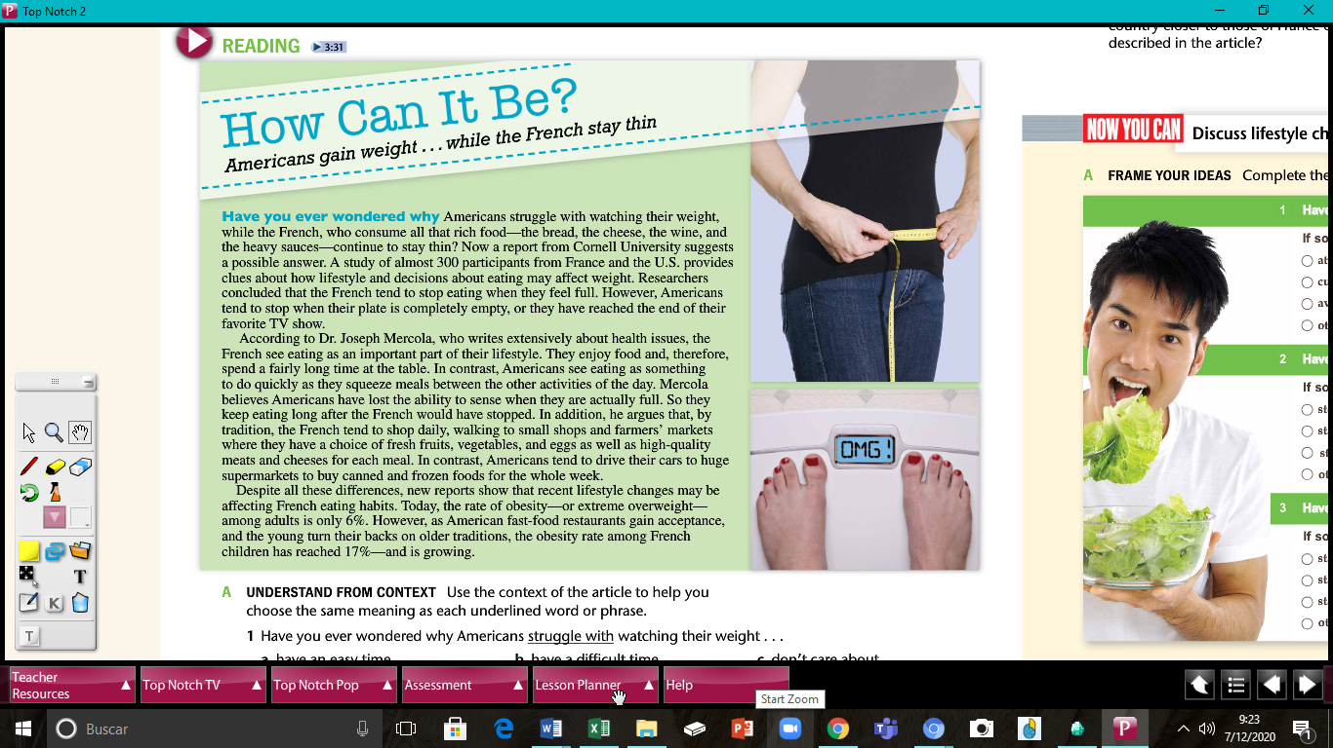

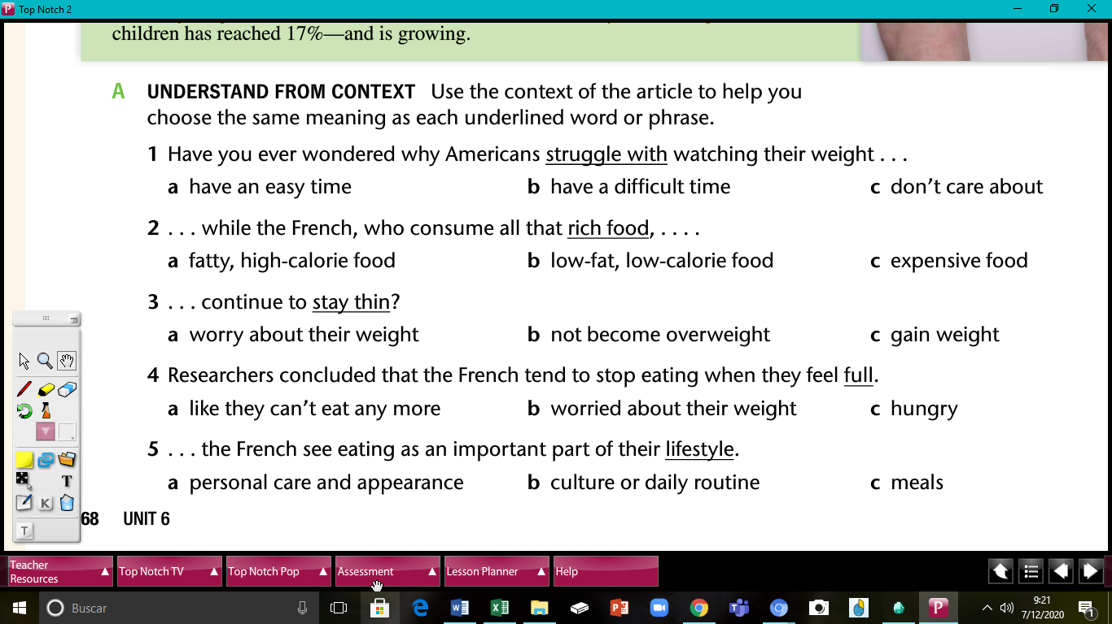

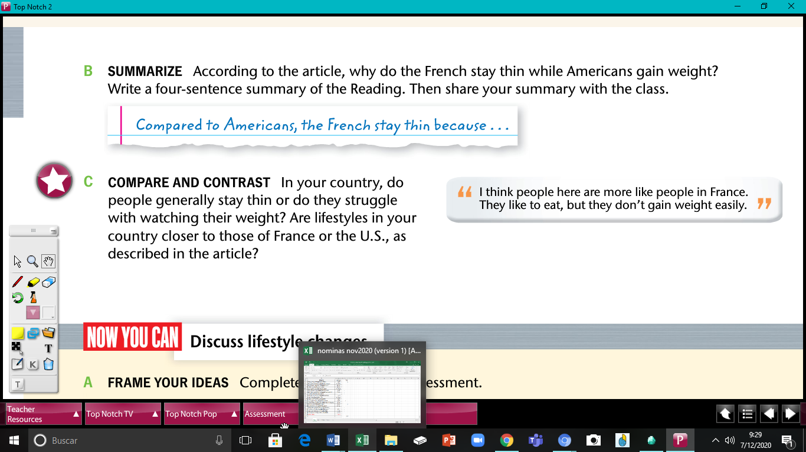

______________________________________________________________________________________________________________________________________________________________________________________________________________________________________________________________________________________________________

# COMPREHENSION QUESTIONS

**A. Check all the items that make the statements true, according to the article.**

|  |  |  |  |
| --- | --- | --- | --- |
| 1. Americans eat ___. | □ everything on | □ canned and | □ high-quality meats |
|  | their plates | frozen foods | and cheeses |
| 2. The French eat ___. | □ fresh foods | □ quickly | □ rich foods |
| 3. Americans stop eating | □ their plates | □ they’re full | □ they’re watching |
| when ____. | are empty |  | TV |
| 4. The French stop eating | □ they feel full | □ their plates | □ they travel |
| when ____. |  | are empty |  |

# CRITICAL THINKING

**B. According to the article, are these statements definitely true or probably true?**

**Circle the best answer. Explain your reasons.**

[NOTE: A statement is “Definitely true” if it is stated in the article.]

1. Americans struggle to keep their weight under control.

Definitely true Probably true

Explanation:______________________________________________

1. When Americans are young, they are taught to eat all the food on their plates.

Definitely true Probably true

Explanation:______________________________________________

1. Americans watch more TV than the French.

Definitely true Probably true

Explanation:______________________________________________

1. The French sit at the dining room table longer than Americans do.

Definitely true Probably true

Explanation:______________________________________________

1. Americans keep eating even though they are full.

Definitely true Probably true

Explanation:______________________________________________

1. The French usually don't drive to supermarkets.

Definitely true Probably true

Explanation:______________________________________________

1. The obesity rate among French children is growing.

Definitely true Probably true

Explanation:______________________________________________

***Top Notch 2,* Third Edition Unit 6**

Copyright ©2015 by Pearson Education. Permission granted to reproduce for classroom