**VOCABULARY REVIEW**

_ _ _ _ - _ _ _ _ _ _

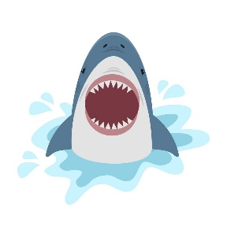

_ _ _ _ _ _ - _ _ _ _ _ _ _



_ _ _ _ _ _ - _ _ _ _ _ _ _ _ _



Self-assure - smooth talking - highly respected

**Lesson 1B Part 2**

