1B THE COOL FACTOR
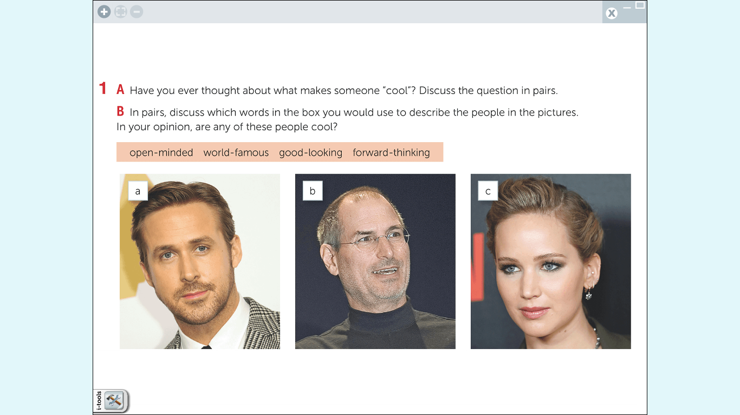
2. Read the skill box. Then watch or listen to the first part of a web show called “Talking Zone” and answer the question:
What’s Albany’s attitude toward being cool?

