What is AI ( Artificial Intelligence) When and How to use it?

Material prepared by: Mgs. Doris Valle V.

………………………………………………………………………………………………………………………………………………………?

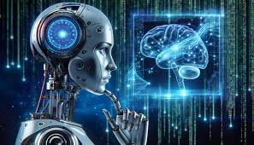

* According to my own experience, my students and pupils from overseas, AI is a tool that enables computers, laptops, cell phones to perform a variety functions to support the activities in class and at home. In class we should be CURIOUS, CREATIVE ( CRITICAL THINKERS, CREATIVE and overall there must be HUMAN CONNECTION)

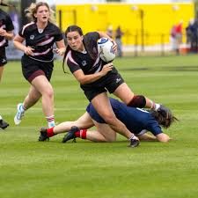Ex: AI: My family and me went to the Central Park to play rubgy yesterday.

HI: My family and me or ( My friends and me) went to the Parque Ecologico

to play basketball yesterday afternoon.

