**Political and Administrative Sciences College – Department**



Tourism Career



Formative Research Activity Report

Academic Period

2024- 2S

Tabla de contenido

1. AUTHOR 3

2. ACADEMIC STAFF 3

3. LEARNING OUTCOMES 3

4. RESEARCH TOPIC 3

5. GOALS 3

6. DATE 4

7. REPORT´S DEVELOPMENT 4

7.1. Introduction 4

7.2. Methodology description 4

7.3. Development 4

7.4. History 5

7.5. Geography 5

8. Tourist attractions in el altar 5

8.1. El Altar snow-capped (Nevado El Altar) 5

8.2. Mandur Lagoon 6

8.3. Mandur Waterfall 7

8.4. Blue Lagoon 8

9. Gastronomy in province of El Altar 8

9.1. Papas con cuy 8

9.2. Chicha de Jora 9

9.3. Choclos con Queso 11

9.4. Caldo de pollo 12

10. Conclusión 13

11. Bibliografía 14

12. Evidence of the formative research project 14

# **AUTHOR**

Second Semester Parallel "A"

# **ACADEMIC STAFF**

Dr. Victor Velasco Tourism School Director

M.T.E.F.L. Andrea Sofia Ribadeneira Vacacela First Level of English Teacher

# **LEARNING OUTCOMES**

To demonstrate the ability of deep understanding to talk about on Ecuadorian tourism attraction in English.

# **RESEARCH TOPIC**

To Promote an Ecuadorian Tourist Destination in English that Includes the Most Relevant Geography, History, Heritage, and of a Tourist Attraction. In this researcher, these groups have chosen El Altar as the attraction to research.

# **GOALS**

* Explore the Volcanic Landscape: Learn about and enjoy the views and natural formations of the volcano, appreciating its beauty and uniqueness.
* Learn about Volcano History: Discover the history and interesting facts about the volcano, including its past eruptions and its importance to the region.
* Promote Camaraderie and Teamwork: Carry out group activities that promote cooperation and team spirit while exploring the high mountain environment.

# DATE

May twenty-third, 2024

# **REPORT´S DEVELOPMENT**

# Introduction

During our formative research project as the first level of English, we have improved our weakness on English since the first researchwe did. It has been extremely beneficial to have our teachers' feedback in order to correct the mistakes we have had in writing as well as in speaking. In this formative research report, we are going to demonstrate all what we have studied, researched, understood, corrected, and put into practice to get our final product, which is a promote video that answers to the question: ¿Why to visit El Altar?

### Methodology description

As UNACH students we are happy to be able to promote El Altar since it is a great tourist attraction in our province that has also been exponentially enhanced in recent times. To obtain the necessary knowledge to meet the needs of this project, we have studied and researched from unit one to unit four with the following findings.

Practice of vocabulary and grammar

Writing practices with dialogues and essays

Oral presentations and recordings.

### Development

First, unit number one talks about Welcome to Ecuador. In this unit, we learnt to introduce ourselves and the city or place that we are going to talk about. It is our responsibility as tourism students to be able to introduce ourselves as well as the place we are guiding on. Therefore, we needed some grammar and vocabulary knowledge stated on the syllabus of our level. It includes the following learning outcomes:

To use and to describe the usages of the simple present tense to communicate.

To provide personal information and meet someone new to introduce yourself and the visited place.

Apply WH Words such as: Where/ When/How/ Why in a Tourist trip.

To discriminate rules of regular and irregular verbs to communicate well.

To identify the zero and first conditional to communicate.

To use there is and there are to describe things.

### History

The altar, a mountain in Chimborazo

It is the most beautiful of the snow-capped mountains, called Altar, Collanes or Capac Urco. El Altar is an extinct volcano, whose caldera, collapsed into several peaks arranged in the shape of a horseshoe, opens to the Collanes valley; In its crater is the Yellow Lagoon, protected by a spectacular frozen mantle of hanging glaciers. It is estimated that its last eruption took place in 1490.

The Incas called this volcano Capac Urcu, which means almighty mountain or majestic hill. The Altar has countless legends, it is believed that it was higher than Chimborazo and that due to a natural phenomenon, it sank until it took its current shape. The glaciers of the altars form magical lagoons, among the most important we have: the Amarillo or Caldera, Azul, Verde, Pintado and Mandur, among others. Temperature: 2 to 10ºC.

### Geography

Location

The Altar is located in the province of Chimborazo, in the eastern mountain range of the Ecuadorian Andes. It is located within the Sangay National Park.

Extension

It is a stratovolcano with a west-facing caldera approximately 3 km in diameter and within which a yellow water crater lagoon has formed. The basal diameter of the building is 14 km, while the flanks rise at an angle of 34°.

## **Tourist attractions in el altar**

### El Altar snow-capped (Nevado El Altar)

The El Altar snow-capped mountain is located in the eastern mountain range, reaching a maximum height of 5,319 meters above sea level at its peak called Obispo. Besides this significant peak, there are seven more notable peaks that make up the El Altar. The months with the most snow are from September to February; during the other months, the amount of snow decreases but does not disappear completely. Additionally, there are eight volcanic lakes around it, with the most important one located in its crater, called Laguna Amarilla (GADM del Cantón Penipe, 2024).

**Figure 1.**El Altar

**Source:** *GADM del Cantón Penipe*

### Mandur Lagoon

It is one of the lagoons in the lake system of the El Altar snow-capped mountain, located on the back side of the mountain at 4,100 meters above sea level, resembling a 200-meter-wide mirror of water. Its waters are calm with a dark-colored bottom. This lagoon has an entrance passageway into its interior in the form of a walkway (GADM del Cantón Penipe, 2024).

**Figure 2.**   
Mandur Lagoon

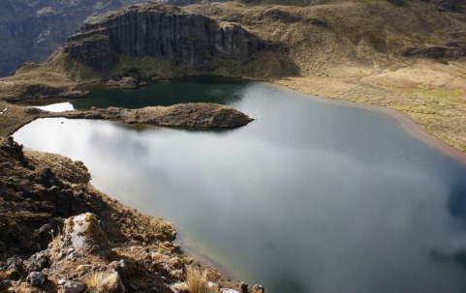

**Source:** *GADM del Cantón Penipe*

### Mandur Waterfall

It is a waterfall that originates from Mandur Lagoon, located on the front side of the snow-capped mountain at 4,100 meters above sea level, with a water drop of 100 meters in height. Its waters come from the melting of El Altar and the outflows of Mandur Lagoon (GADM del Cantón Penipe, 2024).

**Figure 3.**   
Mandur Waterfall

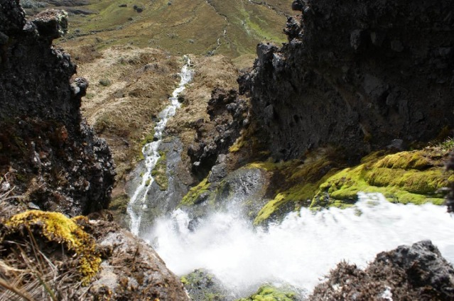

**Source:** *GADM del Cantón Penipe*

### Blue Lagoon

It is one of the lagoons in the lake system of the El Altar snow-capped mountain, located on the back side of the mountain at 4,100 meters above sea level, resembling a 500-meter-wide mirror of water. Its waters are calm and have an intense blue color, hence its name "Blue." It features two enormous waterfalls, each 100 meters high. One falls into it, and the other flows from it (GADM del Cantón Penipe, 2024).

**Figure 4.**   
Blue Lagoon

**Source:** *GADM del Cantón Penipe*

# **Gastronomy in province of El Altar**

### Papas con cuy

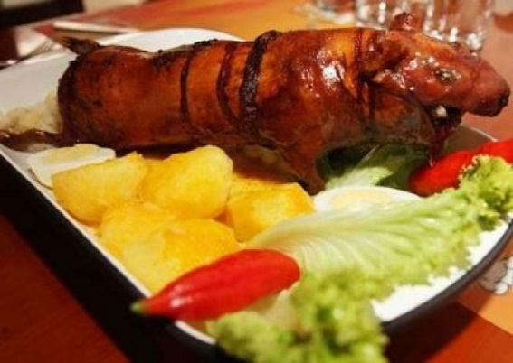

It is a roast guinea pig that is turned over the coals until it reaches a crispy point. It is served with boiled potatoes, either with peanut sauce or simply with potatoes alone, along with salad and a chili sauce.

* **Ingredients**
* guinea pig
* potatoes
* peanuts
* white onions
* 1ounce oregano
* Annatto
* Salt
* **Elaboration**

1. we season the guinea pig
2. We pierce the body of the guinea pig with a clean stick, then put it on the ember so that it cooks on the ember.
3. We peel the potatoes and place them in a pot with water and seasonings then we put them on the fire
4. We serve the guinea pig along with the cooked potatoes

* **Nutritional Facts**

|  |  |
| --- | --- |
| **Product** | **Nutritional Facts** |
| potatoes | * Sodium * Carbohydrates * Fiber * Sugars * Protein |
| guinea pig | * calcium * match * zinc * iron * protein |

### Chicha de Jora

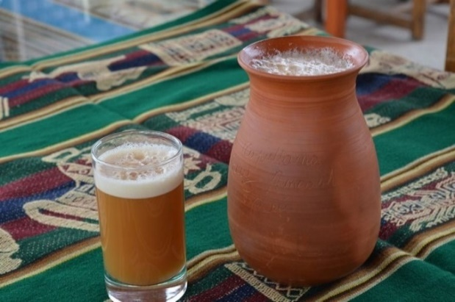

Being one of the areas of production of corn, the population is dedicated to the production of chicha de jora and is popular due to its cultural heritage in indigenous traditions. Its handmade production keeps ancestral customs alive and is a symbol of identity and local pride.

* **Ingredients**
* 1 ½ cup Jora flour
* 1 1 /3 cup Panela
* 10 Cloves
* 10 Sweet pepper
* 3 Cinnamon stick
* 5 Ishpingo
* ½ cup Pineapple peel
* 1 cup orange juice
* ¾ cup Water
* **Elaboration**

1. Boil all the ingredients and dilute the jora flour in water.
2. Add the jora flour to the pot where all the ingredients are cooked, mix and cook over low heat for at least 2 hours.
3. Add the naranjilla juice and mix this preparation well.
4. Allow to ferment for at least 2 days.
5. Sift and serve well chilled.

* **Nutritional Facts**

|  |  |
| --- | --- |
| **Product** | **Nutritional Facts** |
| Jora flour | * Proteins * Fiber * B complex * Iron * Phosphorus * Calcium |
| orange juice | * Vitamin C * Calcium * Potassium |
| Pineapple peel | * Vitamin A * Vitamin C * Fiber * Antioxidant |
| Panela | * Magnesium * Iron * Calcium * Potassium * Selenium * Phosphorus |
| Cinnamon stick | * Proteins * Iron * Calcium * Zinc * Potassium * Selenium * Vitamins B6, C |

### Choclos con Queso

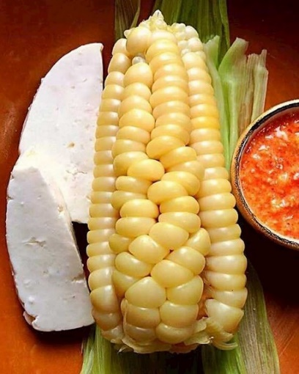

Choclos con queso is a delicious preparation typical of some Latin American countries, especially in Peru and Ecuador. It consists of cooked corn cobs, stuffed with fresh cheese and served hot.

* **Ingredients**
* Choclos (fresh corn cobs)
* Fresh cheese
* Salt
* Butter (optional)
* Corn husks for wrapping (optional)
* **Elaboration**

1. Peel the corn cobs, boil water with a pinch of salt in a pot until the kernels are tender.
2. While the corn is cooking, crumble the queso fresco into a bowl. If you prefer, you can cut it into small pieces.
3. Once the corn is cooked, remove it from the water and let it drain.

Place the corn on a plate, add a portion of butter on top and add the cheese.

* **Nutritional Facts**

|  |  |
| --- | --- |
| **Product** | **Nutritional Facts** |
| Corn cobs | * Phosphorus * Magnesium * Potassium * Vitamin C * B vitamins * Provitamin A * Vitamin E * Iron * Manganese * Selenium * Sodium * Zinc |
| Cheese | * Calcium * Phosphorus * Zinc * Vitamin A * Vitamin B12 |

### Caldo de pollo

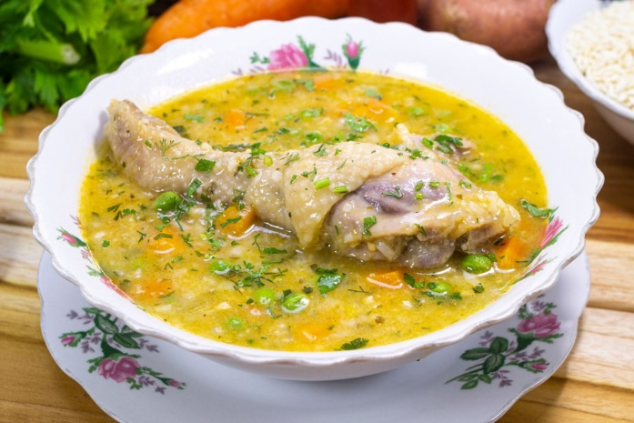

Creole chicken or Ecuadorian chicken broth is a very simple dish that can be served as a consommé or accompanied by a piece of meat. You can also accompany it with cooked potatoes, white onion and chopped cilantro or parsley.

* **Ingredients:**
* 1 Chicken cut into portions
* 8 cups of Gustadina Chicken Broth Base
* 1 1/2 cups of Gustadina Tetra Recart Peas
* 3 tablespoons of Gustadina Sunflower Oil
* 1 cup of cooked Gustadina Rice
* 10 cups of water
* 6 tablespoons of chopped flat-leaf parsley
* 4 tablespoons of chopped cilantro
* 8 Chola potatoes, peeled and cut into cubes
* 1 cup of chopped green bell pepper
* 2 1/2 cups of white onion
* 3 tablespoons of annatto oil
* 1/2 teaspoon of cumin
* 2 tablespoons of chopped garlic
* 1 1/2 cups of chopped carrots
* 1 1/2 cups of chopped celery
* Salt and pepper to taste
* **Elaboration**

1. In a pot, heat the sunflower oil and brown the chicken thighs, then set aside.
2. In the same pot, heat the annatto oil and sauté the garlic, half of the white onion, and the green bell pepper.
3. Add the celery and carrots, return the chicken to the pot, and add the water, broth, and cilantro.
4. When the chicken is tender, add the potatoes.
5. Once the potatoes are cooked, add the rice, peas, and season with salt, pepper, and cumin.
6. Separately, mix the remaining white onion with the parsley.
7. Serve the hot soup accompanied by the onion and parsley mixture.

* **Nutritional facts:**

|  |  |
| --- | --- |
| Ingredients | Nutritional facts |
| Chicken | Iron  Zinc  Vitamin B3  Vitamin B6  Vitamin B12 |
| Potatoes | Potassium  Match  Vitamin C  Vitamin B6  Vitamin B3 |
| Onion | Vitamin C  Vitamin B6  Folic acid |
| Carrot | Vitamin A  Vitamin K  Vitamin C  Potassium  Match  Calcium |

# **Conclusión**

In these units 1 and 2 we work on the correct use of verbs, writing and pronunciation. It helps us crucially to communicate, to order our ideas effectively in English. We described the tourist attraction that was visited on the academic tour, which is the volcano El Altar, where we described its geographical location, its history and the traditional gastronomy of the place. This project was carried out with responsibility, dedication, companionship, joy and a lot of effort.

# **Bibliografía**

(Espejo, 2023) (*Caldo de gallina*, 2022) (*Calorías en Caldo de Gallina e Información Nutricional*, s. f.)

*Caldo de gallina*. (2022, marzo 22). http://www.pronacatqma.com/recetas-de-sopa/recipe/7328-caldo-de-gallina.html

*Calorías en Caldo de Gallina e Información Nutricional*. (s. f.). Recuperado 23 de mayo de 2024, de https://www.fatsecret.com.mx/calor%C3%ADas-nutrici%C3%B3n/gen%C3%A9rico/caldo-de-gallina

Espejo, J. (2023, marzo 10). *Caldo de Gallina Criolla—RECETA Ecuatoriana Paso a Paso*. recetasdecomidaecuatoriana.com. https://recetasdecomidaecuatoriana.com/caldo-de-gallina-criolla/

GADM del Cantón Penipe. (23 de 05 de 2024). *GADM del Cantón Penipe*. Obtenido de https://penipe.gob.ec/index.php/turismo/la-candelaria

# **Evidence of the formative research project**

Tourism attraction of Chimborazo province First Level of English unit 1: Welcome to Ecuador and Geography of Ecuador

Quiz unit 1: Speaking #1: Welcome to El Altar

Group 1:

Name: Madeline Calderon – Carlos Mendieta

Link: <https://www.youtube.com/watch?v=rKNqvClUsnk>

Quiz unit 1: Speaking #1: Welcome to El Altar

Group 2:

Name: Marco Pataron – Michael Padilla

Link: <https://www.youtube.com/watch?v=5fbBz2p7Q38>

Quiz unit 1: Speaking #1: Welcome to El Altar

Group 3:

Name: Joe Mora – Cristofer Maroto

Link: <https://www.youtube.com/watch?v=2M6XmoMDXSw>

Quiz unit 1: Speaking #1: Welcome to El Altar

Group 4:

Name: Erika Bastidas – Santiago Falconi – Javier Benítez

Link: <https://www.youtube.com/watch?v=-yA8KIJsrs0>

Quiz unit 1: Speaking #1: Welcome to El Altar

Group 5:

Name: Micaela Cevallos – Anderson Aguinda – Lizbeth Atupaña

Link: <https://www.youtube.com/watch?v=XufqIATByJ0>

Quiz unit 1: Speaking #1: Welcome to El Altar

Group 6:

Name: Jonathan Estrada – Margarita Tanguila – Nicol Paltan

Link: <https://www.youtube.com/watch?v=bJE1DHILN9A>

Quiz unit 1: Speaking #1: Welcome to El Altar

Group 7:

Name: Henry Carguachi – Brayan Lagua

Link: <https://www.youtube.com/watch?feature=shared&v=nZRxVMVRGek>