**Homework Week #1**

**Name:**

**Date:**

**Due date:**

1. Activity #1: Self-Introduction

<https://youtu.be/QgjkjsqAzvo>

Please write a paragraph about yourself in 5 to 10 sentences.

…..

1. Activity #2 Please write 3 quantities in numbers and in letters

For example: $1,987.534.20 = One million ….

1. Activity #3 Please study noun research and make a chart of at least seven kinds of pronouns in English and in Spanish.

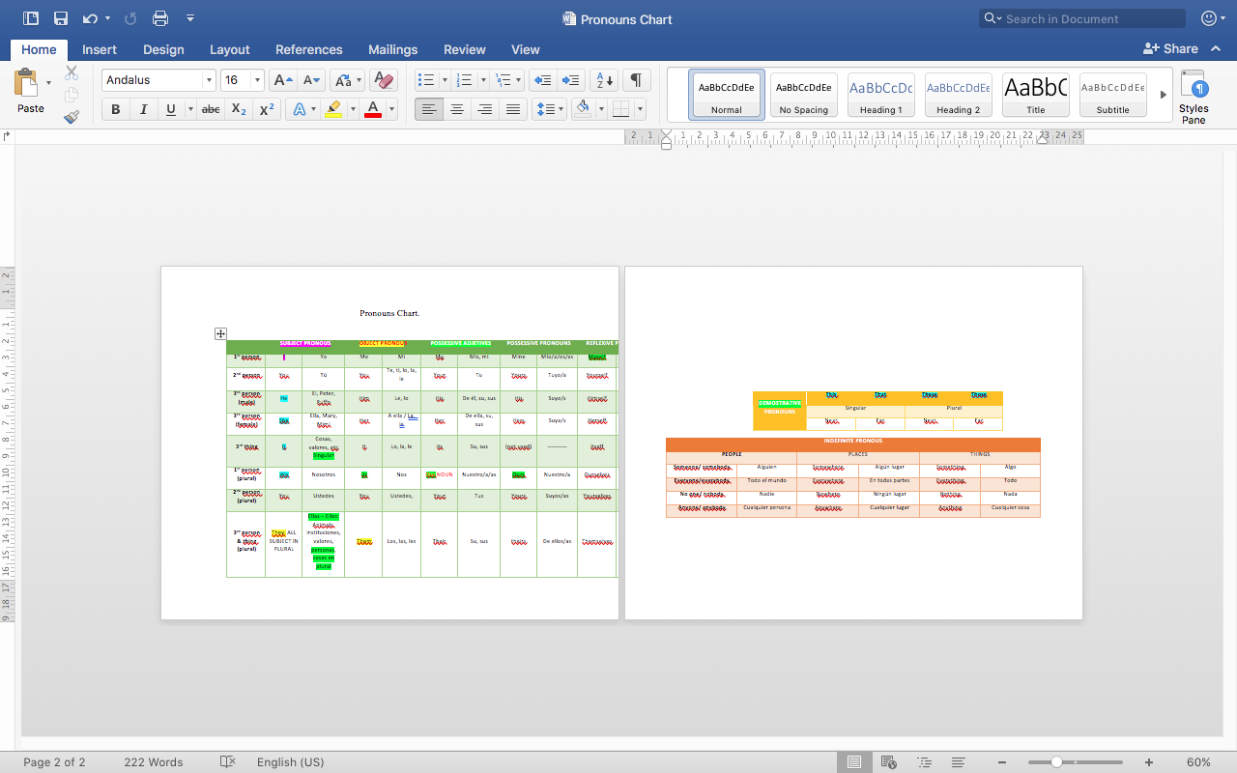

Please include a reference on your research.

1. Activity #4 Please research, study and practice the recognition of nouns and its pronoun.
2. Activity #5 Please research about plural noun rules. Please include a reference on your research.
3. Activity #6 Please research, study and practice the usage of modals.
4. Activity #7 Please research, study and practice the usage of prepositions.
5. Activity #8 Please research, study and practice the usage and the order of adjectives.
6. Activity #9 Please research, study and practice the usage and the order of adverbs.
7. Activity #10 Please research, study and practice the usage of WH words.
8. Activity #11 Please talk about 3 nations.

|  |  |  |  |  |  |  |  |  |  |
| --- | --- | --- | --- | --- | --- | --- | --- | --- | --- |
| # | COUNTRY’S NAME | FLAG | LANGUAGE | NATIONALITY | Capital | Currency Unit /Equivalent | President’s Name | Calling phone code | Famous for… |
| 1 | Ecuador | /Users/sofyrv/Desktop/Unknown.png | Official: Spanish  Native:  -  -  -  -  -  - | Ecuadorian | Quito | USA Dollars | MBA. Daniel Noboa | +593 | * Equator Line * Bananas * The Galapagos Islands * Flowers * Tropical fruits * Sea food * Petroleum * Cocoa and coffee * Chimborazo Mountain. * Jefferson Pérez |
| 2 | CANADA |  |  |  |  |  |  |  |  |
| 3 |  |  |  |  |  |  |  |  |  |
| 4 |  |  |  |  |  |  |  |  |  |

For example:

**Recommendable websites that we have checked and talk about them in class:**

The Cambridge English Scale is aligned to the CEFR

<https://www.cambridgeenglish.org/images/177867-the-methodology-behind-the-cambridge-english-scale.pdf>

Introduce yourself

<https://youtu.be/QgjkjsqAzvo>

Modal Verbs:

<https://bibliotecasantosidiomas.comunidades.net/modal-verbs-in-english>

50 Colors in English

<https://youtu.be/XV59_xspFE0>

Pluralization of nouns

<https://www.grammarly.com/blog/plural-nouns/>

WH Words

<https://www.englishclub.com/vocabulary/wh-question-words-quiz.php>