How to write an essay? 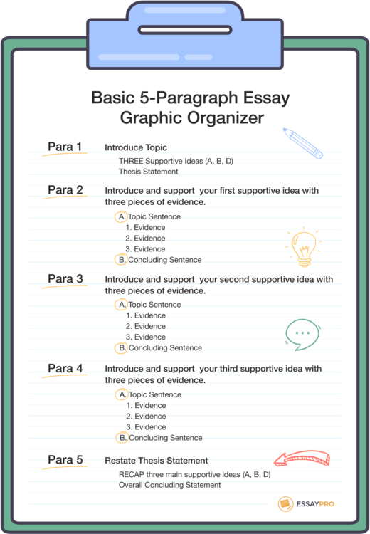

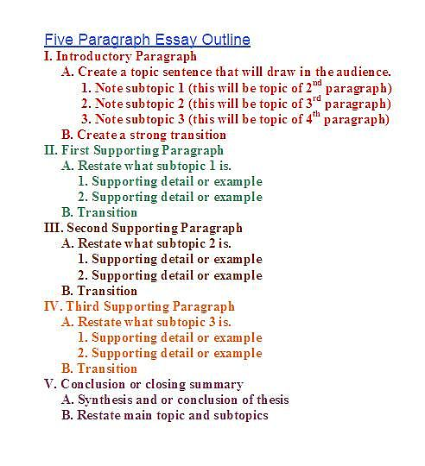

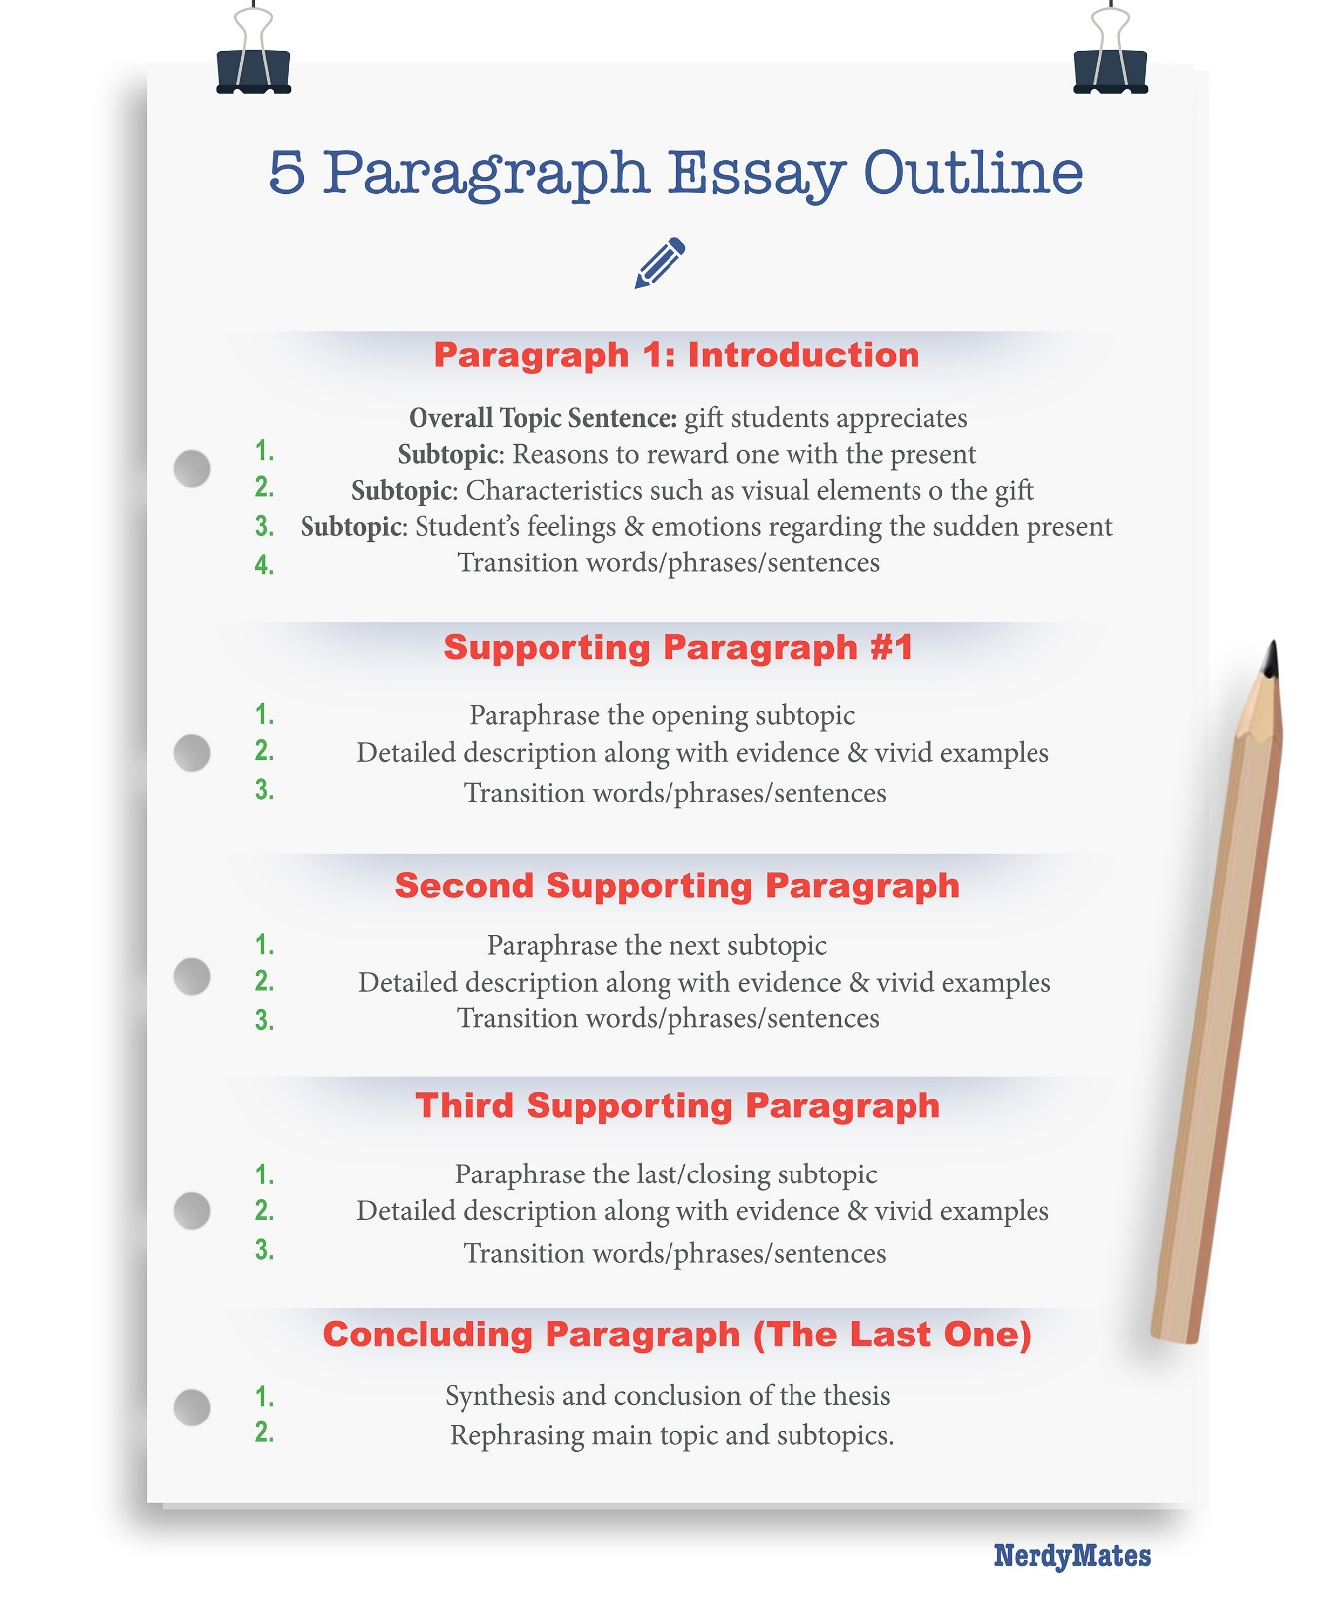

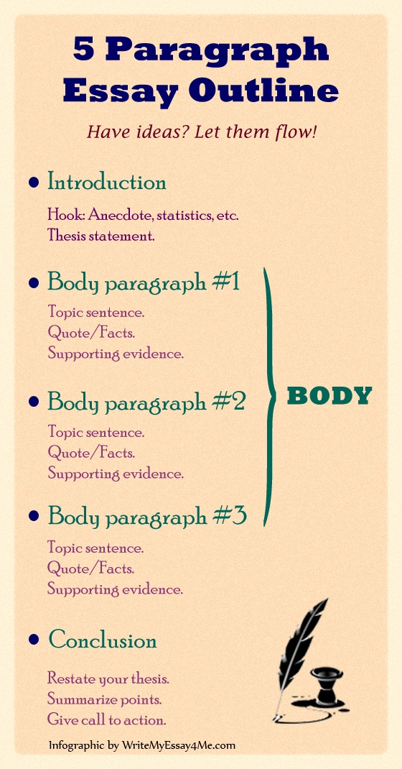

|  |  |  |
| --- | --- | --- |
| Nº | Steps | Description |
| 1 | Format | Select the type of essay: Argumentative, Narrative, |
| 2 | Title and author | Give an appropriate title for the essay. Write your name. |
|  | Introductory paragraph | |
|  | Hook | Start with and interesting attention getter/grabber (hook)  Analogy, a famous quote or a shocking statistics related to the topic |
|  | Background information | Offer detailed background information of the topic.  Begin with broad general statement explaining the topic  Narrow down with more specific statement gearing towards stance/position. |
|  | Thesis statement | State the thesis statement(position) which tells the reader what you intend to prove.  The thesis gives the central argument of the paper, It is a compbination of the specific topic, your opinions, and preview of main ideas’ points or arguments. |
|  | Body paragraphs 1,2,3: Arguments (weakest to strongest points. | |
|  | Topic sentence | For each argumentative paragraph, begin with a topic sentence that tells the main idea or the central thought of paragraph. |
|  | Supportive information | For each paragraph, provide at least 3 supportive sentences.  These are specific examples from reliable sources |
|  | Concluding sentence | It restates the main idea. |
|  |  | |
|  |  | |

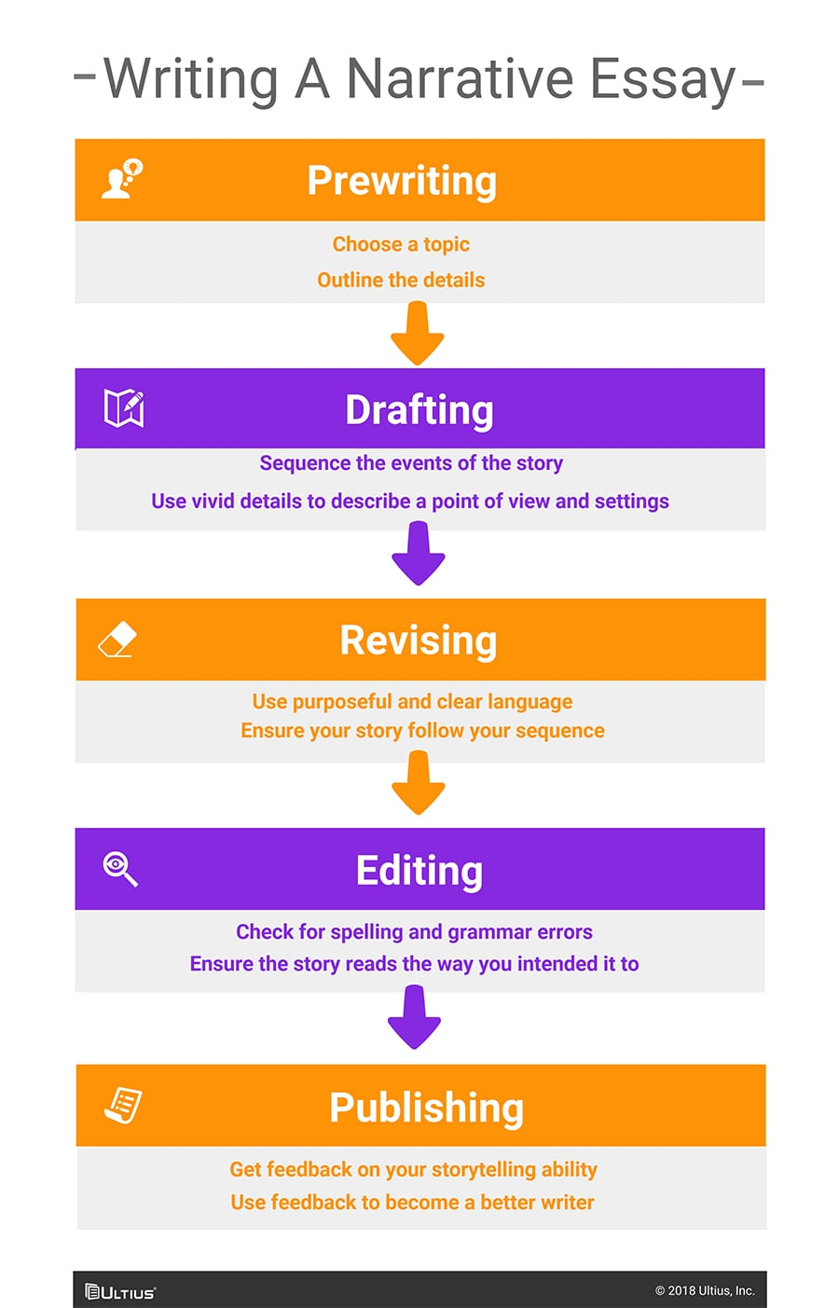

CONNECTORS

