**Vocabulary: Genres of books 1**

Look at the pictures and read the descriptions. Type the missing book genres.

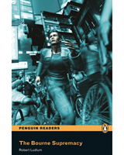

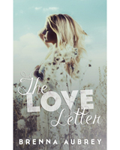

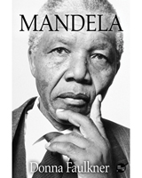

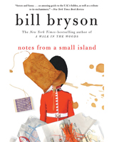

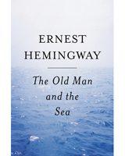

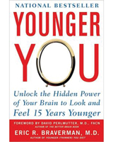

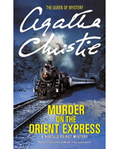

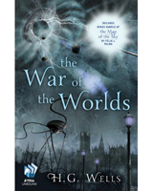

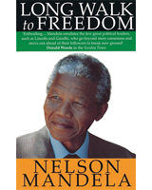

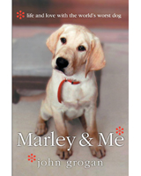

* **1**

An exciting story that will have you sitting on the edge of your seat!

a 

* **2**

A young doctor tries to forget his past. Will he find love again?  
a  novel

* **3**

The true story of Nelson Mandela, the man who inspired millions, written by Donna Faulkner.  
a 

* **4**

An American writer's hilarious account of a trip he took around the United Kingdom.  
a  book

* **5**

Hemingway's masterpiece about a poor fisherman and the big fish he hopes will change his life.  
a 

* **6**

Want to look and feel younger? Here are the secrets to a newer and better you!  
a - book

* **7**

Someone is killing people on Europe’s most famous train. Can Inspector Poirot find the killer?  
a 

* **8**

Strange beings from another planet try to conquer the planet Earth. Will they win?  
a   book

* **9**

In Nelson Mandela's own words—his unforgettable story.  
an 

* **10**

Author John Grogan remembers what life was like with his lovable pet dog, Marley.  
a 

**Vocabulary: Genres of books 2**

Are these genres of books fiction or non-fiction? Drag and drop each genre to the correct box.

* **FICTION**

**NON-FICTION**

a self-help book, a novel, a mystery, a biography, a short story, a memoir, a romance novel, a travel book, a science fiction book, an autobiography, a thriller