**HOMEWORK UNIT 1**

**PREVIEW, PHOTO STORY, SPEAKING**

**NAME: _________________________ LEVEL: __________________**

**DATE: _________________________**

**NOTE: do the homework by HAND.**

**PHOTO STORY UNIT 3**

**Task 1. Read the dialogue and give a summary about it, please include who are in it, what they are talking about.**

**____________________________________________________________________________________________________________________________________________________________________________________**

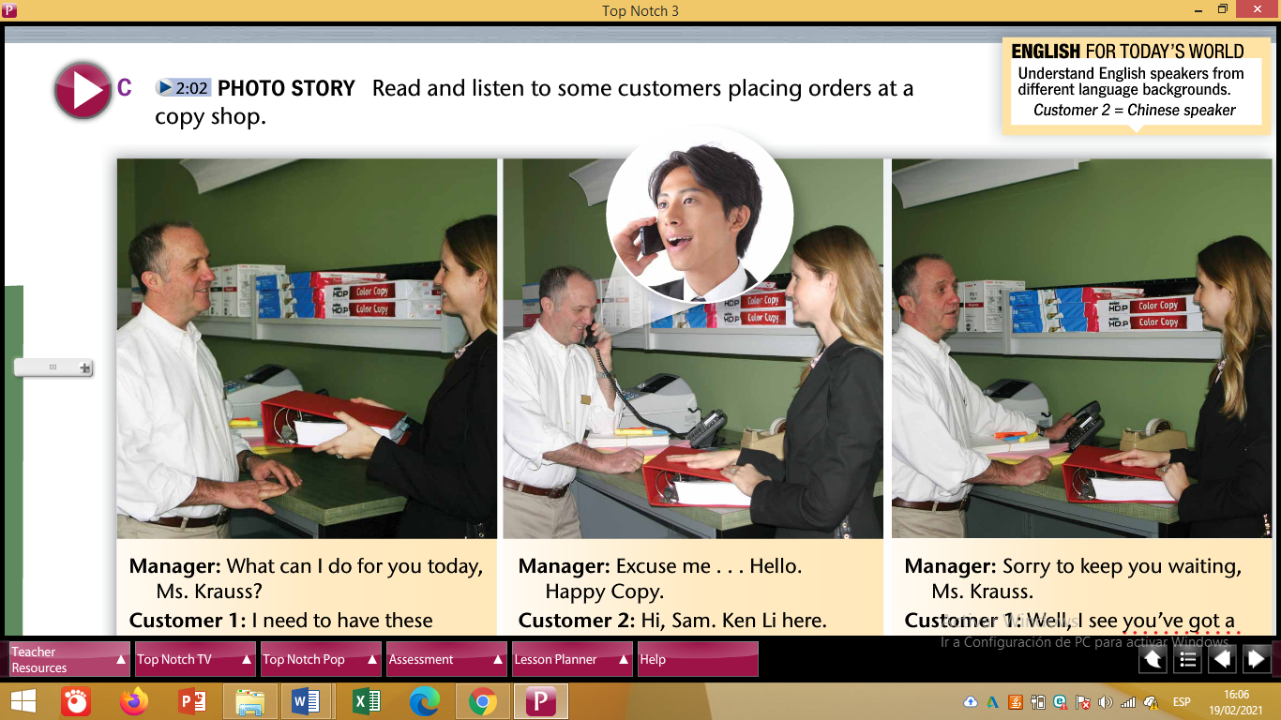

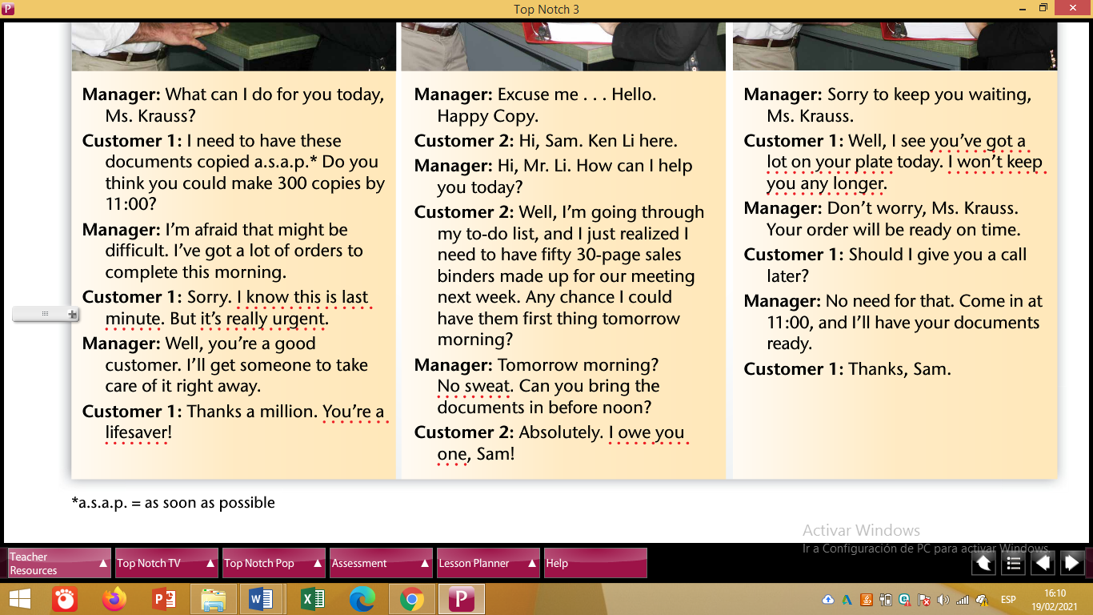

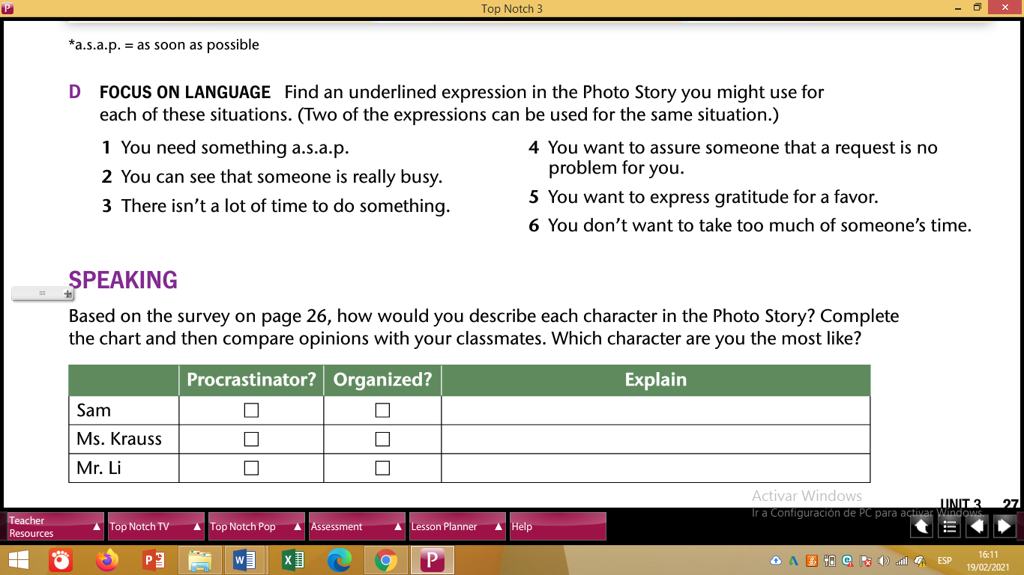

**Task 2. Copy the 6 situations presented and match them with the Photo Story Phrases.**

|  |  |
| --- | --- |
| **SITUATIONS** | **PHOTO STORY PHRASES** |
| 1. |  |
| 2. |  |
| 3. |  |
| 4. |  |
| 5. |  |
| 6. |  |

**VOCABULARY 1**

**Task 1. Read the vocabulary below**

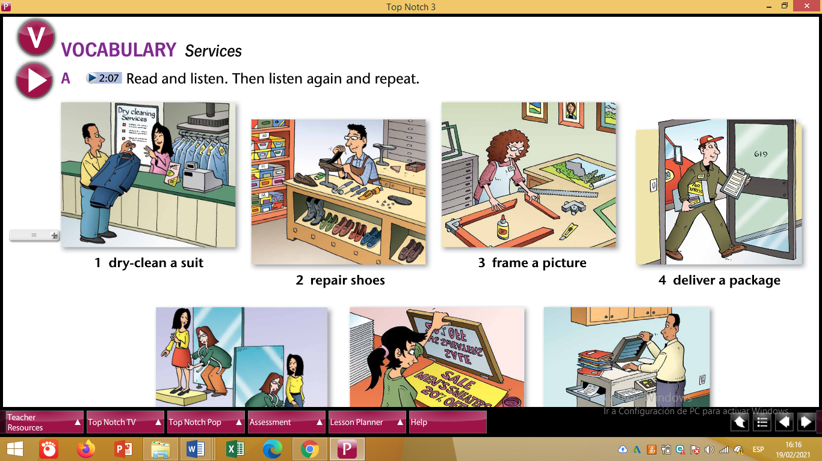

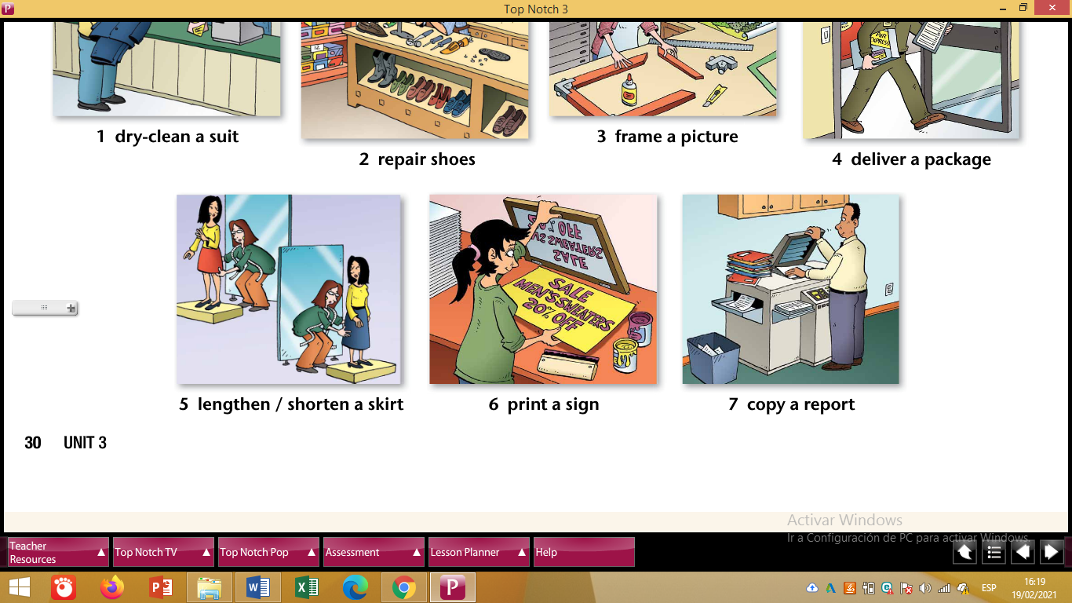

**Task 2. Create sentences using Passive Causatives with the vocabulary words.**

**Example:**

1. **Richard has his suit dry-cleaned in that laundry.**
2. **_______________________________________________________**
3. **_______________________________________________________**
4. **_______________________________________________________**
5. **_______________________________________________________**
6. **_______________________________________________________**
7. **_______________________________________________________**

**VOCABULARY 2**

**Task 1. Check the vocabulary below.**

**PLANNING AND RUNNING AN EVENT**

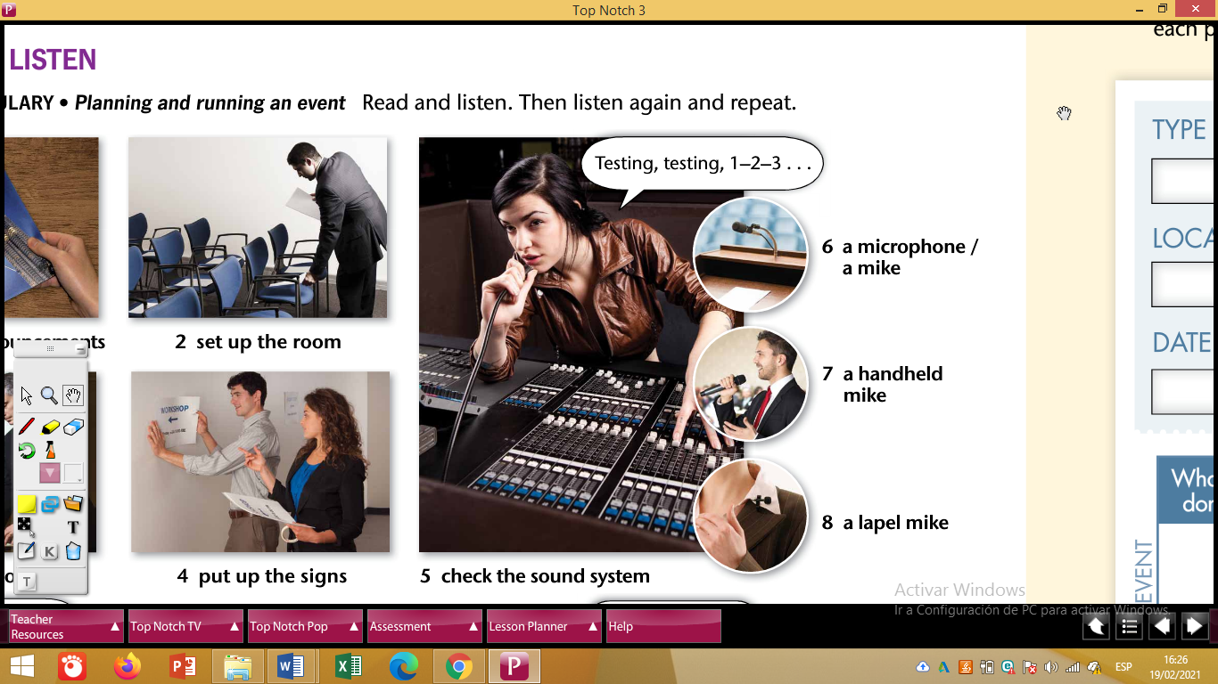

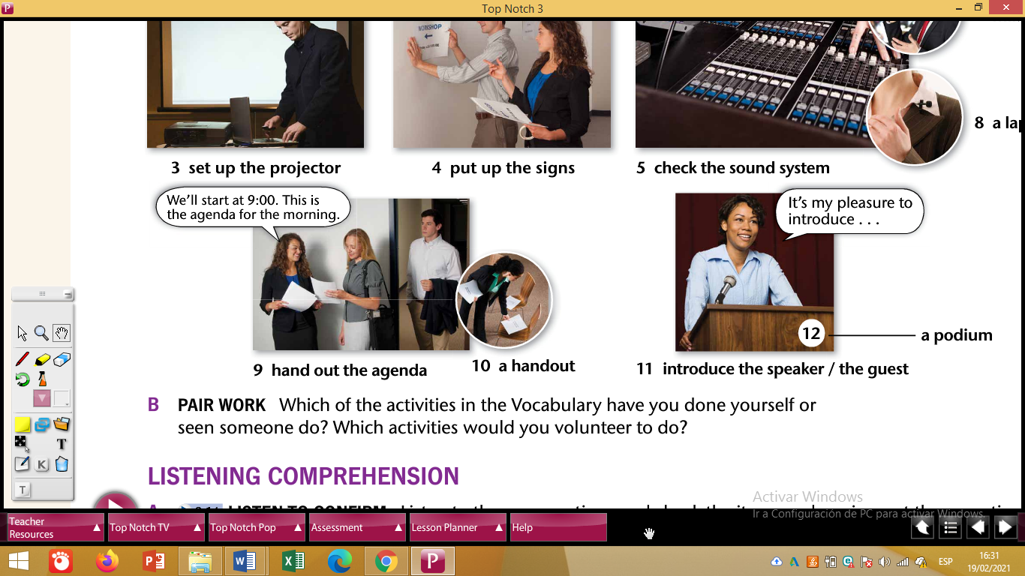

**Task 2. Write 6 sentences using Causatives and Vocabulary.**

**TOPIC: ORGANIZING A WEBINAR.**

**BEFORE THE EVENT**

* **The professors got the students to send out the announcements.**
* **______________________________________________________**

**DURING THE EVENT**

* **______________________________________________________**
* **______________________________________________________**

**AFTER THE EVENT**

* **______________________________________________________**
* **______________________________________________________**

**READING**

**Task1. Read the text.**



**Task 2. Read the text and set 5 KEYWORDS.**

**_____________________________________________________________________________**

**Task 3. Read the text and get the main idea.**

**__________________________________________________________________________________________________________________________________________________________**

**Task 4. Read the text and get the main idea of each paragraph.**

* **Don’t procrastinate ______________________________________________________________________________________________________________________________________________**
* **Be really reliable**

**______________________________________________________________________________________________________________________________________________**

* **Stand by your products or services**

**______________________________________________________________________________________________________________________________________________**

* **Be extremely friendly**

**______________________________________________________________________________________________________________________________________________**

* **Always try to be helpful**

**______________________________________________________________________________________________________________________________________________**

**UNIT 3**

**NOW YOU CAN**

Task 1. Based on the schedule below, complete the sentences by using Past Perfect sentences with **BY, ALREADY AND YET.**



**George’s schedule.**

Friday, May 30th, 2025

|  |  |
| --- | --- |
| **HOUR** | **ACTIVITY** |
| 08h00 | **Write** the final report |
| 09h00 | **Present** the project |
| 10h00 | **Plan** a webinar |
| 11h00 | **Have** a meeting with colleagues |
| 12h00 | **Eat** lunch with colleagues |
| 13h00 | **Send** out the announcements |

1. By 08h30 George **________________________** the final report, but he _______________________________ the project.
2. By 09h15 George _______________________ the project, but

he ______________________________ a webinar.

1. At 10h10 he ________________________ a webinar, but

he __________________________ a meeting with his colleagues.

1. At 11h30 he ________________________ a meeting with his colleagues, but he ________________________ lunch.
2. By 12h30 he __________________________ luch, but

he ___________________________ the announcements.

1. Finally at 13h15 he __________________________ the announcements.