**INTRODUCTION UNIT 3**

**Task 1. Explain what PROCRASTINATOR means (in Engish)**

**Task 2. Present the survey and do it.**

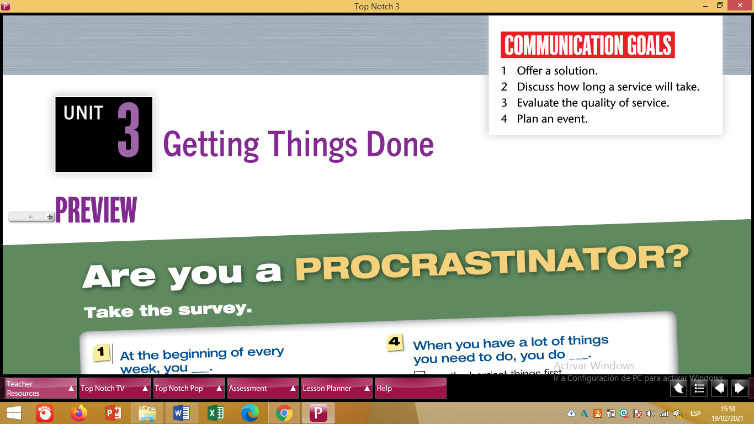

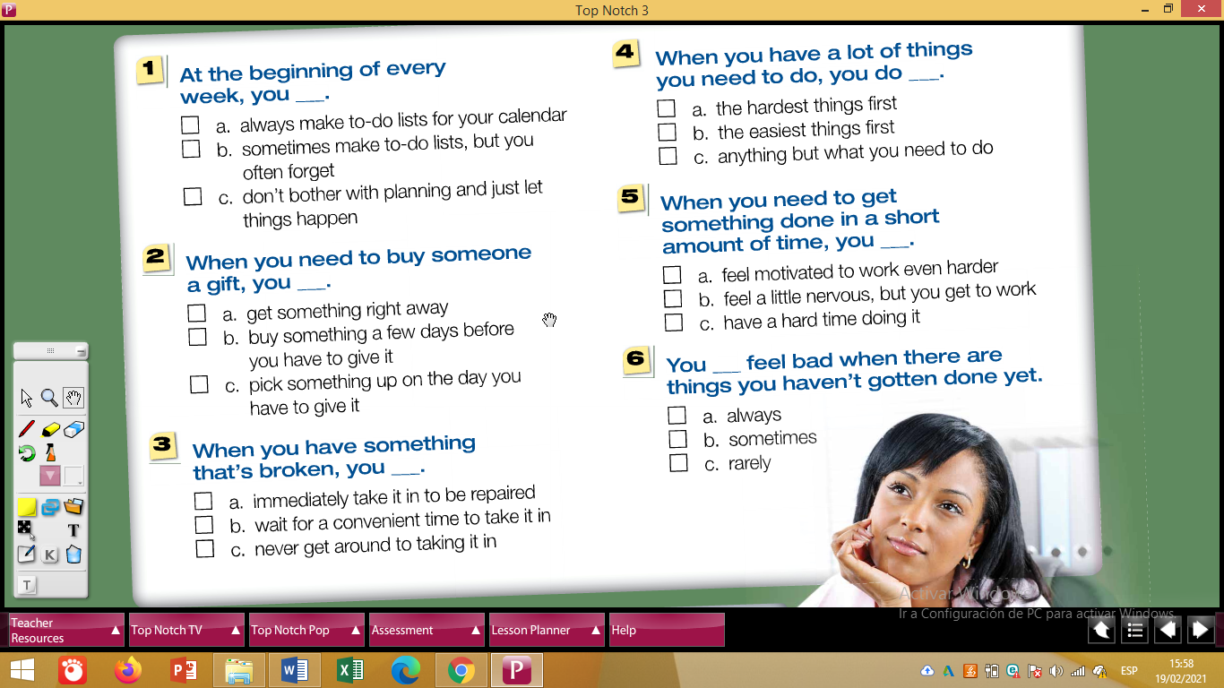

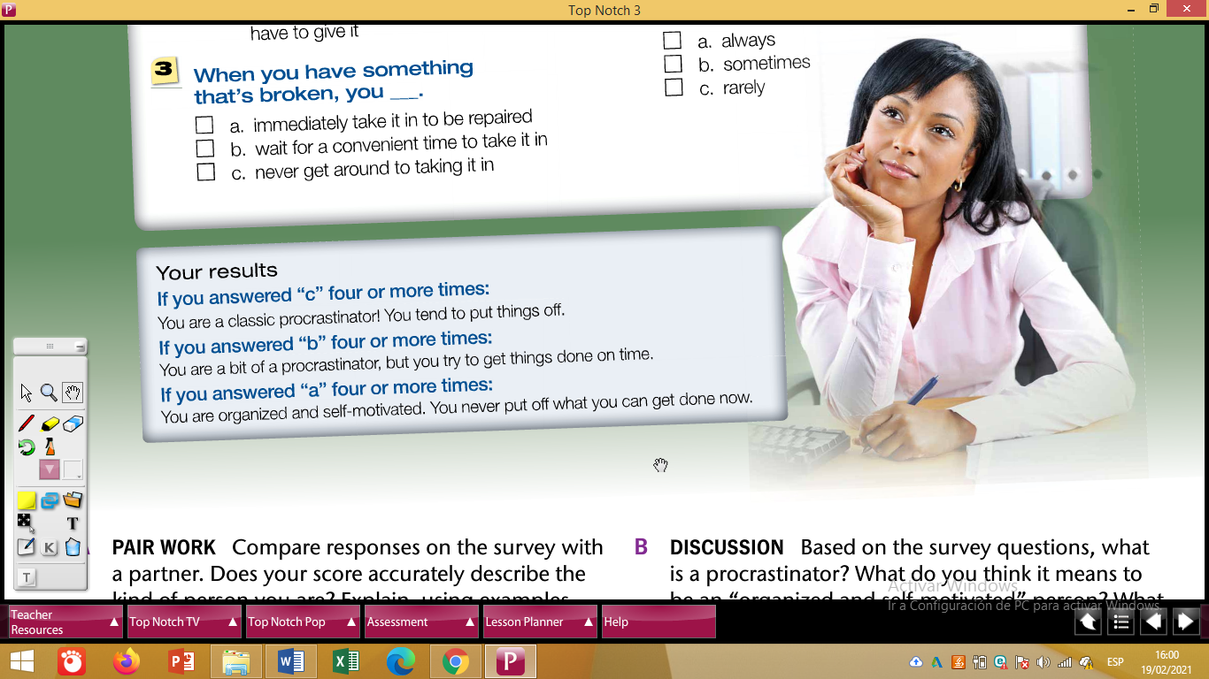

**Task 4. Based on your answers in the survey answer these questions:**

* **Are you a procrasticator or an organized person?**
* **What are the advantages of being an organized person?**