**READING 1 UNIT 2**

**Task 1. Read the questions below and answer.**

* **What do you do when you get sick or you are in pain?**
* **Do you treat the problem yourself or you see a doctor right away?**

**Task 2. Give a General Idea of the Reading and then explain each Medical option.**

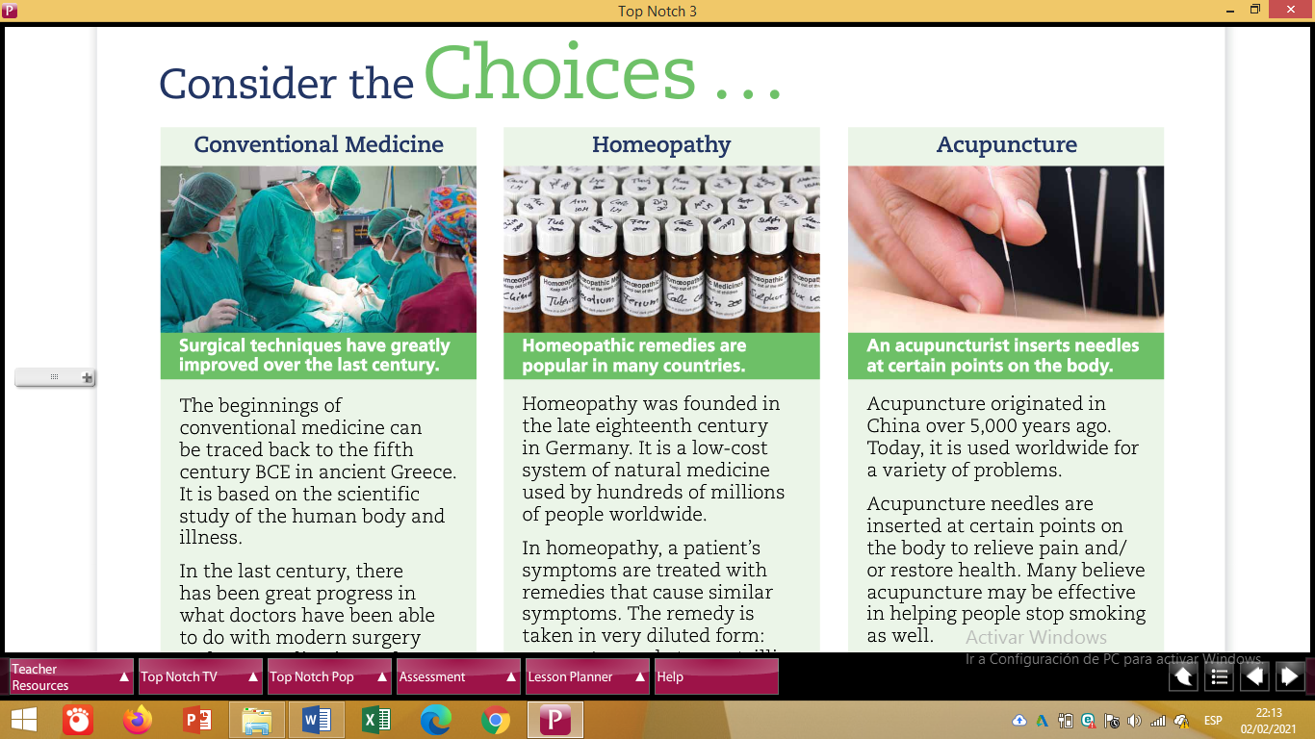

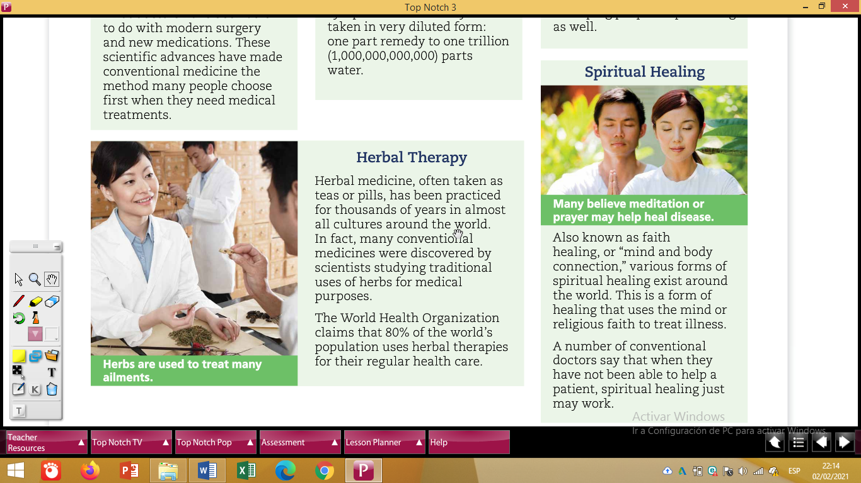

**Task 3. Answer the questions below based on the Reading and on your personal experience.**

