**VOCABULARY 3 OF UNIT 2**

**Task 1. Read and present Medications**

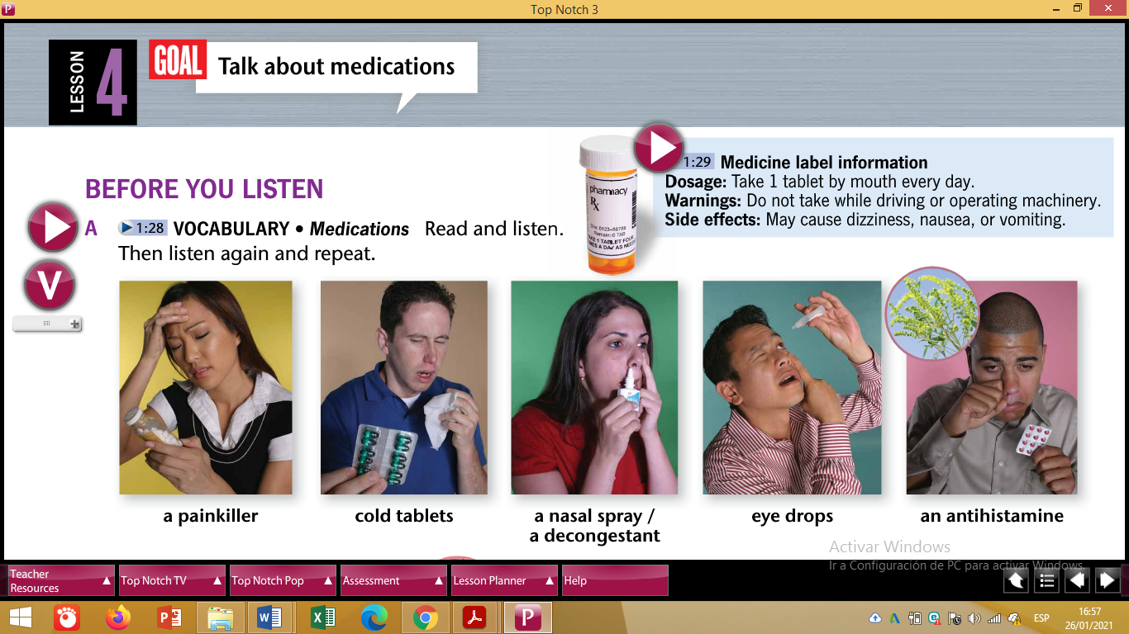

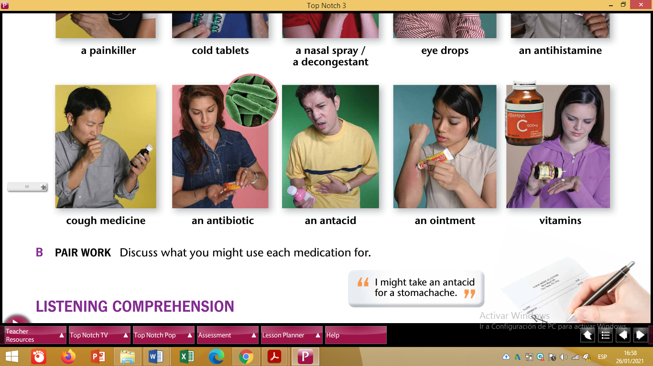

Task 1. Create a GAME for your partners to guess or complete the Vocabulary about Medications.

Task 2. Discuss what medication a person SHOULD use (mention at least 2), in case of

1. A broken arm
2. Pregnancy
3. COVID

Start like this:

1. In a car accident, a person SHOULD take …
2. A pregnant woman SHOULD take …
3. A person who got COVID SHOULD take …