**UNIT 2 PREVIEW**

**Task 1. Read and present the information about Dental cases.**

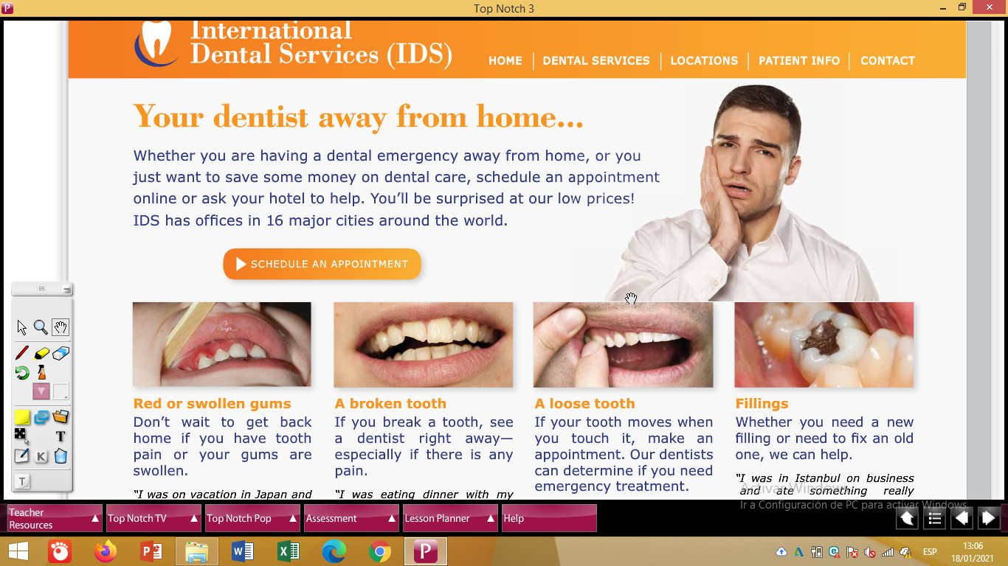

Task 2. Answer these questions:

1. **What would you do if you got swollen gums?**
2. What would you do if you got a broken tooth?
3. What would you do if you lost a tooth?
4. What would you do if you lost a filling?

**Options to answer**: Try to use a different option for each question.

… , I would ignore the problem.

… , I would make an appointment to see a dentist right away.

… , I would call or email my dentist for advice.

**Example:**

1. **What would you do if you got swollen gums?**

***If I got swollen gums, I would ignore the problem.***

1. ________________________________________________

________________________________________________

1. ________________________________________________

________________________________________________

1. ________________________________________________

________________________________________________