**HOMEWORK UNIT 5**

**NAME: ______________________ LEVEL: _______________**

**DATE: ______________________**

**PREVIEW**

**Task 1. Do the activity below.**

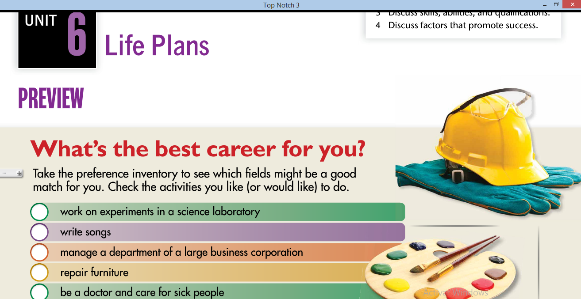

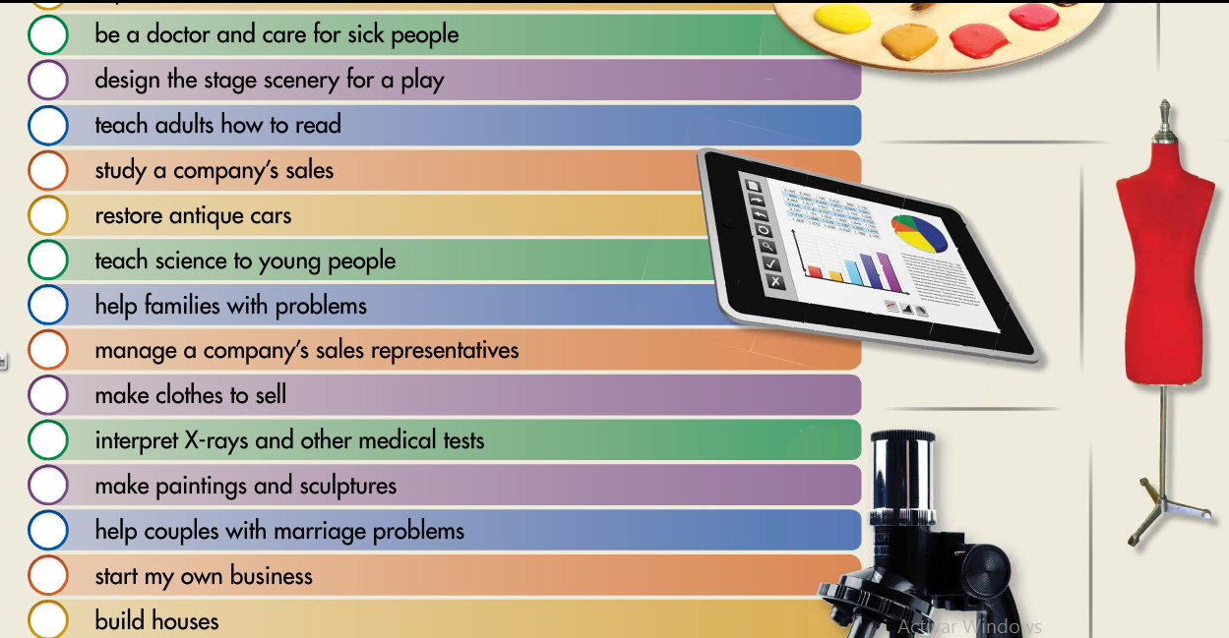

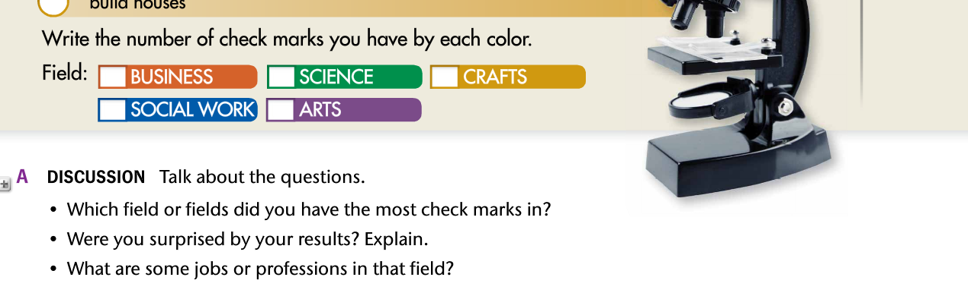

**Task 2. Answer the following questions.**



1. _________________________________________________________________
2. _________________________________________________________________
3. __________________________________________________________________________________________________________________________________

**PHOTO STORY**

**Task 3. Read the dialogue below, explain who they are and what they are talking about.**

**________________________________________________________________________________________________________________________**

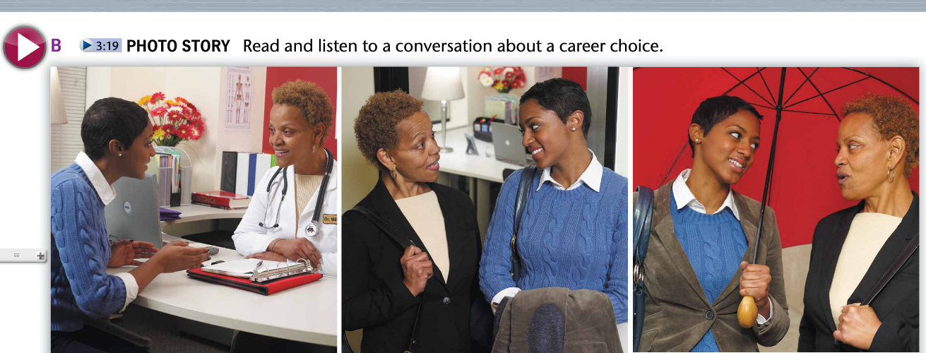

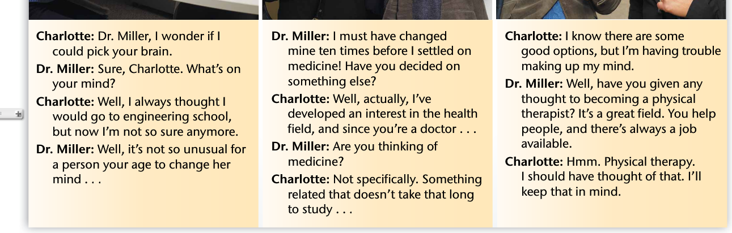

**Task 4. Develop activity C. Underline the 6 expressions in the photo story.**

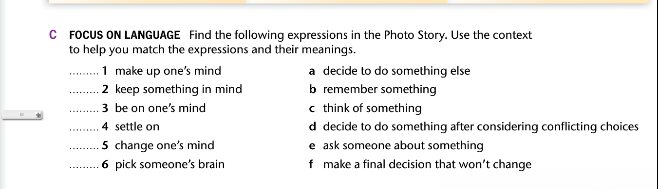

**VOCABULARY 1**

**Task 5. Read the statements below.**

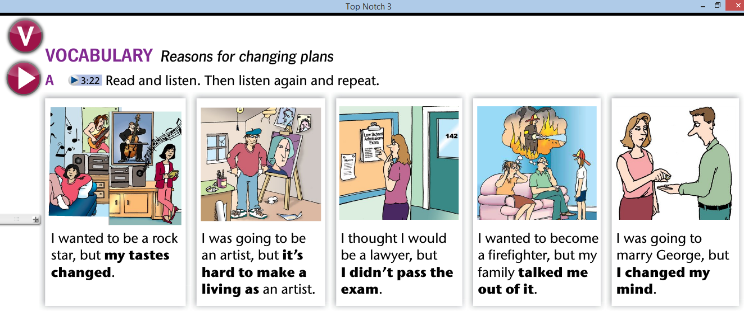

**Task 6. Develop activity B.**

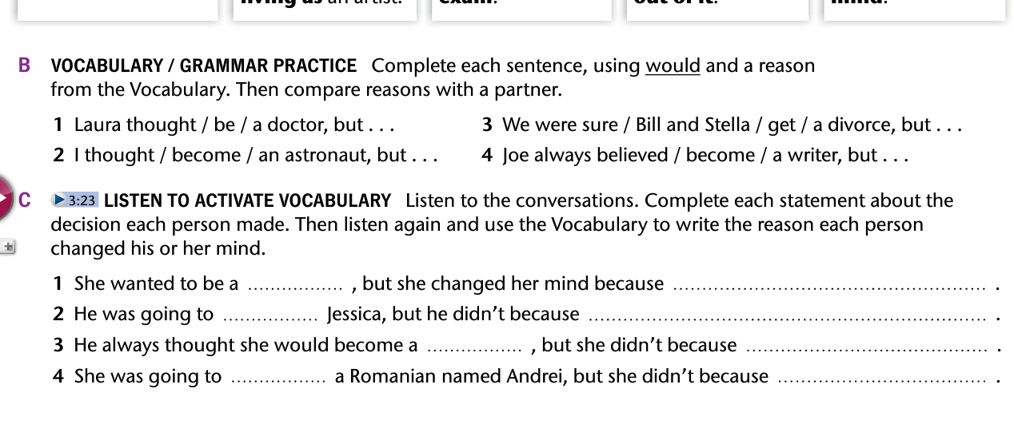

1. _______________________________________________________________________
2. _______________________________________________________________________
3. _______________________________________________________________________
4. _______________________________________________________________________

**VOCABULARY 2**

**Task 1. Check the vocabulary below.**

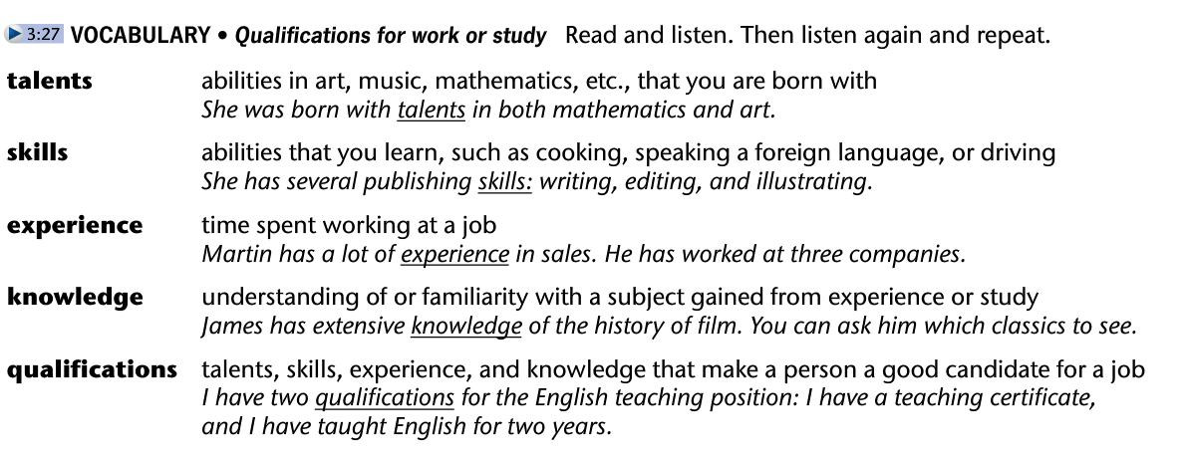

**Task 2. Explain:**

* **The difference between talent and skill.**

**______________________________________________________________________________________________________________**

* **The difference between experience and knowledge.**

**______________________________________________________________________________________________________________**

**Task 4. Describe your talents, skills, experience and knowledge to develop a job related with your career at least 3 of each.**

|  |  |  |  |
| --- | --- | --- | --- |
| **TALENTS** | **SKILLS** | **EXPERIENCE** | **KNOWLEDGE** |
|  |  |  |  |
|  |  |  |  |
|  |  |  |  |

**READING 1**

**Task 1. Develop the activity below.**

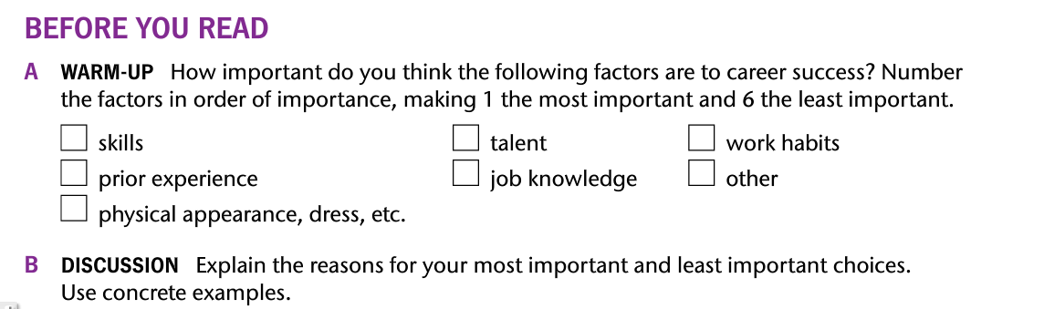

**Task 2. Read the following text.**

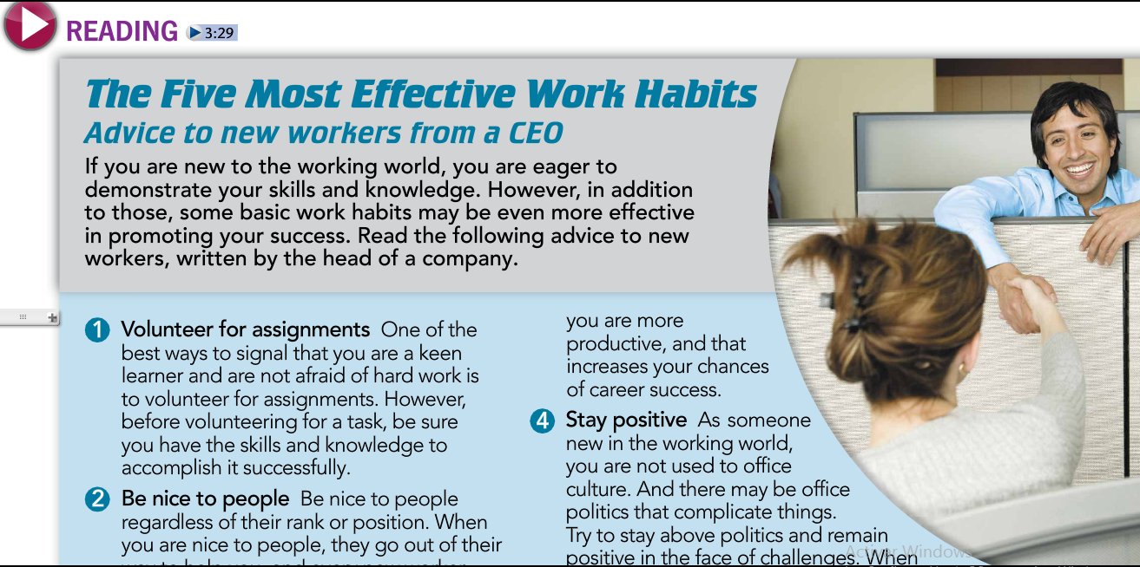

**Task 3. Read the text and get the 5 KEY WORDS of the reading.**

**Task 4. Read the text again and get the General idea.**

**______________________________________________________________________________________________________________________________________________**

**Task 5. Now get the main idea of these aspects:**

* **Volunteer for assignments**

**__________________________________________________________________________________________________________________________________**

* **Be nice to people**

**__________________________________________________________________________________________________________________________________**

* **Prioritize your work**

**__________________________________________________________________________________________________________________________________**

* **Stay positive**

**__________________________________________________________________________________________________________________________________**

* **Highlight a problem but bring solutions**

**__________________________________________________________________________________________________________________________________**