**HOMEWORK UNIT 4**

**NAME: __________________________ DATE: ___________________**

**LEVEL: ___________________________**

**PREVIEW**

**Task 1. Explain what Reading for Pleasure means.**

**______________________________________________________________________________________________________________________________________________**

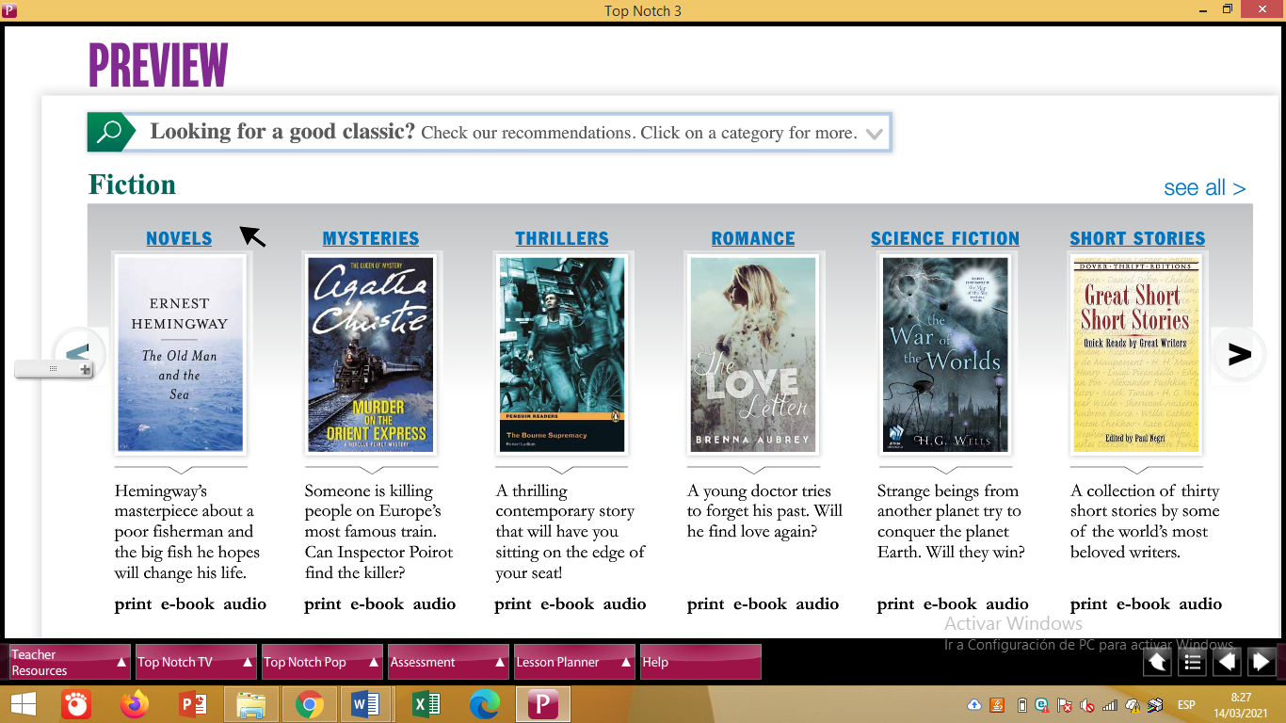

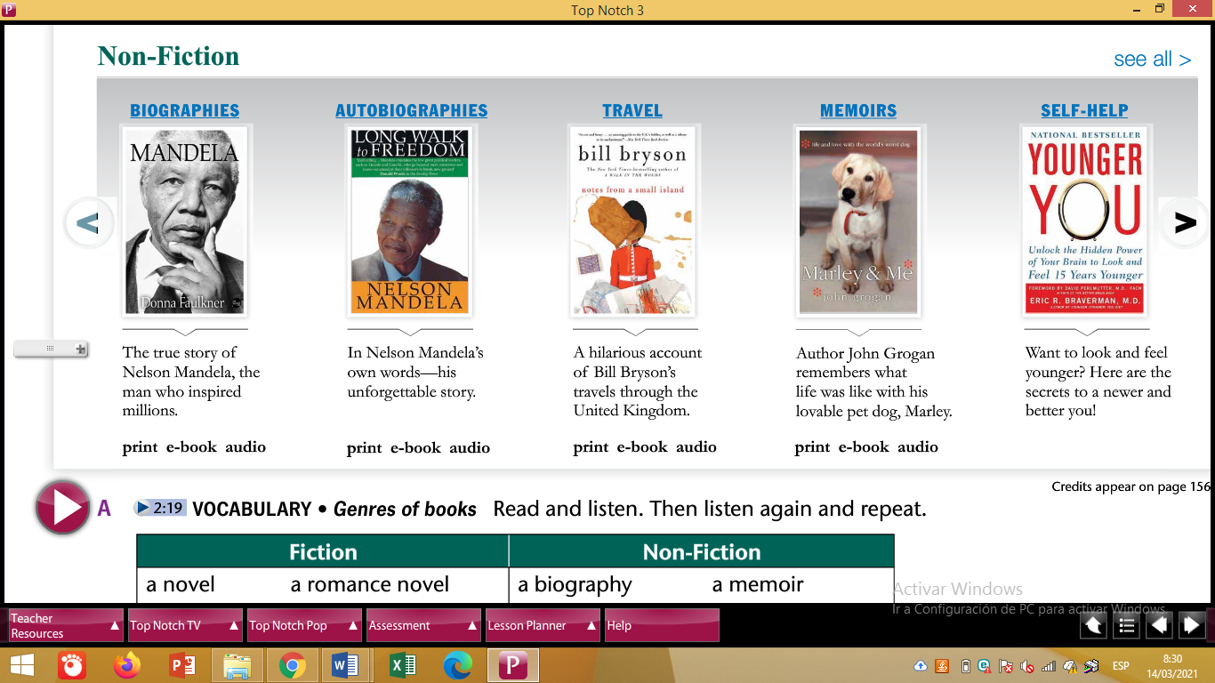

**Task 2. Answer these questions.**

1. **Do you like to read for pleasure?**

**__________________________________________________________________________________________________________________________________**

1. **How many books have you read?**

**__________________________________________________________________________________________________________________________________**

1. **What kind of books do you prefer?**

**__________________________________________________________________________________________________________________________________**

**PHOTO STORY**

**Task 1. Read the dialogue and give a summary about it, please include who they are and what they are talking about.**

**______________________________________________________________________________________________________________________________________________**

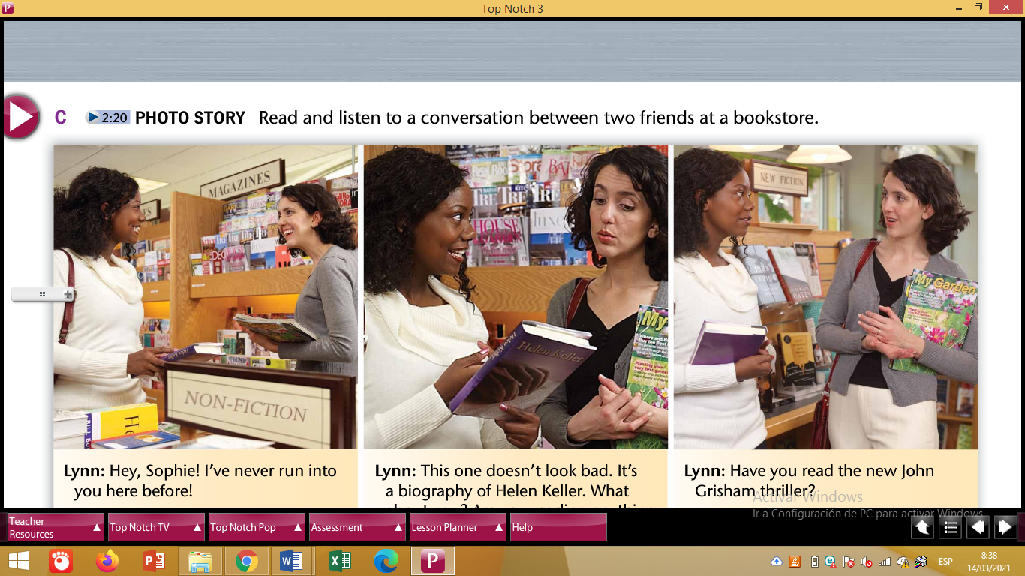

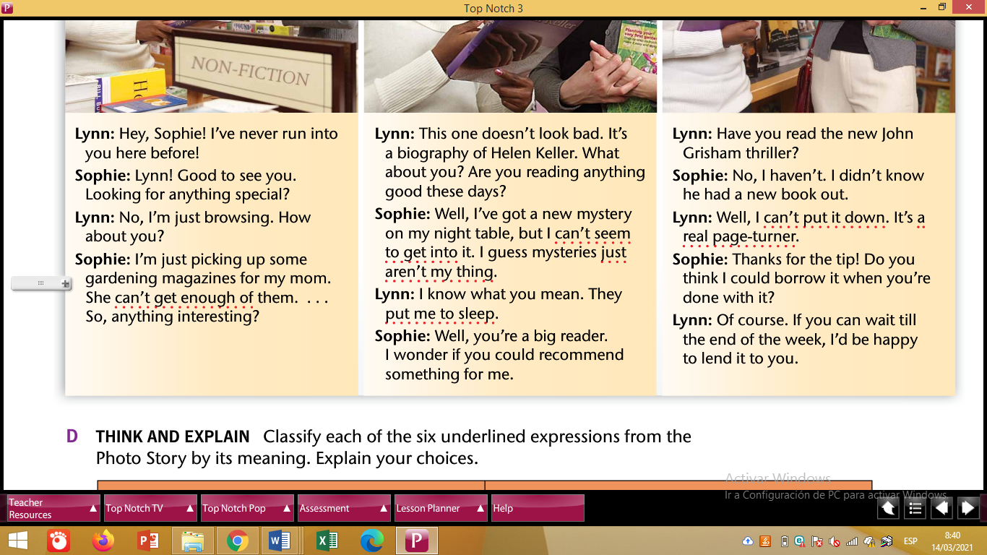

**Task 2. Develop D and E activities.**

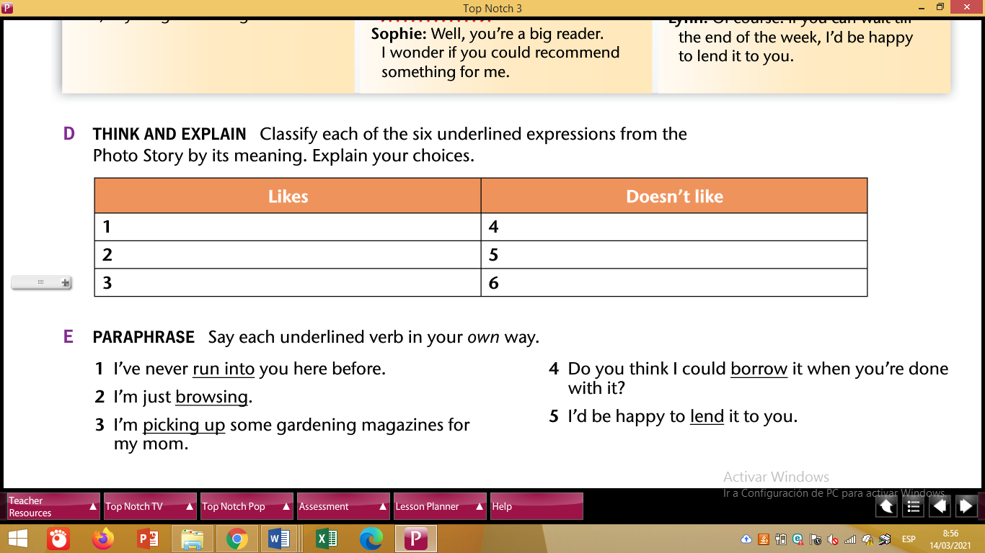

1. **_________________________________________________________________**
2. **_________________________________________________________________**
3. **_________________________________________________________________**
4. **_________________________________________________________________**
5. **_________________________________________________________________**

**VOCABULARY 1**

**Task 1. Check the vocabulary**

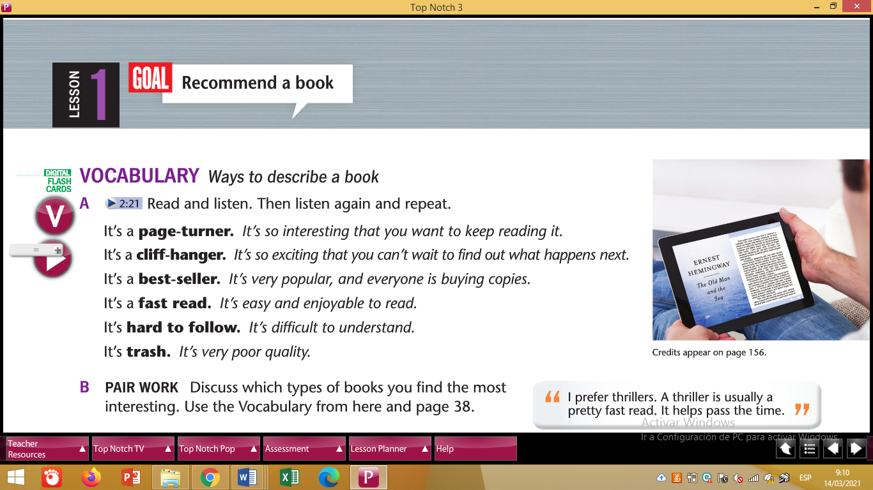

**Task 2. Write sentences using Noun Clauses, the name of a book and a characteristic based on the vocabulary.**

**For instance:**

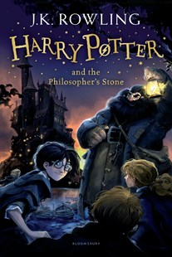

1. **Many people agree that Harry Potter and the Philosopher’s stone is a cliff hanger book because … ____________________________**
2. **______________________________________________________________________________________________________________**
3. **_____________________________________________________________________________________________________________________________________________________________________**
4. **_____________________________________________________________________________________________________________________________________________________________________**
5. **_____________________________________________________________________________________________________________________________________________________________________**
6. **__________________________________________________________________________________________________________________________________**