**VOCABULARY 2 of UNIT 2**

**Task 1. Read and present the Medical Procedures.**

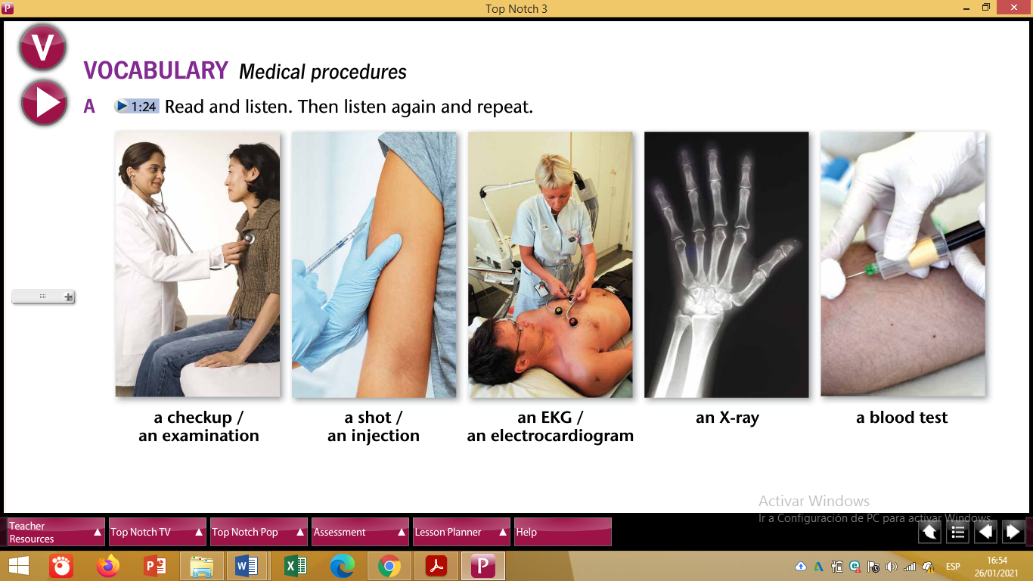

Task 2. Create a GAME for your partners to guess or complete the Vocabulary about Medical Procedures.

Task 3. Explain which Medical Procedure (mention at least 2) a person MUST get in case of …

1. A car accident
2. Pregnancy
3. COVID

Start like this:

1. In a car accident, a person MUST get …
2. A pregnant woman MUST get …
3. A person who got COVID MUST get …