**HOMEWORK UNIT 1**

**PREVIEW, PHOTO STORY, SPEAKING**

**NAME: _________________________ LEVEL: __________________**

**DATE: _________________________**

**NOTE: do the homework by HAND.**

**PREVIEW**

**Task 1. Based on Ecuadorian customs, answer these questions.**

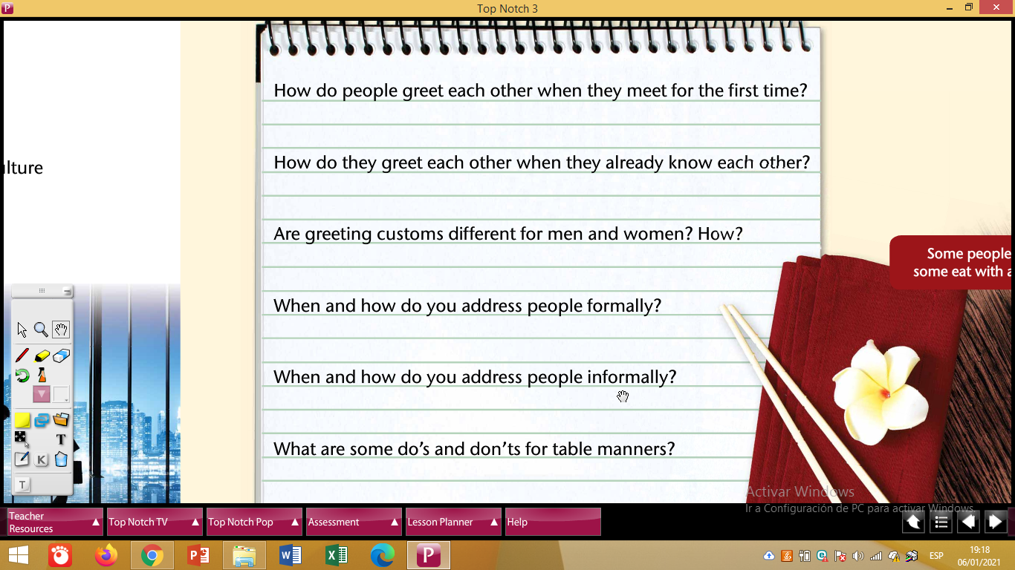

**PHOTO STORY**

Task 2. Read the photo story and explain who they are and what they are talking about.

_____________________________________________________________________________________________________________________________________________________________________________________________________________________

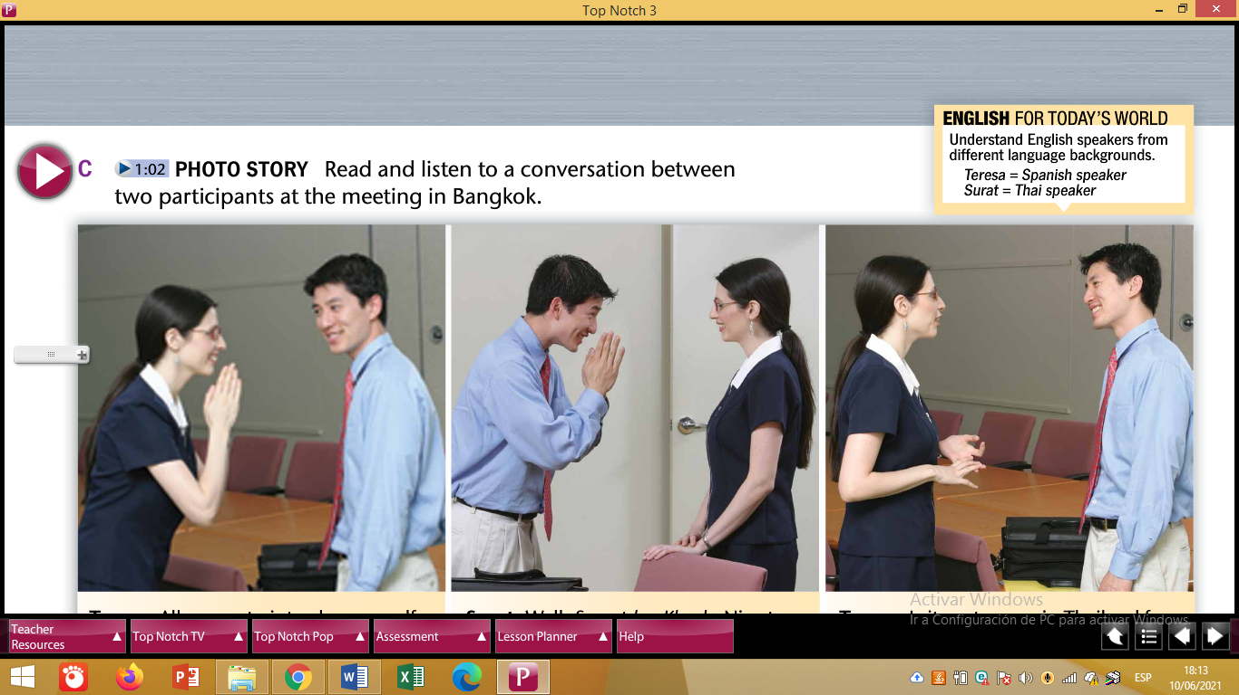

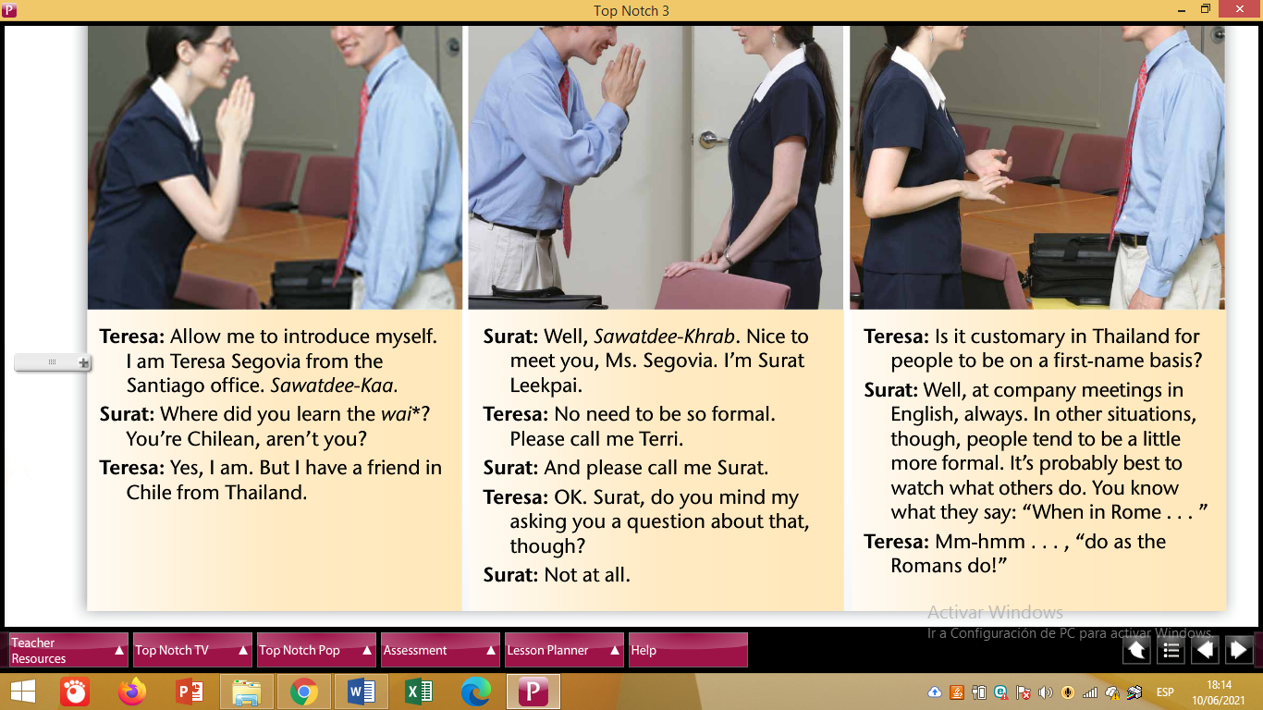

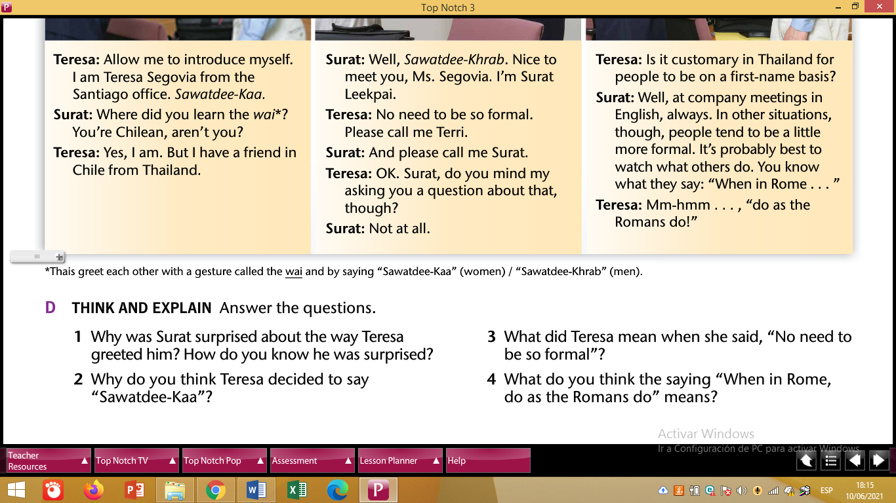

Task 3. Answer the questions written in activity D.

1. __________________________________________________________________________________________________________________________________
2. __________________________________________________________________________________________________________________________________
3. __________________________________________________________________________________________________________________________________
4. __________________________________________________________________________________________________________________________________