**HOMEWORK UNIT 2**

**PREVIEW, PHOTO STORY, SPEAKING**

**NAME: _________________________ LEVEL: __________________**

**DATE: _________________________**

**NOTE: do the homework by HAND.**

**PREVIEW**

**Task 1. Read and present the information about Dental cases.**

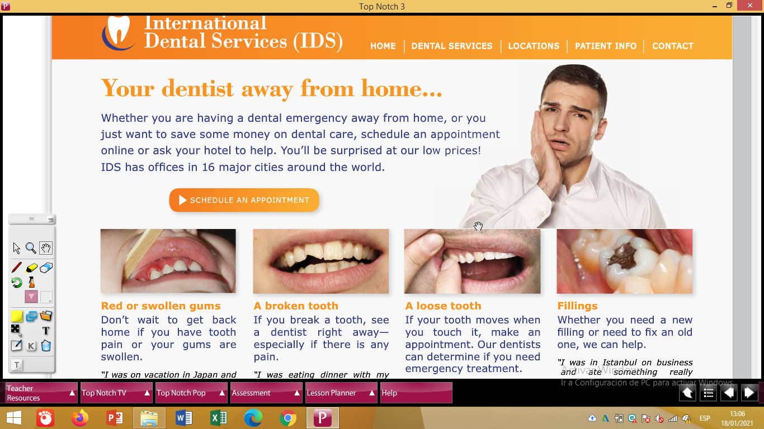

**Task 2. Answer these questions, and explain your reasons.**

1. **What would you do if you got swollen gums?**
2. What would you do if you got a broken tooth?
3. What would you do if you lost a tooth?
4. What would you do if you lost a filling?

**Options to answer**: Try to use a different option for each question.

… , I would ignore the problem.

… , I would make an appointment to see a dentist right away.

… , I would call or email my dentist for advice.

**Example:**

1. **What would you do if you got swollen gums?**

***If I got swollen gums, I would ignore the problem because …___________________________________***

1. _____________________________________________________________________________________

_____________________________________________________________________________________

1. _____________________________________________________________________________________

_____________________________________________________________________________________

1. _____________________________________________________________________________________

_____________________________________________________________________________________

**PHOTO STORY: A DENTAL EMERGENCY**

Task 1. Read the dialogue and give a summary about it, and explain who they are.

____________________________________________________________________________________________________________________________________________________________________________________

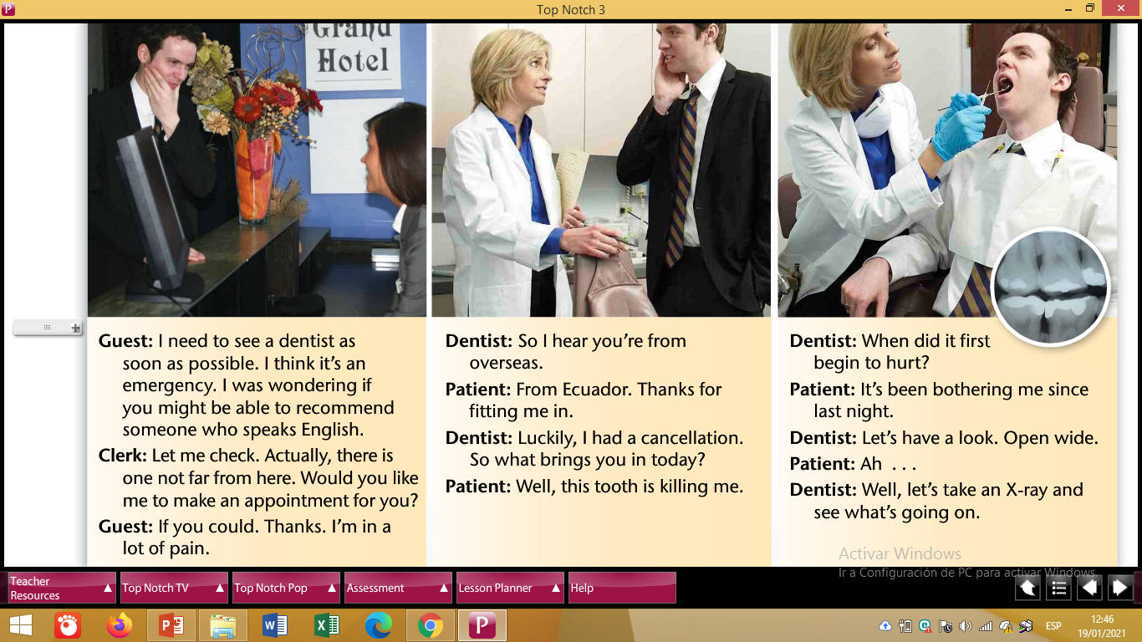

Task 2. Develop the activity C.

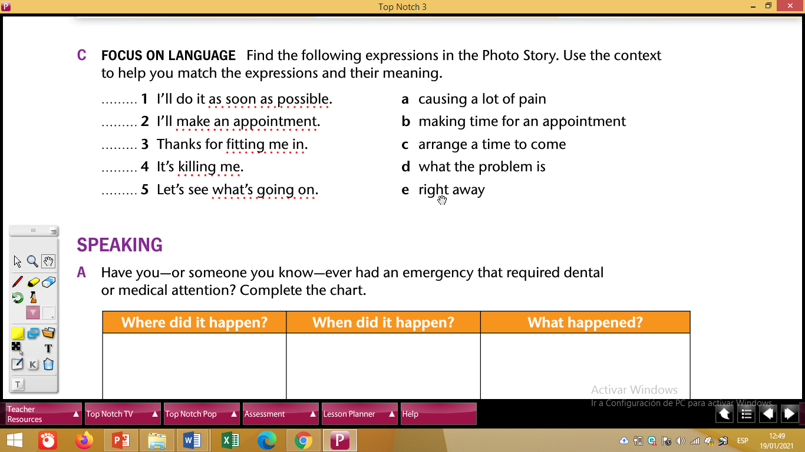

**SPEAKING UNIT 2**

Task 1. Develop Speaking activities A and B.

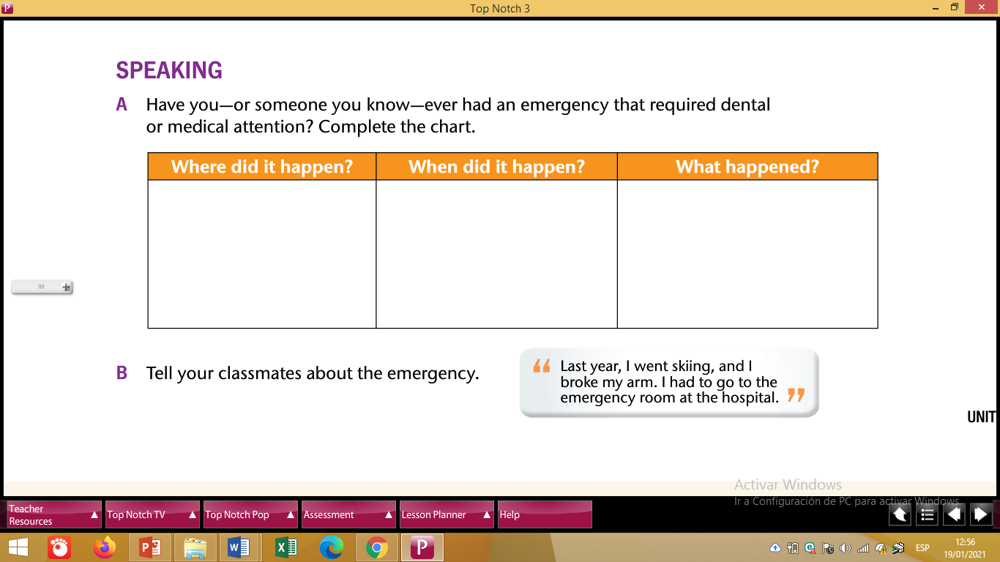

To develop the activity above use PICTURES.