Part 1
Listen to the conversations. Look at the pictures. Choose the picture that best matches each conversation.

Example:    a. |   b. |   [c.]
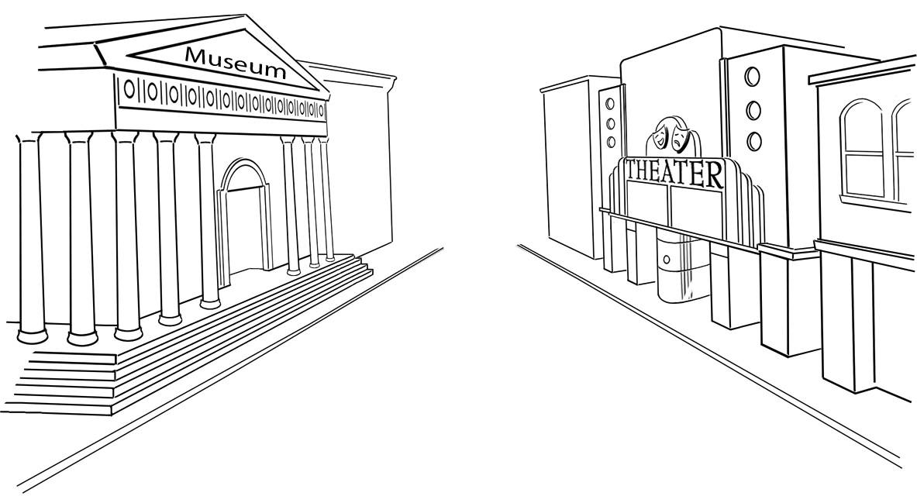  1. a | 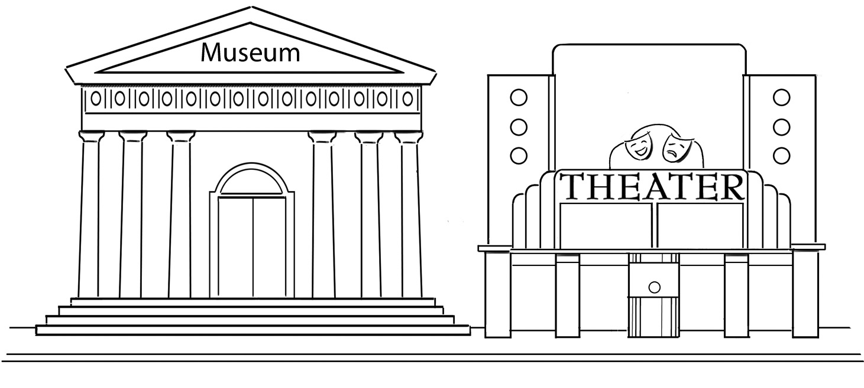  b. | 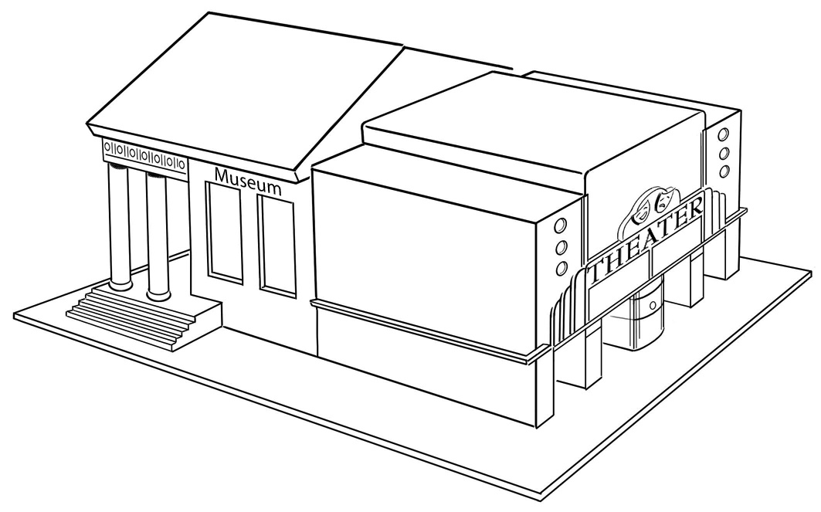  c.
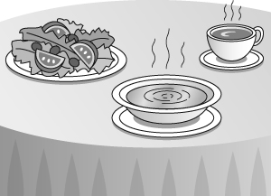  2. a. | 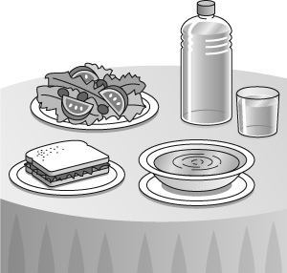  b. | 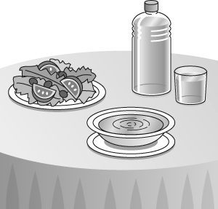  c.

Part 2
Listen to the conversation. Choose the correct answer for each question.

Example: Why do Paul and Rita have a conversation?
[a. They know each other.]
b. They want to meet each other.
c. One of them works in the store.

3. What is Rita shopping for?
a. a laptop
b. a printer
c. a digital camera

4. Why is Paul shopping for a printer?
a. His printer is an antique.
b. His printer is broken.
c. His printer is too slow.

5. What is Paul buying next month?
a. a computer
b. a printer
c. a digital camera

6. What does Rita say about the price of the printer she recommends?
a. She says it’s expensive..
b. She says it is not very expensive.
c. She doesn’t know the price.

Part 3
Read each sentence. Then check (✓) Correct or Incorrect for each one.

Correct Incorrect

Example: Mark Sinclair is great musician. ( ) ( ✓ )

7. Does Leslie have any children? ( ) ( )

8. My aunt works, but my uncle doesn’t works. ( ) ( )

9. I meet my mother this afternoon at my aunt’s house. ( ) ( )

10. Are there any bananas in the kitchen? ( ) ( )

11. What you are eating? ( ) ( )

12. Pierre comes from France, so he’s French. ( ) ( )

13. There’s coffee to drink with breakfast. ( ) ( )

14. How many pets do he have? ( ) ( )

Part 4
Read each group of words. Cross out the word or phrase that does NOT belong.

Example: rock / jazz / concert / classical

15. apples / beans / peppers / carrots

16. entrée / appetizer / pie / beverage

17. stepsister / aunt / mother / grandfather

18. unhealthy / low-fat / high-calorie / soup

19. game / play / concert / art exhibit

20. juice / milk / water / cookie

21. Chinese / Germany / Mexican / Canadian

22. who’s / how / they’re / when’s

23. bananas / meat / vegetables / seafood

24. blender / refrigerator / oven / camcorder

25. turn left / be careful / go around the corner / walk four blocks

26. won’t turn on / is clogged / is working / won’t flush

Part 5
Choose the correct word or phrase to complete each sentence.

Example: A: ( Do / [Does] / Don’t ) Jeff like hip-hop?
B: No, he ( don’t / do not / [doesn’t] ).

27. A: Is Ellen ( use / uses / using ) the computer right now?
28. B: No, she ( aren’t / isn’t / don’t ).

29. A: Where does Carla ( live / lives / living )?
30. B: She ( live / lives / living ) on Elm Street.

31. A: Would you like ( a / an / the ) apple?
32. B: No, thanks. I don’t (likes / like / liked ) fruit .

33. A: Is your wife ( in / on / at ) work?
34. B: No, she doesn’t work ( in / on / at ) the afternoon.

35. A: Do you work ( in / on / at ) Saturday and Sunday?
36. B: Sometimes I do ( in / on / at ) in the summer.

Part 6
Read the answers. Then complete the questions. Use contractions when possible.

Example: A: ____What’s_____ he doing?
B: He’s looking for new headphones.

37. A: the art exhibit?
B: It’s at 8:00 on Friday night.

38. A: that in the yellow dress?
B: That’s my sister-in-law, Liz.

39. A: people are going to the movies?
B: Six or seven, I think.

40. A: you and Helen cousins?
B: Yes, we are.

Part 7
Complete each conversation by choosing the correct response.

Example: A: What do you feel like eating?
B: _______________________

a. May I have the check, please?
[b. I think I’d like some kind of seafood.]
c. Coffee with milk in it.

41. A: Bob, this is my wife, Celia.
B: _________________________

a. Nice to meet you.
b. Please call me soon.
c. Sorry, I’m not from around here.

42. A: Jennifer, would you like to go to a movie with me on Saturday night?
B: ________________________

a. How’s it going?
b. I’m sorry, but I’m busy.
c. My friends call me Jen.

43. A: What does the pasta come with?
B: _________________________

a. Either soup or a salad.
b. The tip is included in the check.
c. You can use cash or a credit card.

44. A: The air conditioner isn’t working in my room.
B: _________________________

a. It’s an expensive piece.
b. Well, your room is warm.
c. I’ll send someone up right away.

Part 8
Read the paragraph. Then read the statements and check ( ✓ ) True, False, or No information for each one.

Ellen Martin is having a party at her house next week. She is inviting several family members and some friends from the office. Ellen works as a computer programmer at a large company. There are twenty people invited to the party. For dinner, the menu is shrimp in orange sauce, coconut rice, and a fresh fruit salad. Ellen doesn’t really like to cook, but her husband, Ron, does. In fact, Ron is a chef at a major hotel, so the meals at Ellen and Ron’s house are always amazing because he cooks! Everyone wants to come to their parties. Ellen wants to introduce her sister Amy to Alan Waters, a colleague. Amy works as a manager for an international company, and she loves to travel and listen to salsa and rock music. Amy is single. Alan is single, too. Alan also loves to travel, and he is a fan of salsa music.

True False No information

Example: Ellen is inviting only colleagues to the party. ( ) ( ✓ ) ( )

45. Ron is a chef. ( ) ( ) ( )

46. Ellen has a brother. ( ) ( ) ( )

47. The menu includes seafood, fruit, and potatoes. ( ) ( ) ( )

48. Alan really wants to meet Amy. ( ) ( ) ( )

49. Amy and Alan are similar in several ways. ( ) ( ) ( )

50. Amy works as a computer programmer. ( ) ( ) ( )

Units 1-5 Writing Test

Choose one of these three topics. Write at least three sentences about each.

• How machines help me

• Meeting new people

• My favorite things to go to (concerts, movies, museums, and so on)

Topic:

