QUESTIONS ABOUT SHOPPING FOR CLOTHES

VIDEO.

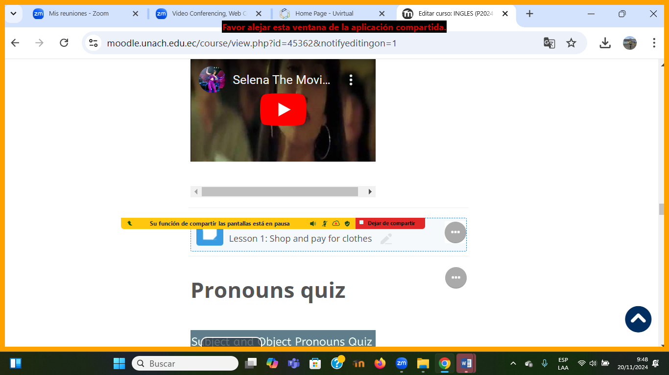

1.- Watch the video and answer these questions.

1.- What does Selena want to buy?

. She wants to buy a dress

2.- What color is it?

It´s salmon.

3.- How much is it?

It´s $ 800

4.- How was the service ( clerk) of the Clothing store?

It was very bad, terrible, discrimination.

5.- Why doesn´t Selena want to buy it?

Because the service was pretty bad and Selena gives her a life lesson.