**Superlative adjectives.**

**Material prepared by: Mgs. Doris Valle V.**

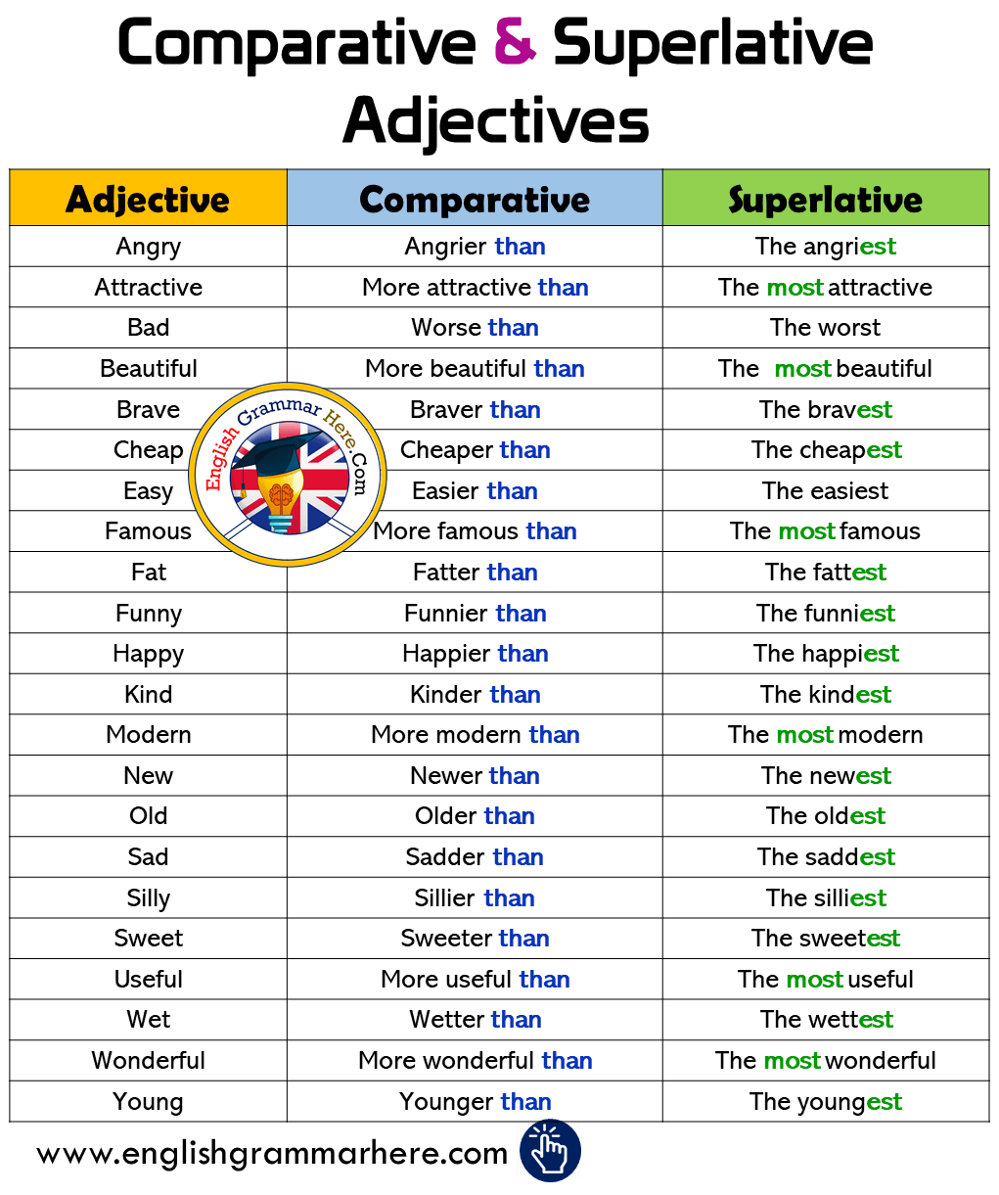

SUPERLATIVE FORM: are used to describe an object which is at the upper or lower limit of a quality

a.- Single syllable

Adjective + est

Herb medicine is cheapest than conventional medicine.

b.- TWO SYLLABUS:

Adjective + the most

Spiritual medicine is the most effective alternative.