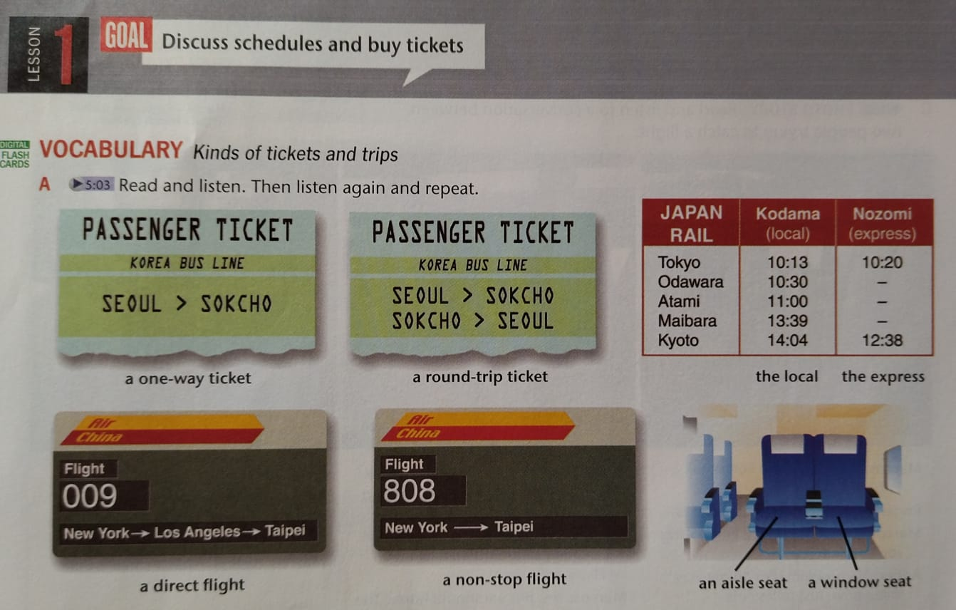

1. **Complete the conversations with phrases from the Vocabulary.**
2. **A:** Would you like a window or an aisle?

**B:** .................... I like to walk around.

1. **A:** Is Flight 3 a .................... flight?

**B:** No. It's a ...................... flight. It makes a stop, but you don't have to change planes.

1. **A:** Do you want a ..................... ticket to Rome?

**B:** Actually, I need a .......................... I'm not coming back!

1. **A:** I'm sorry. It's too late to make the local .............. I'm not in a hurry.

**B:** Well, I'll take the .................. I´m not in a hurry.

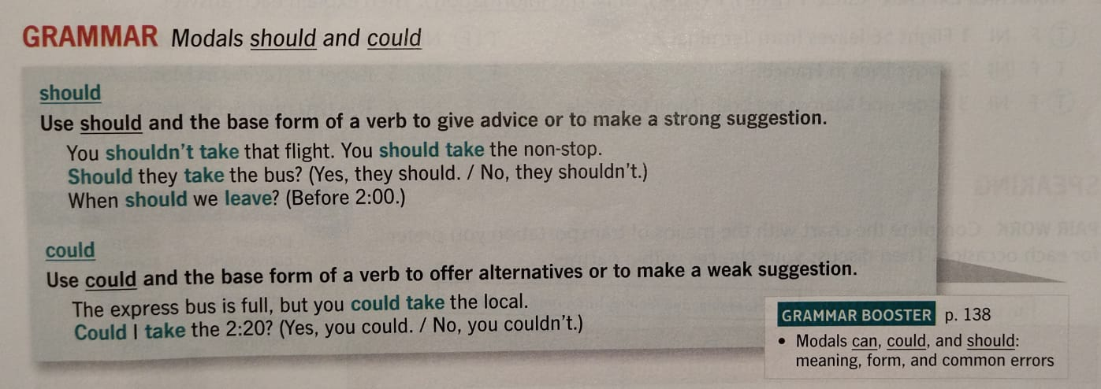

1. **GRAMMAR PRACTICE: Complete each statement or question with a form of should or could and the base form.**
2. ............................ (he/ take) the express. The local arrives too late.
3. They said.................... (we / have two) aisle seats or an aisle and a window seat.
4. ...........................(you / not get) a one-way ticket. It's much more expensive each way.
5. Which train ...................(we / take)? We absolutely have to be there on time.
6. ....................(they / buy) a ticket at the station or on the train. It doesn't matter.

