** UNIVERSIDAD NACIONAL OF CHIMBORAZO**

**DIAGNOSTIC TEST**

**Student´s name: ……………………. Date: ……………………….**

**Level: ………………. Room: …………………….**

**Note: Write legible and don´t cheat during the test.**

**Question 1 (4 marks) 0.5  
  
Write down the questions for the answers given, as in the example.  
  
Example: What's your name?  
  
Answer:  My name is Thomas**.  
  
 1__________________________________________________________________?  
  
 I'm fine, thanks.  
  
2.__________________________________________________________________?

    He is thirty years old.

3________________________________________________________________ __?

      He's an architect.

4. __________________________________________________________________?

    My mother works **in an office.**

5. __________________________________________________________________?

    Yes, I can dance in a folk group.

6. __________________________________________________________________?

    He starts school **at seven thirty** every morning.  
  
 7. _______________________________________________________________ ?

Mark Zuckerberg is **from New York.**  
        
       
 8._________________________________________________________________?   
    I met **a nice classmate** yesterday.

Question 2 ( 3 marks) 0.5  
 **All the following sentences are incorrect. Re-write them correctly as in the example below.  
  
E.g. The childrens are in the garden.**

The children are in the garden.  
  
1. Why **does** he arrive late yesterday?  
     ___________________________________________________________  
  
2. The boy's eyes **is** brown.  
     ___________________________________________________________________  
  
3. The man over **their** is our Maths teacher.  
  
     ___________________________________________________________________

4.  The old woman is **more short** than the young woman.  
      ____________________________________________________________________

5.  How **many** money have you got?  
      ____________________________________________________________________

6.  My brother **take** the bus to school every morning.

……………………………………………………………………………….     

Question 3 (2 marks) 0.5 **Fill in the spaces by finding / giving the opposite word to the one in brackets.  
  
 Example:  This test is very  _________________. (easy)  
  
 Answer:  This test is very difficult.**  
  
  
 1. Don't sit on that bench! It's ____________________. (dry)

………………………………………………………….  
  
 2. The new Italian restaurant is really ___________________. (cheap)

…………………………………………………………………………..  
  
 3. I live in the centre of town so it's really __________________. (quiet)

………………………………………………………………………

4. Be careful not to go near the river edge. It's _____________________. (safe)

…………………………………………………………………….  
  
 Question 4 (1mark) 0,5  
  
 **Read the following passage about Monika who works in an hydroelectrical company in Baños, and answer the questions that follow. Answer the questions in complete sentences.**

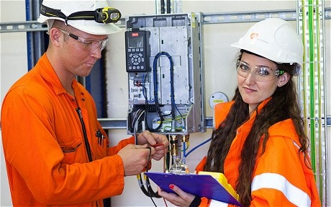

It's a job, in a Company.

Monika is an electrical engineer. She works at an hydroelectric company in Baños. Her day always starts early. She gets up at five thirty in the morning. At seven she walks to the shop and buys some milk and bread for her breakfast. When she goes to work, she surpervises the installation including electrical motors, She loves her job because she control to supply energy to the community,   
  
  
  
1. Where does Monika work ?  
  
____________________________________________________________________

2. What does she do in her job?  
  
  
_____________________________________________________________________

_____________________________________________________________________

………………………………..

Student´s Signature