**INTRODUCING MYSELF**: **MY LIFE**

Listen and read, then write and introduce yourself.

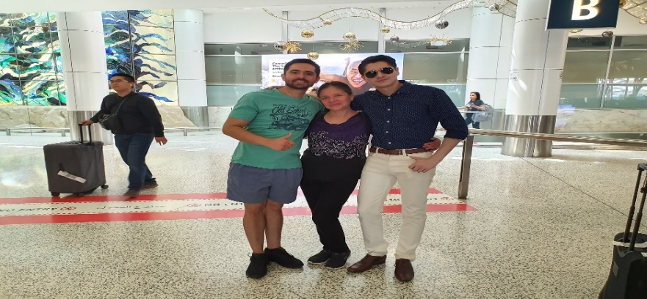

Hello dear students, it´s nice to meet you. My name is Doris Valle but I prefer you call me Miss Doris, I´m……… (age) I was born in …………….., but now I live in ……………… for more than 3 years. I´m responsible and trustworthy.

I studied at Languages School Unach. I have two adorable sons. I have been working at Unach for 18 years old. I´m convinced education is an investment in knowledge and prosperity, and overall our students are the protagonists in the classroom and play an active and dynamic role in the teaching and learning process. I really like volunteering, read self-help books: such as a “Life without limits” and watch motivational videos, “The Emperaro´s Club”, also I spend my free time doing gardening.

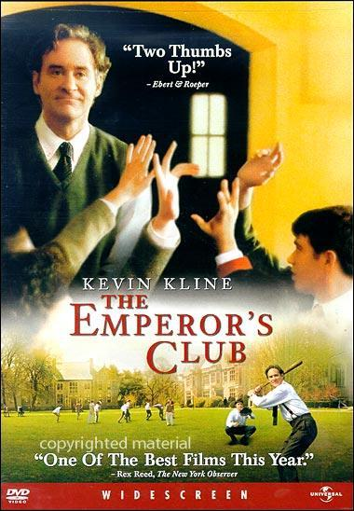****

**What about you?**

Your name: ………………………… I like……………………