**UNIT 1**

**Photo Story**

Task 1. Explain who are talking and what the dialogue is about.

______________________________________________________________________________________________________________________________________________

Task 2. Based on the dialogue answer the questions of the Activity D.

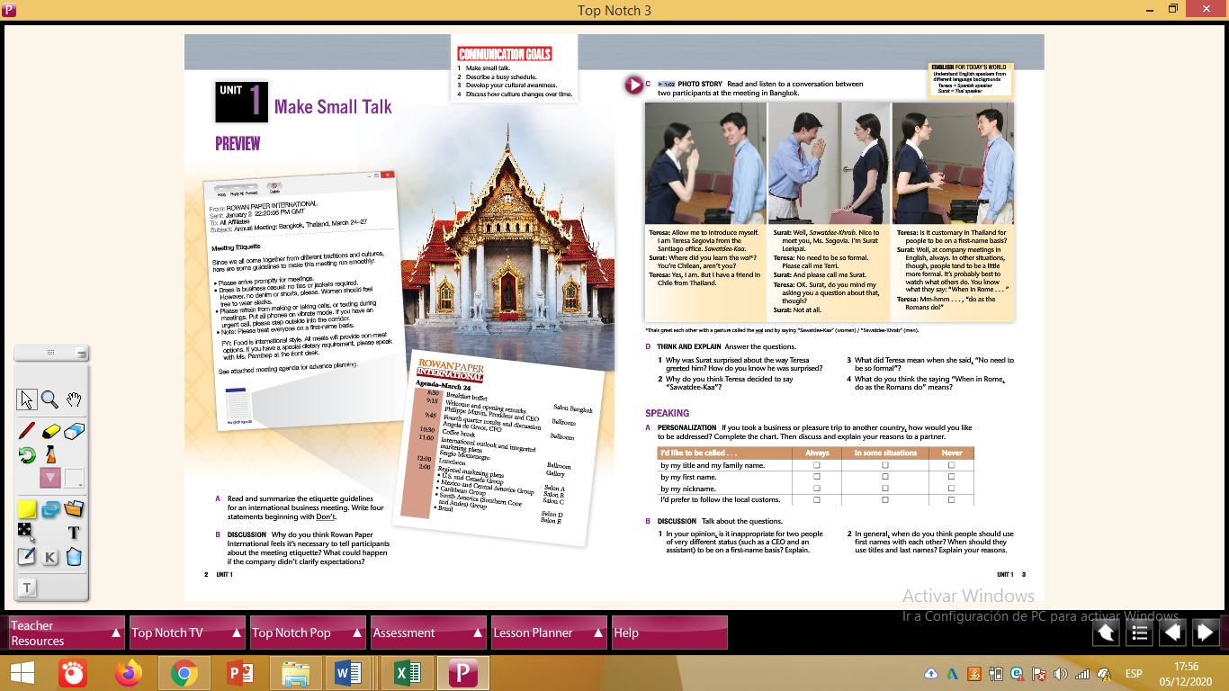

**1. ___________________________________________________**

**2. ___________________________________________________**

**3. ___________________________________________________**

**4. ___________________________________________________**