**UNIT 5**

**READING 1**

**Task 1. Read the following text.**



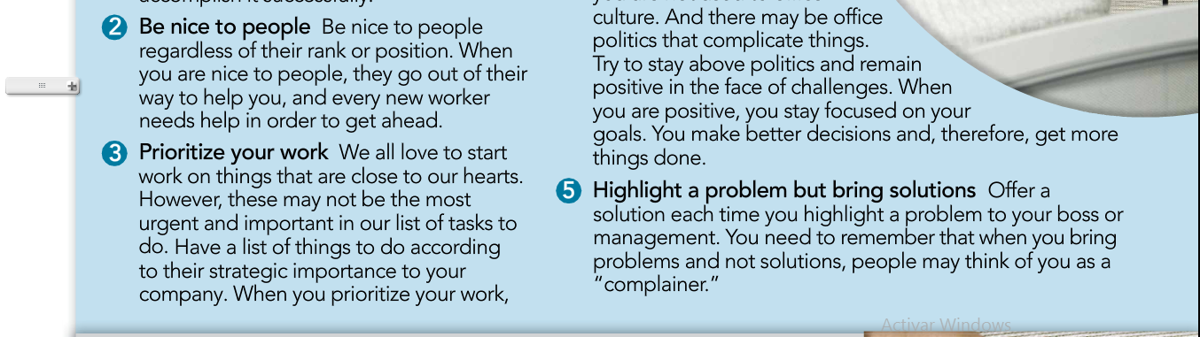



**Task 2. Based on the reading answer these questions.**

1. **Which may be the most important in determining a new worker’s success?**
2. **Why should worker volunteer to do a task?**
3. **Why is “being nice” a valuable habit to develop?**
4. **What is the value of prioritizing tasks?**
5. **How does staying positive help you be more productive?**
6. **What’s wrong with stating a problem without proposing a solution?**