**SPEAKING UNIT 2**

Task 1. Develop Speaking activities A and B.

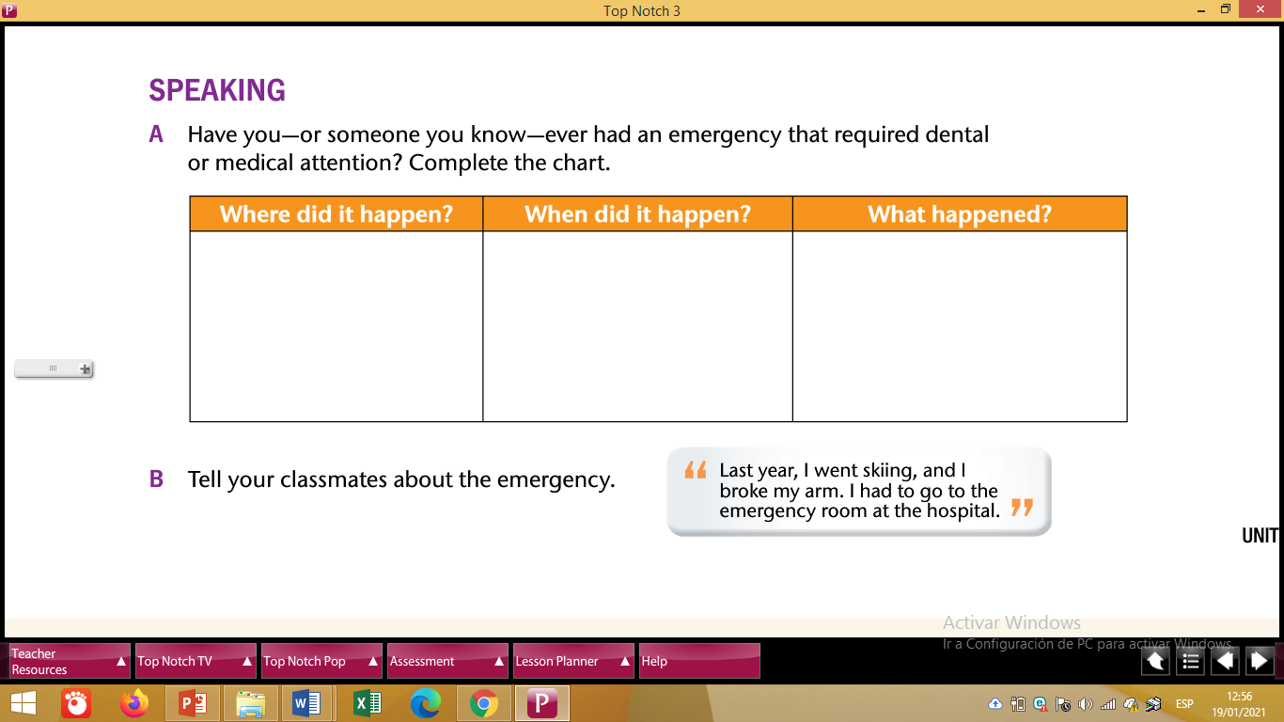

To develop the activity above use PICTURES.