**UNIT 5**

**READING 1**

**Task 1. Develop the activity below.**

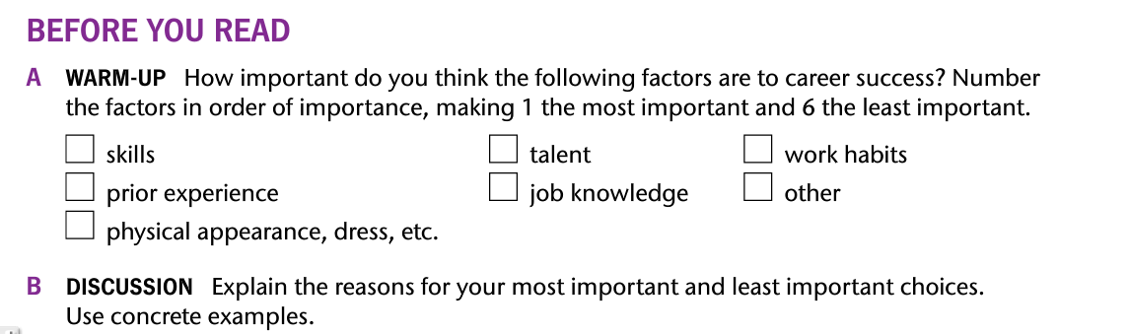

**Task 2. Read the following text.**

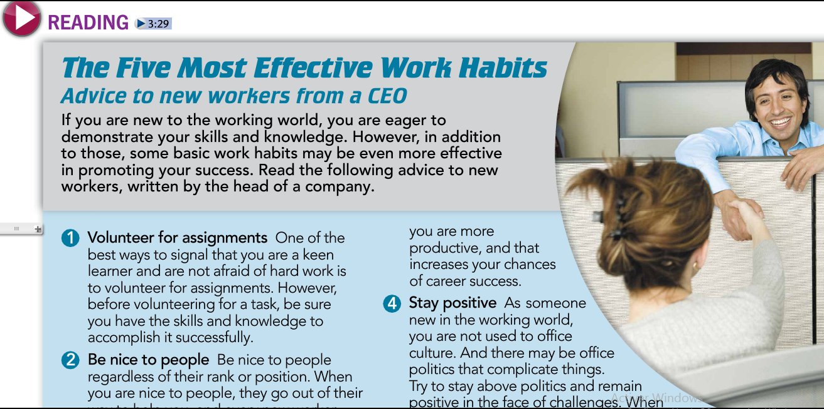

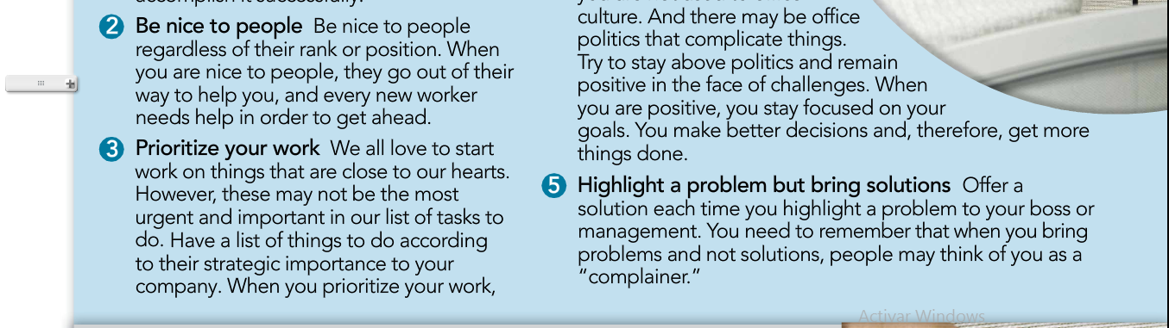

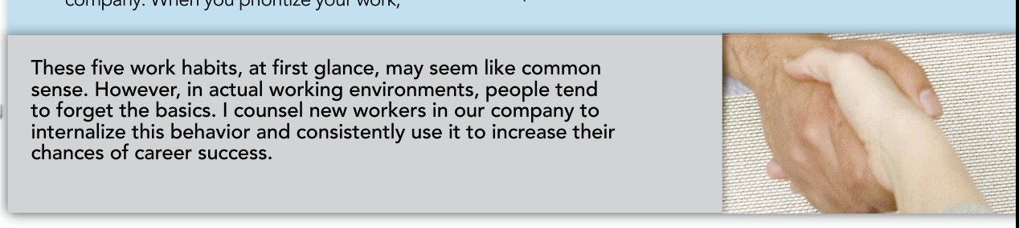

**Task 3. Read the text and get the 5 KEY WORDS of the reading.**

**Task 4. Read the text again and get the General idea.**

**Task 5. Now get the main idea of each paragraph.**