**UNIT 5**

**VOCABULARY**

**Task 1. Read the statements below and then explain what those expressions are used to. Use Tophonetics to practice a correct pronunciation.**

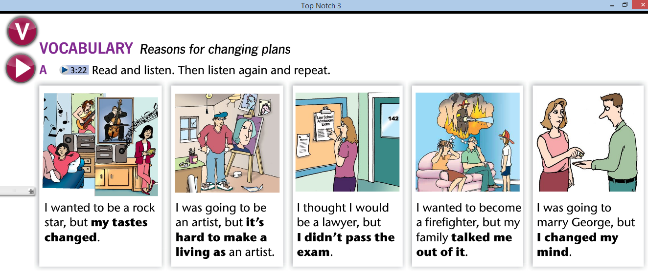

**Task 2. Create a game based on the vocabulary.**

**Task 3. Develop activity B.**

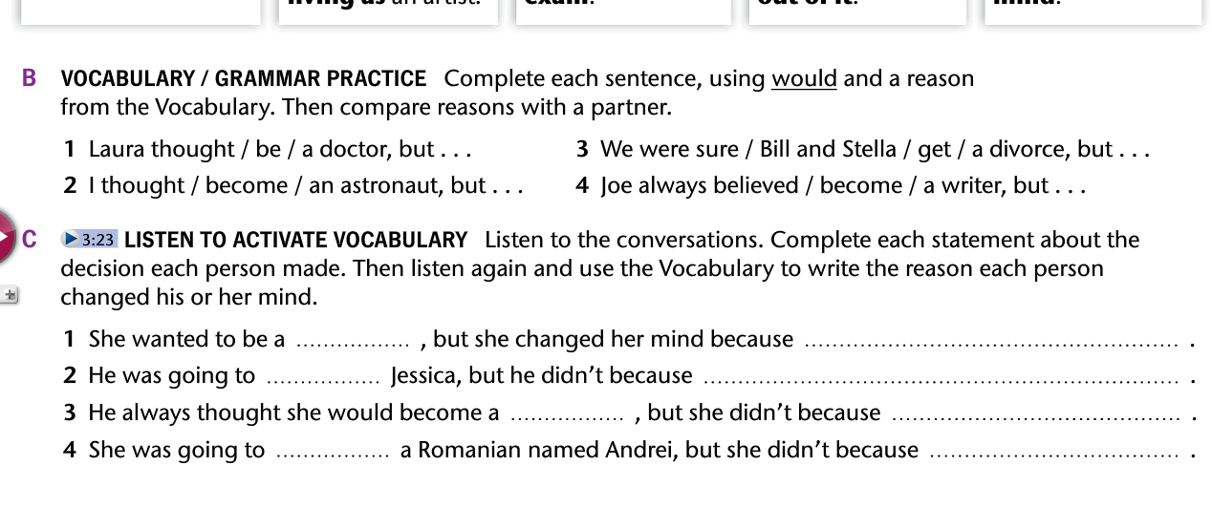

1. _______________________________________________________________________
2. _______________________________________________________________________
3. _______________________________________________________________________
4. _______________________________________________________________________