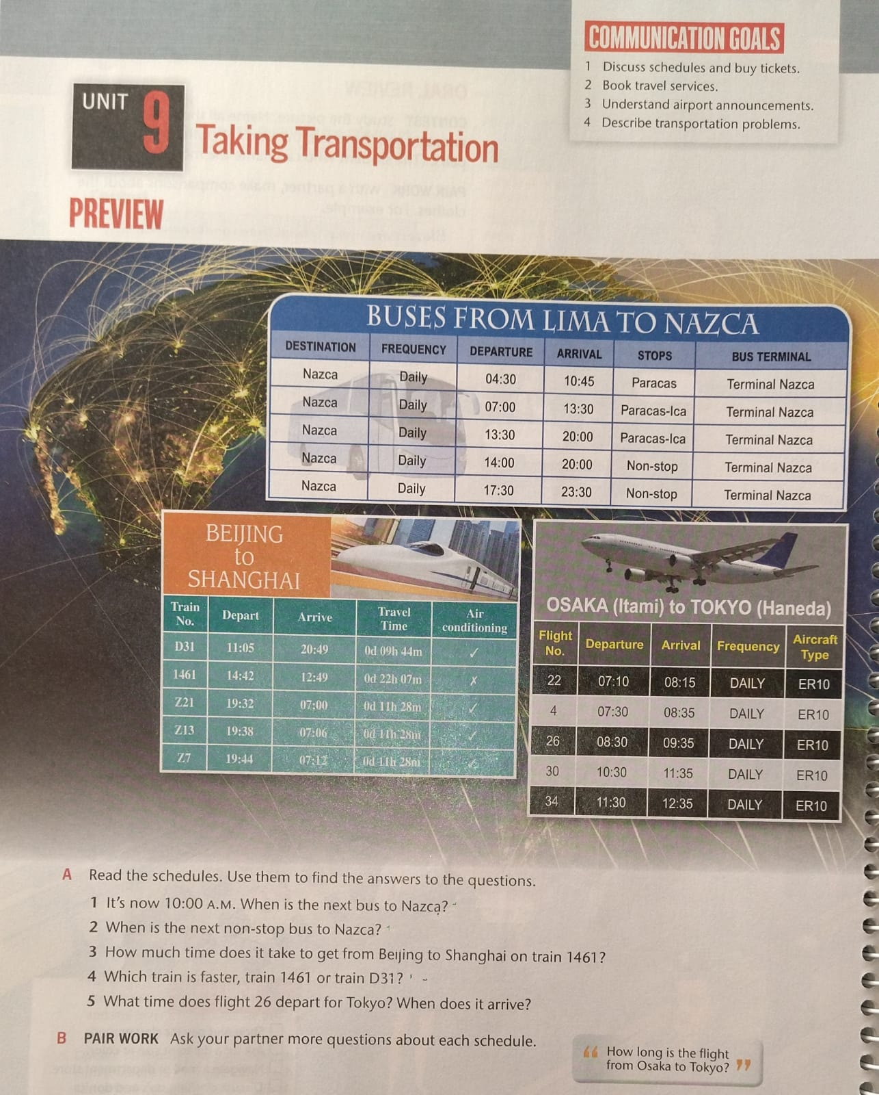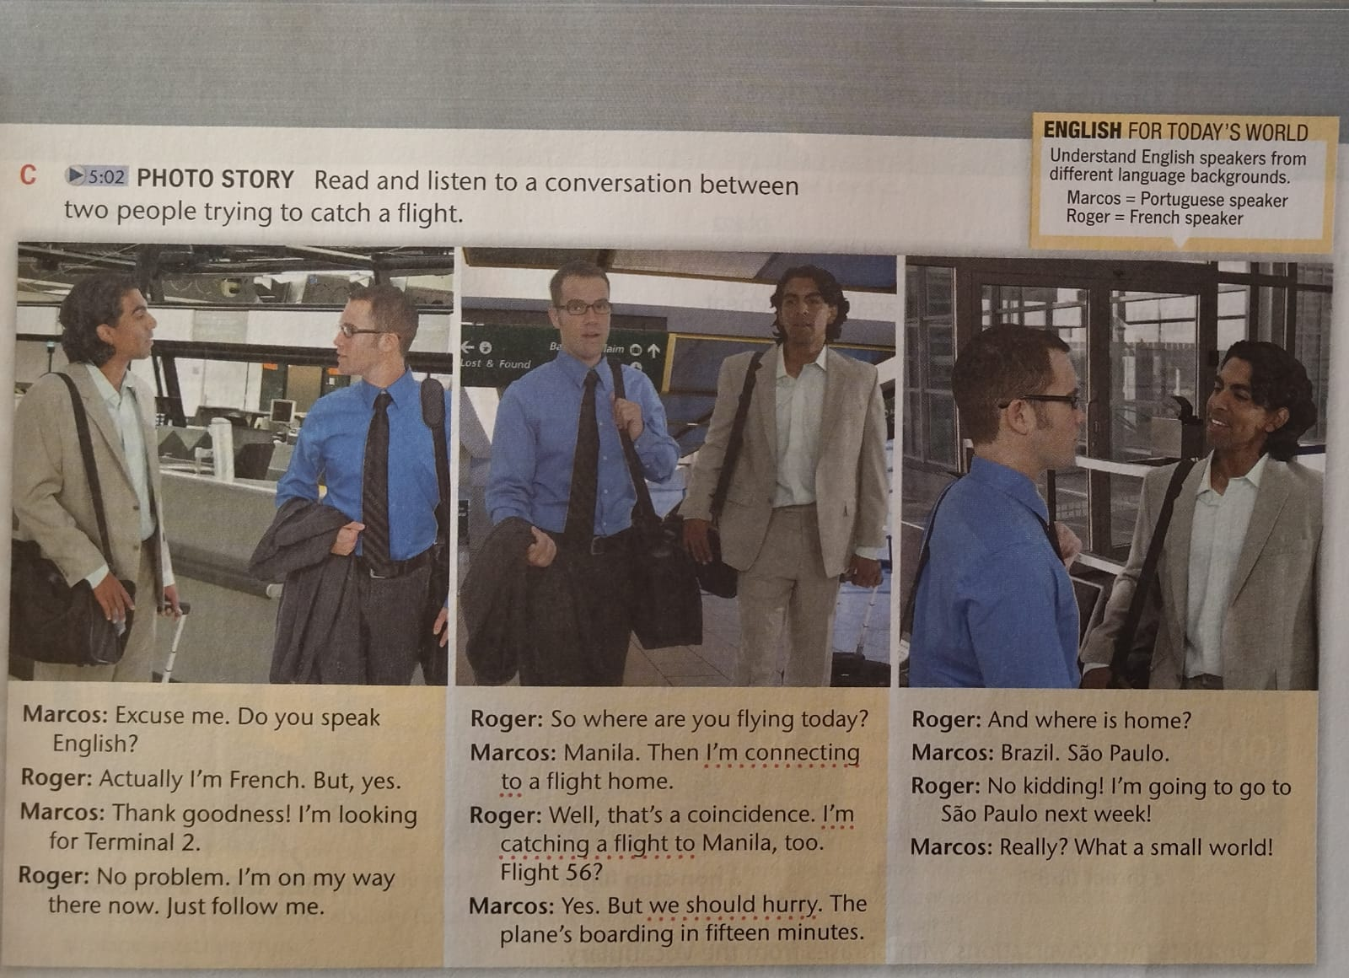

1. **FOCUS ON LANGUAGE Find and write an underlined word or expression from the Photo Story with the same meaning:**
2. I'm taking a plane to .........................................
3. Let's walk faster...........................................
4. I'm taking another flight to .........................................
5. **THINK AND EXPLAIN Circle T (true), F (false), or NI (no information). Then explain each answer.**
6. T F NI Flight 56 leaves from Terminal 2.
7. T F NI Roger lives in France.
8. T F NI Roger and Marcos are both flying to Manila.
9. T F NI Marcos is staying in Manila.
10. T F NI Roger is staying in Manila.
11. T F NI The two men get to the flight on time.
12. **Complete the chart with the means of transportation you prefer for each occasion. Then discuss your choices with a partner.**

|  |  |  |
| --- | --- | --- |
|  | **Means of transportation.** | **Reason.** |
| **To school or work** |  |  |
| **To social events on weekends** |  |  |
| **For travel in my country** |  |  |
| **For travel outside of my country.** |  |  |