**LESSON 6B HEALTHY LIVING: MYTHS AND FACTS**

1. Investigate the difference between ***a fact*** and ***a myth.*** Write down your findings.

A fact is ……………………………………………………………………………………………………………………………….

A myth is ……………………………………………………………………………………………………………………………..

1. Read the text and look carefully at ***the facts*** for each myth. Decide which summary is best for each myth.

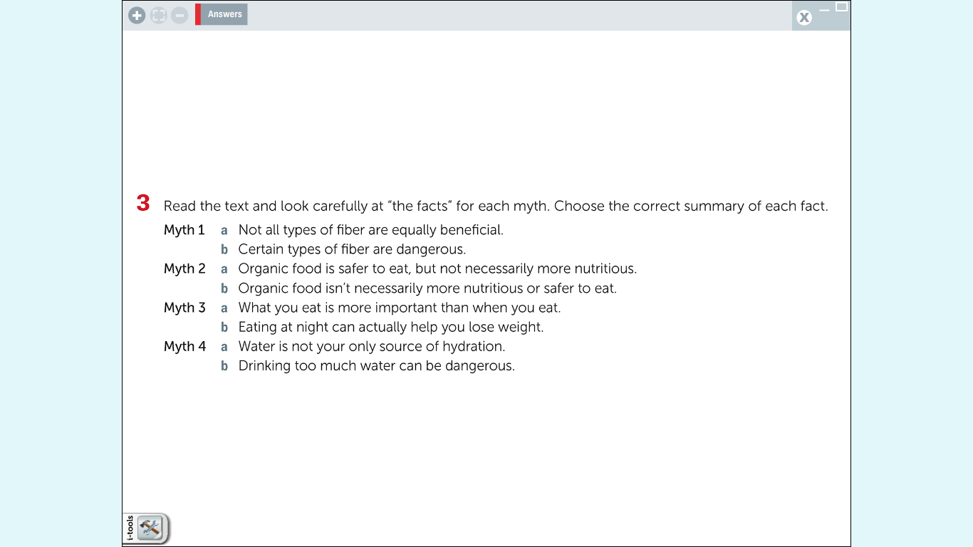

1. Read the skill box about understanding non-literal meaning. As you can see we use words and phrases in a different way from their usual sense to make our writing more interesting and memorable. There are four types of non-literal meaning .

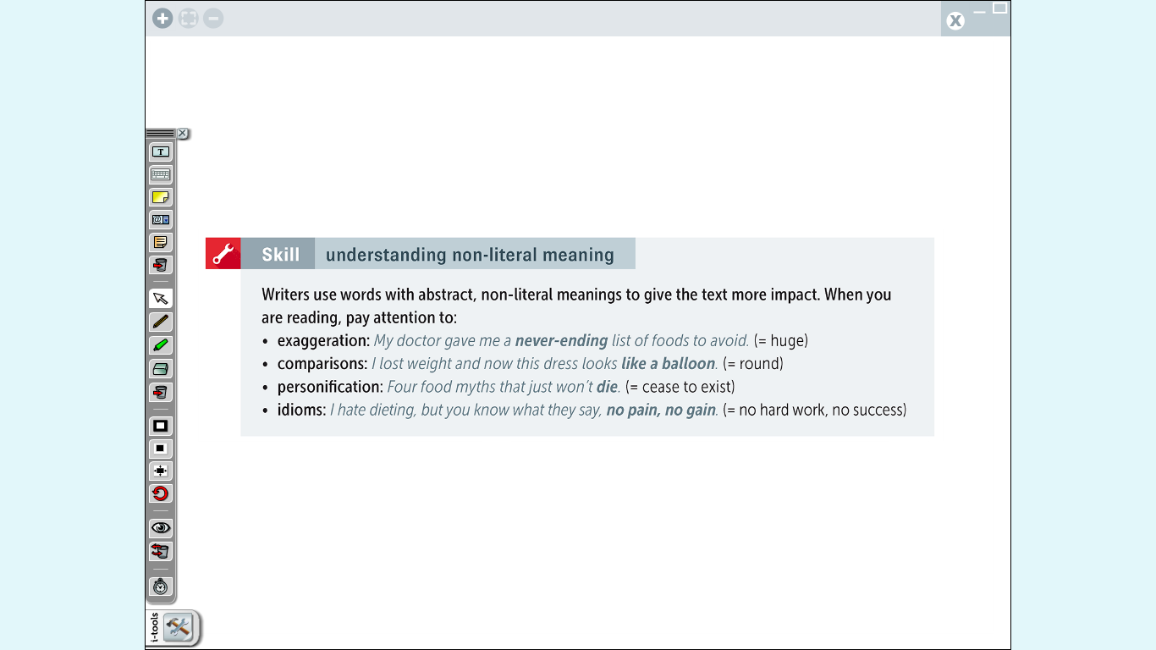

1. Read the following sentence from the introduction. What kind of non-literal language is being used.

***We are faced with a flood of information.***

………………………………………………….

1. Read the main text. Look at the underlined phrases 1-8 in the text. What kind of non-literal language in the skill box is used in each one?
2. …………………………………….
3. …………………………………….
4. …………………………………….
5. …………………………………….
6. …………………………………….
7. …………………………………….
8. …………………………………….
9. …………………………………….
10. In myth 1, find the question **“Does this mean you can stop eating broccoli…..?”** Read the next sentence. What expression tells you the answer is ***no***?

…………………………………………