**UNIT 1**

**SPEAKING**

Task 1. Answer the questions in activities A and B.

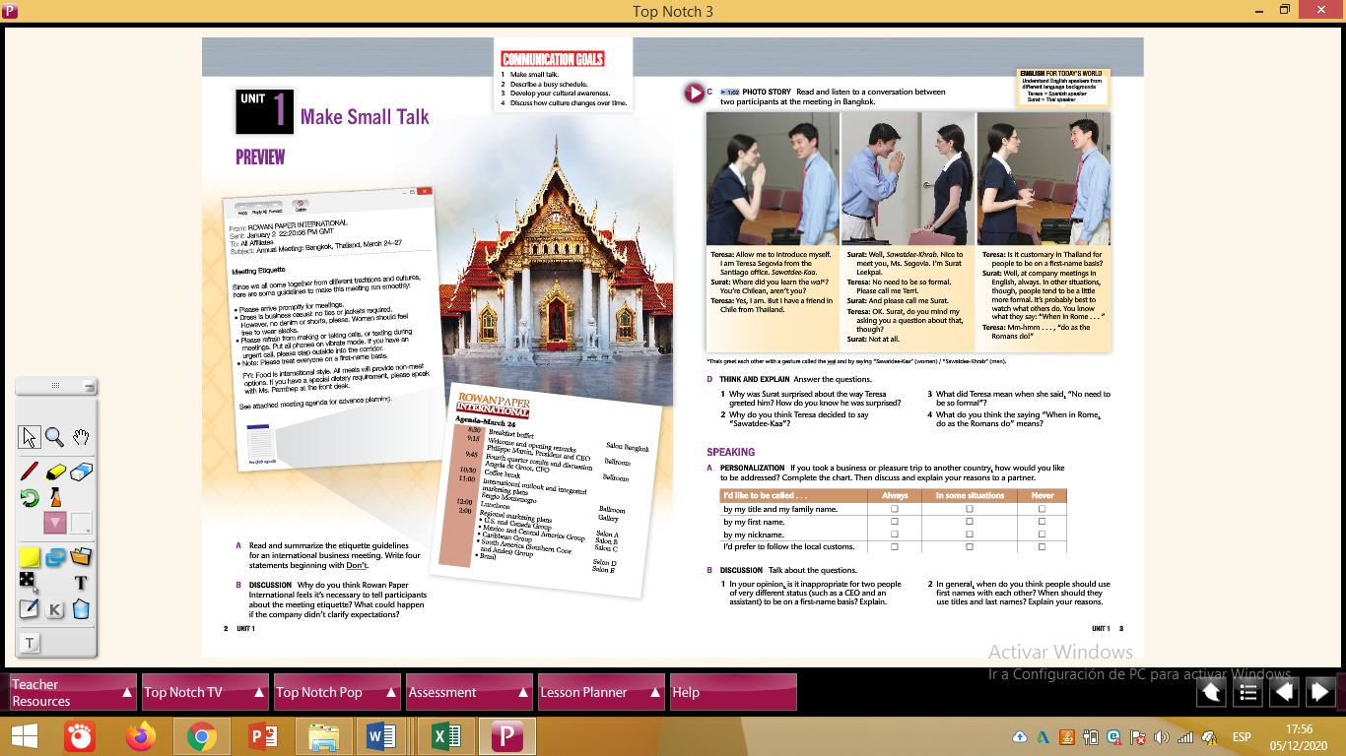

**Activity A Example:**

* **If I took a business or pleasure trip to another country, I’d like to be called by my title and family name in some situations because …**