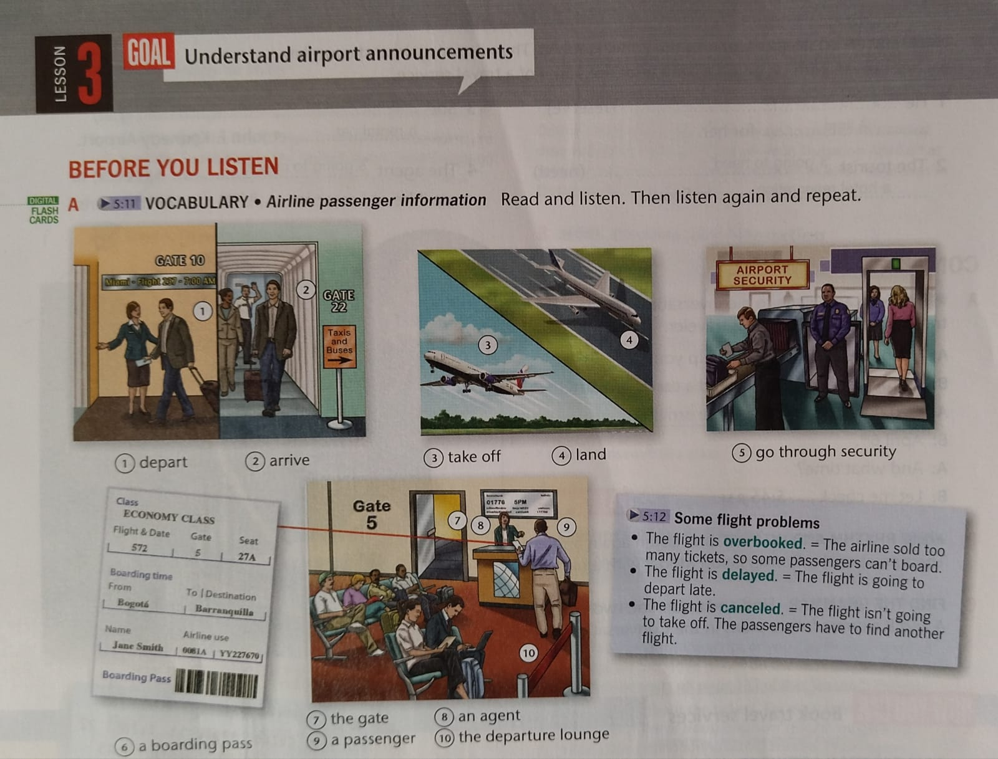

1. **Use the vocabulary to complete the pre-flight instructions.**

When you ................................ at the airport, you should take your ............................... luggage to the check-in then you can ....................................., where ............................... have to put all their hand luggage on the belt. From there you should go to the ......................... your plane is departing from. If you are early and your plane isn't at the gate, just have a seat in the ..............................

When they call your flight, you can show your boarding pass to the .................... and get on the plane. Be sure to turn off your phone before your plane ........................ from the gate. Enjoy the takeoff, and have a good flight!

1. **LISTEN FOR DETAILS Listen to the announcements. Write the flight information.**
2. flight number: ........................
3. original departure gate: .................
4. final departure gate: ......................
5. final departure time: ....................
6. **LISTEN TO UNDERSTAND ANNOUNCEMENTS Listen again and check the travel problems.**

* a delay
* a cancellation
* an overbooked flight
* a gate change
* a security problem
* a mechanical problem

