**UNIT 5**

**VOCABULARY 2**

**Task 1. Present the vocabulary below. Use pictures to represent each word and definition. Use Tophonetics to practice a correct pronunciation.**

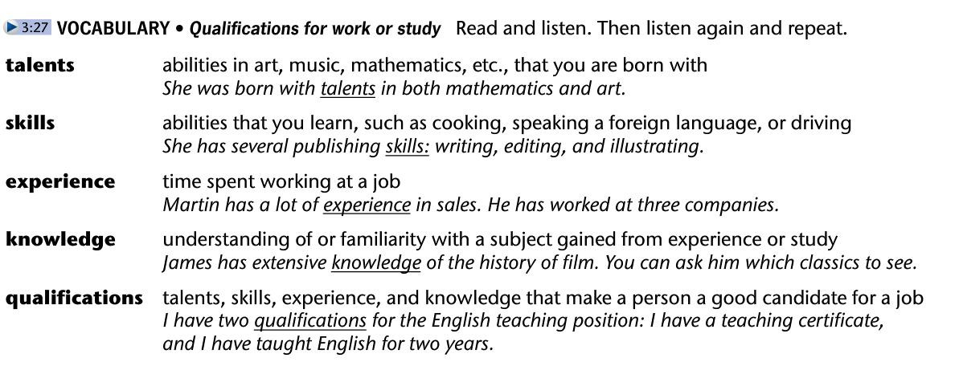

**Task 2. Create a game based on the vocabulary.**

**Task 3. Develop activity B.**

