**VOCABULARY OF UNIT 3**

**Task 1. Present the vocabulary. Use Tophonetics platform to know the correct pronunciation of these words.**

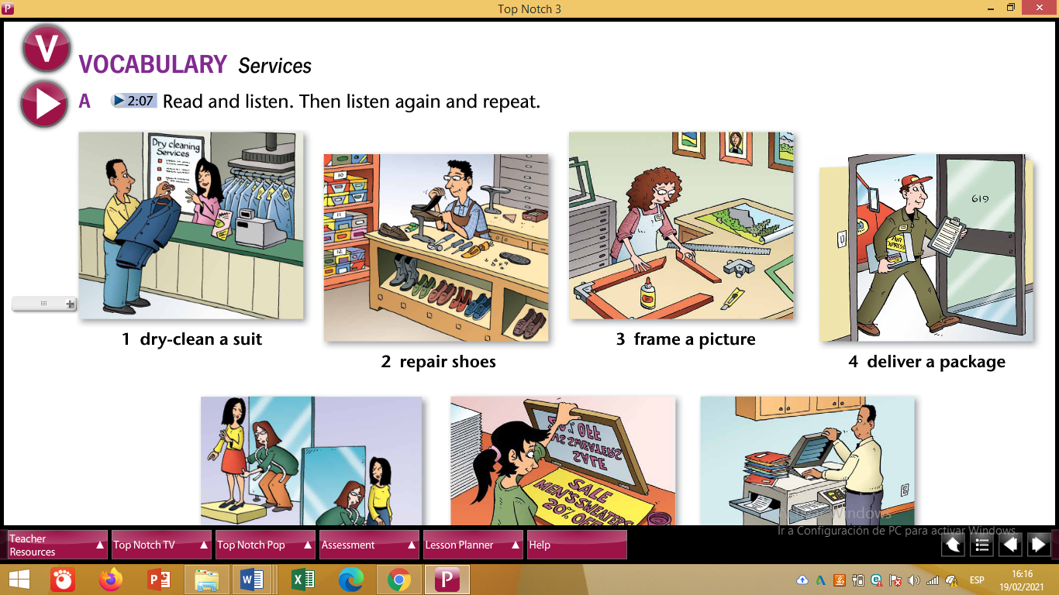

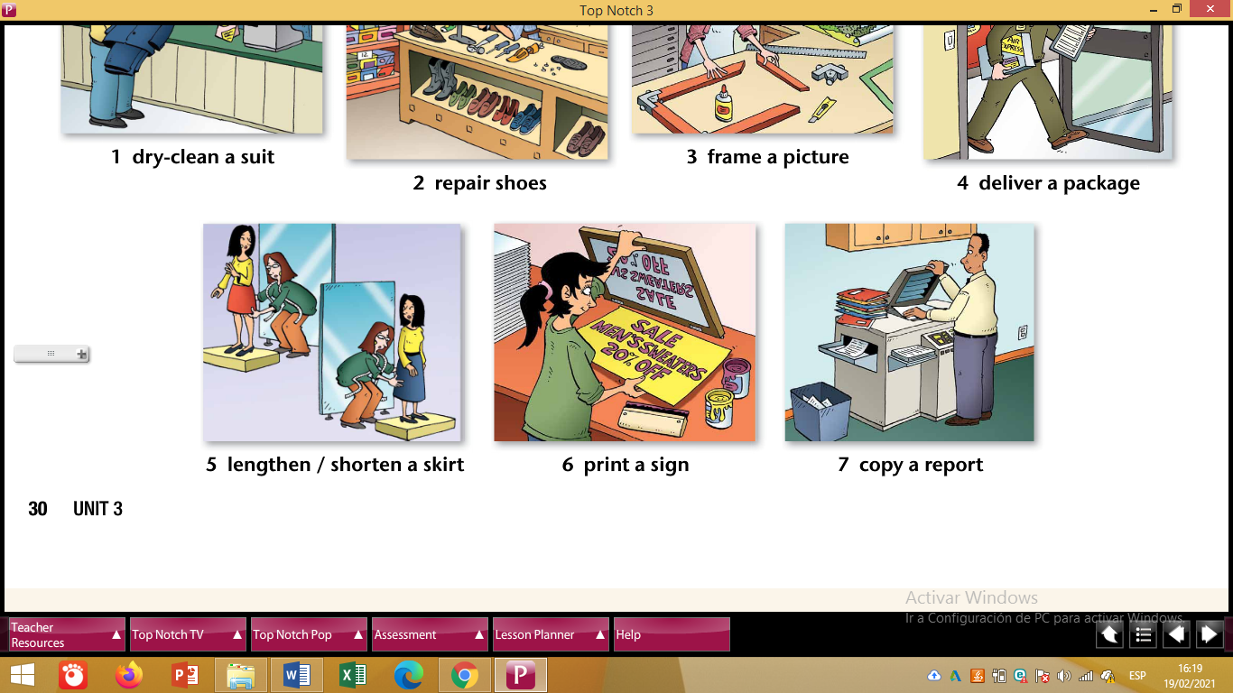

**Task 2. Create a GAME for your partners to guess or complete words based on the Vocabulary.**

**Task 3. Create sentences using Passive Causatives.**

**Example:**

1. **Richard has his suit dry-cleaned in that laundry.**
2. **_______________________________________**
3. **_______________________________________**
4. **_______________________________________**
5. **_______________________________________**
6. **_______________________________________**
7. **_______________________________________**

**NOTE: Use as many SLIDES as necessary.**